**HOME PAGE**

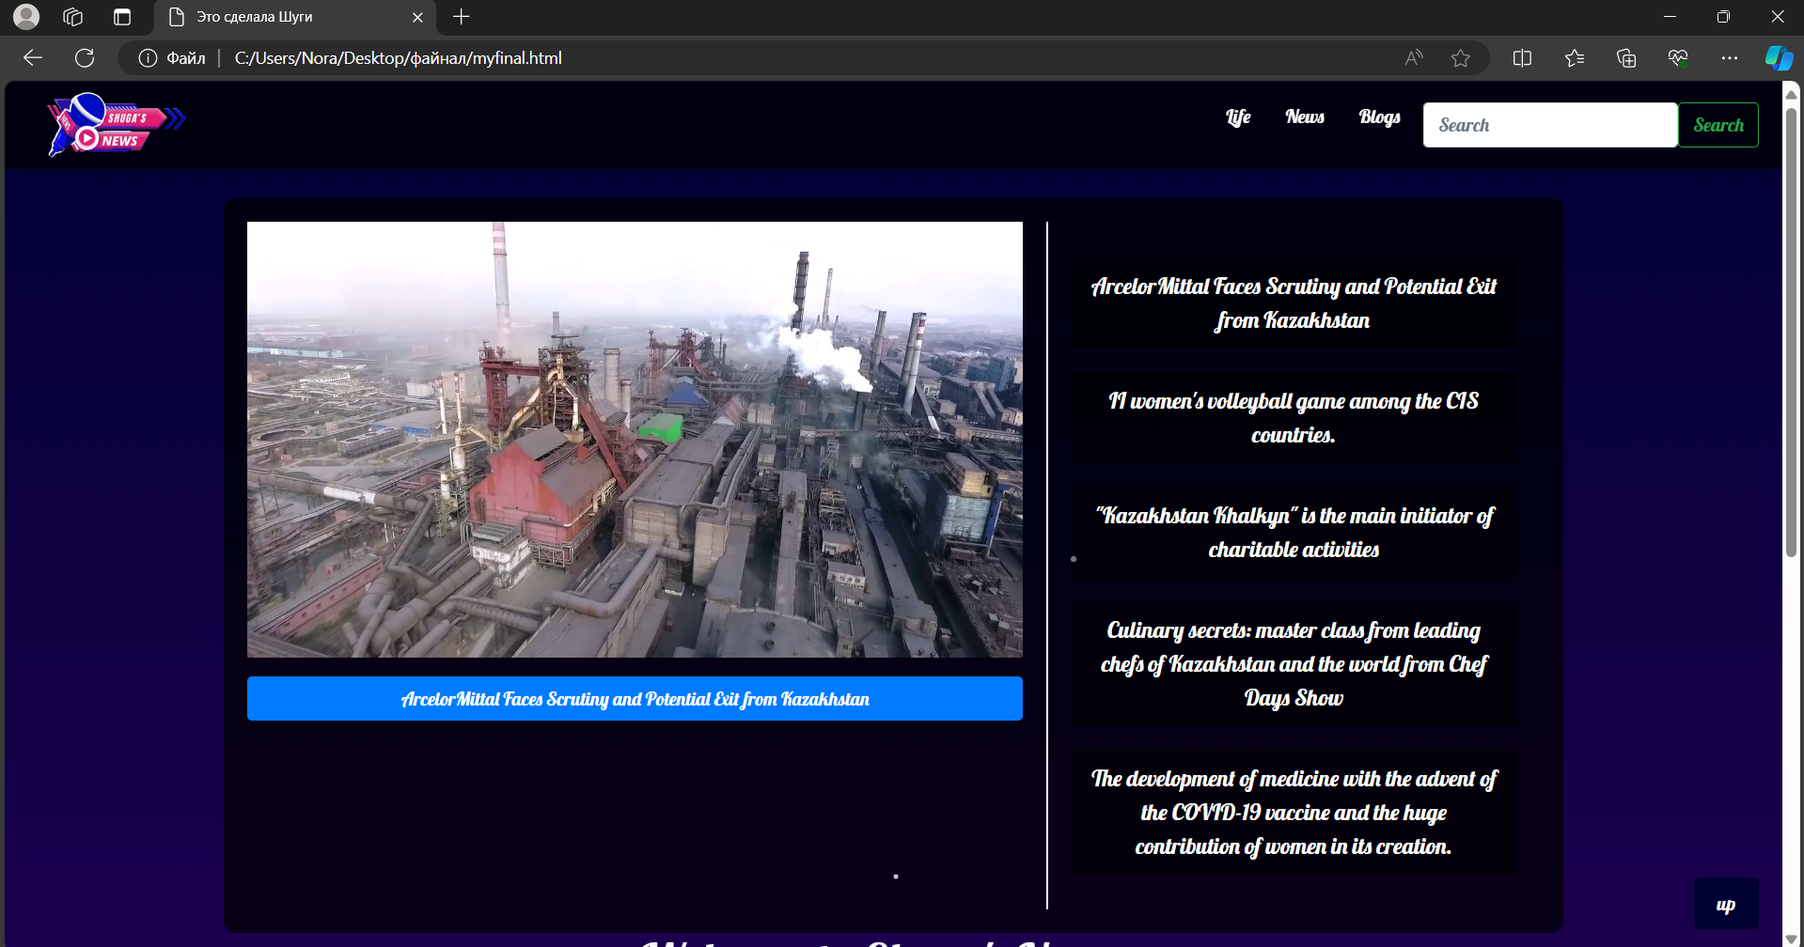

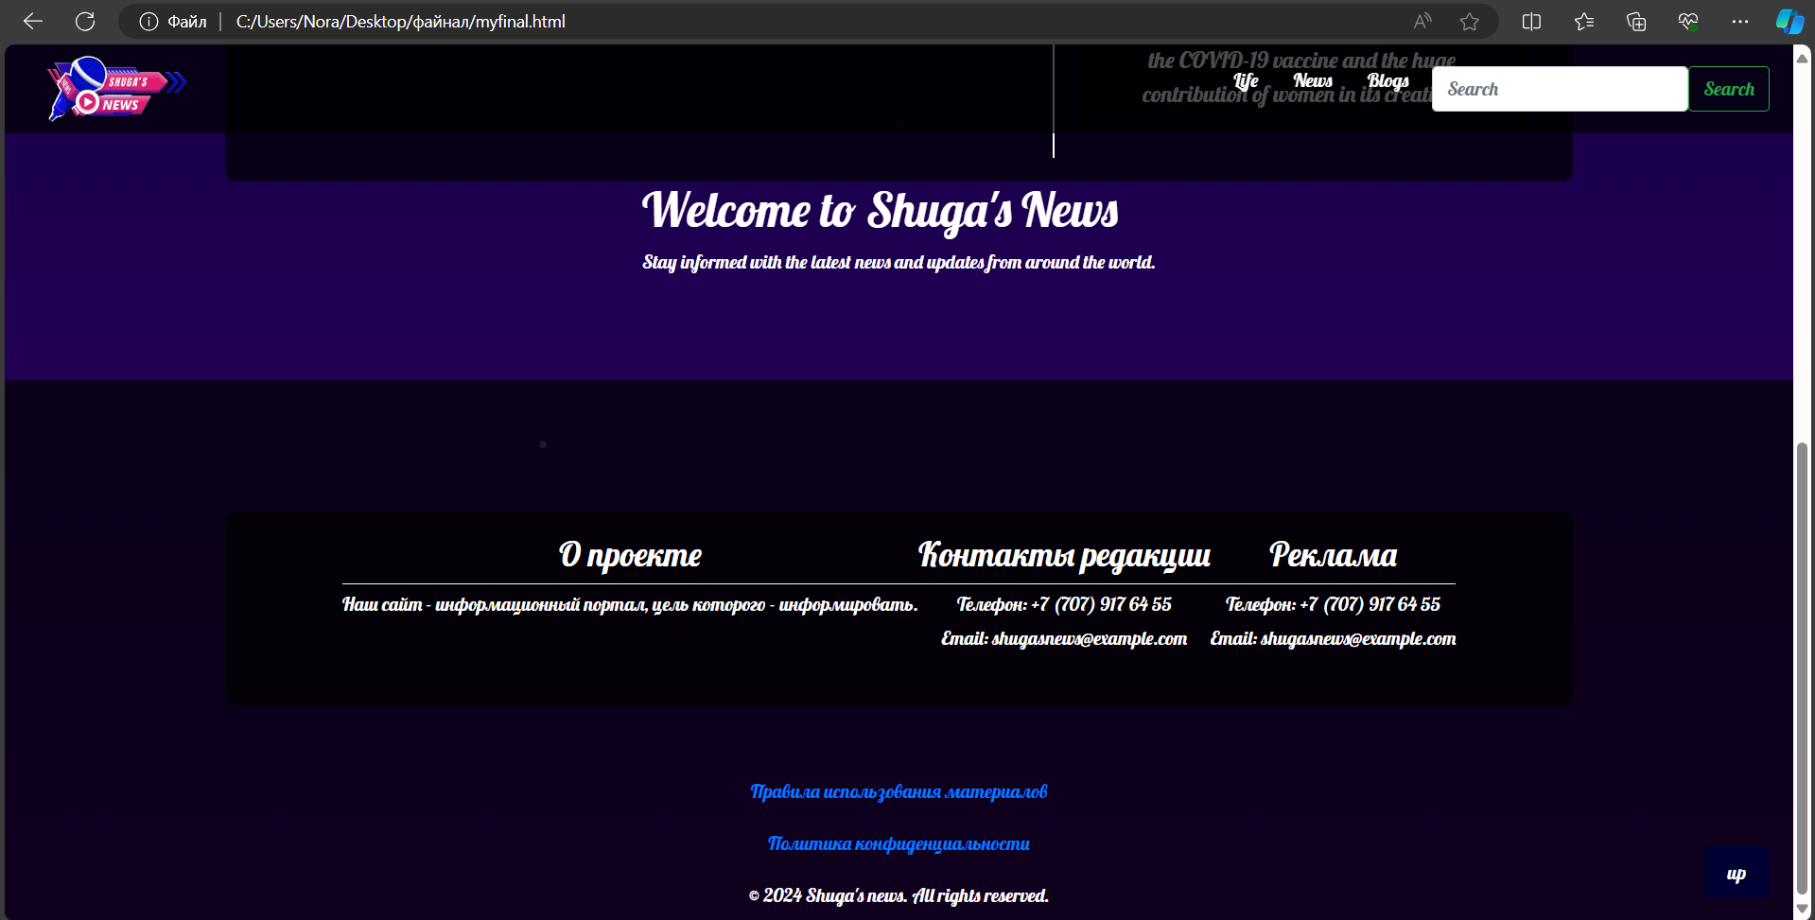



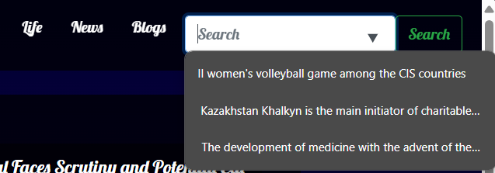

**By clicking on search, from the selective that we have here. You will be redirected to the pages of what you are looking for**

<!DOCTYPE html>

<html lang="en">

<head>

<meta charset="UTF-8">

<meta name="viewport" content="width=device-width, initial-scale=1.0">

<title>Это сделала Шуги</title>

<!-- Bootstrap CSS -->

<link href="https://stackpath.bootstrapcdn.com/bootstrap/4.5.2/css/bootstrap.min.css" rel="stylesheet">

<style>

@import url('https://fonts.googleapis.com/css2?family=Lobster&display=swap');

body {

margin: 0;

padding: 0;

background: linear-gradient(180deg, #000033 0%, #330066 100%);

color: white;

font-family: 'Lobster', cursive;

display: flex;

flex-direction: column;

align-items: center;

min-height: 100vh;

overflow-x: hidden;

position: relative;

}

/* Fireworks animation */

@keyframes fireworks {

0% { opacity: 1; transform: scale(1); }

100% { opacity: 0; transform: scale(2); }

}

.firework {

position: absolute;

background-color: white;

border-radius: 50%;

width: 3px;

height: 3px;

animation: fireworks 1.5s infinite;

}

.firework:nth-child(1) { top: 20%; left: 40%; animation-delay: 0.1s; }

.firework:nth-child(2) { top: 30%; left: 60%; animation-delay: 0.3s; }

.firework:nth-child(3) { top: 50%; left: 50%; animation-delay: 0.5s; }

.firework:nth-child(4) { top: 70%; left: 30%; animation-delay: 0.7s; }

.firework:nth-child(5) { top: 80%; left: 70%; animation-delay: 0.9s; }

.top-menu {

position: fixed;

top: 0;

width: 100%;

background-color: rgba(0, 0, 0, 0.7);

padding: 10px 20px;

display: flex;

align-items: center;

justify-content: space-between;

z-index: 1000;

height: 75px;

}

.navbar-logo img {

width: 150px;

transition: transform 0.3s;

}

.navbar-logo img:hover {

transform: scale(1.1);

}

.menu-main {

list-style: none;

display: flex;

margin: 0;

padding: 0;

}

.menu-main li {

position: relative;

margin-left: 10px;

}

.menu-main a {

text-decoration: none;

color: white;

padding: 5px 10px;

transition: color 0.3s, background-color 0.3s;

}

.menu-main a:hover {

color: yellow;

background-color: rgba(255, 255, 255, 0.2);

}

.menu-main a:hover::after {

content: '⭐️';

position: absolute;

right: -20px;

top: 0;

}

.container {

display: flex;

margin-top: 100px;

justify-content: center;

width: 100%;

}

.carousel-container {

flex: 2;

max-width: 60%;

}

.links-container {

flex: 1;

display: flex;

flex-direction: column;

justify-content: center;

align-items: flex-start;

padding: 20px;

border-left: 2px solid white;

margin-left: 20px;

}

.links-container a {

color: white;

text-decoration: none;

margin: 10px 0;

padding: 10px 15px;

background-color: rgba(0, 0, 0, 0.5);

font-size: 1.2em;

transition: background-color 0.3s;

}

.links-container a:hover {

background-color: rgba(255, 255, 255, 0.2);

}

footer {

margin-top: auto;

padding: 10px;

background-color: rgba(0, 0, 0, 0.7);

text-align: center;

width: 100%;

}

footer p {

margin: 0;

}

.scroll-to-top {

position: fixed;

bottom: 20px;

right: 20px;

background-color: #000033;

color: white;

border: none;

padding: 10px 20px;

border-radius: 5px;

cursor: pointer;

font-size: 16px;

transition: background-color 0.3s, color 0.3s;

}

.scroll-to-top:hover {

background-color: #330066;

}

</style>

</head>

<body>

<!-- Fireworks Background -->

<div class="firework"></div>

<div class="firework"></div>

<div class="firework"></div>

<div class="firework"></div>

<div class="firework"></div>

<nav class="top-menu">

<a class="navbar-logo" href="C:\Users\Nora\Desktop\файнал\abouusshuga.html"><img src="C:\Users\Nora\Downloads\yoooo-removebg-preview.png" alt="Logo"></a>

<ul class="menu-main">

<li><a href="C:\Users\Nora\Desktop\файнал\life.html">Life</a></li>

<li><a href="C:\Users\Nora\Desktop\файнал\myfinal.html">News</a></li>

<li><a href="C:\Users\Nora\Desktop\файнал\consultation.html">Blogs</a></li>

<li>

<form class="d-flex" role="search">

<input class="form-control me-2" list="suggestions" type="search" placeholder="Search" aria-label="Search">

<datalist id="suggestions">

<option value="II women's volleyball game among the CIS countries" data-url="C:\Users\Nora\Desktop\файнал\articletwo.html">II women's volleyball game among the CIS countries</option>

<option value="Kazakhstan Khalkyn is the main initiator of charitable activities" data-url="C:\Users\Nora\Desktop\файнал\articlethree.html">Kazakhstan Khalkyn is the main initiator of charitable activities</option>

<option value="The development of medicine with the advent of the COVID-19" data-url="C:\Users\Nora\Desktop\файнал\articlefive.html">The development of medicine with the advent of the COVID-19</option>

</datalist>

<button class="btn btn-outline-success" id="searchButton" type="button">Search</button>

</form>

</li>

</ul>

</nav>

<script>

document.getElementById('searchButton').addEventListener('click', function() {

var input = document.querySelector('input[type="search"]');

var selectedOption = document.querySelector('option[value="' + input.value + '"]');

if (selectedOption && selectedOption.dataset.url) {

window.location.href = selectedOption.dataset.url;

}

});

</script>

<div class="container">

<div class="carousel-container">

<div id="carouselExampleSlidesOnly" class="carousel slide" data-ride="carousel">

<div class="carousel-inner">

<div class="carousel-item active">

<img src="C:\Users\Nora\Pictures\для универа\арселор 2.jpg" class="d-block w-100" alt="...">

</div>

<div class="carousel-item">

<img src="C:\Users\Nora\Pictures\для универа\арселор 3.jpg" class="d-block w-100" alt="...">

</div>

<div class="carousel-item">

<img src="C:\Users\Nora\Pictures\для универа\арселор 2.jpg" class="d-block w-100" alt="...">

</div>

</div>

</div>

<a href="C:\Users\Nora\Desktop\файнал\articleone.html" class="btn btn-primary mt-3" style="display: block; text-align: center;">ArcelorMittal Faces Scrutiny and Potential Exit from Kazakhstan</a>

</div>

<div class="links-container">

<a href="C:\Users\Nora\Desktop\файнал\articleone.html">ArcelorMittal Faces Scrutiny and Potential Exit from Kazakhstan</a>

<a href="C:\Users\Nora\Desktop\файнал\articletwo.html">II women's volleyball game among the CIS countries.</a>

<a href="C:\Users\Nora\Desktop\файнал\articlethree.html">"Kazakhstan Khalkyn" is the main initiator of charitable activities</a>

<a href="C:\Users\Nora\Desktop\файнал\articlefour.html">Culinary secrets: master class from leading chefs of Kazakhstan and the world from Chef Days Show</a>

<a href="C:\Users\Nora\Desktop\файнал\articlefive.html">The development of medicine with the advent of the COVID-19 vaccine and the huge contribution of women in its creation.</a>

</div>

</div>

<div>

<h1>Welcome to Shuga's News</h1>

<p>Stay informed with the latest news and updates from around the world.</p>

</div>

<button class="scroll-to-top" onclick="scrollToTop()">up</button>

<a class="btn btn-primary" href="C:\Users\Nora\Desktop\файнал\newsrus.html" role="button">rus</a>

<br> <br> <br>

<footer>

<div class="container">

<div class="info-section">

<h3>about the project</h3>

<hr>

<p>Our website is an information portal whose purpose is to inform.</p>

</div>

<div class="info-section">

<h3>Editorial contacts</h3>

<hr>

<p>+7 (707) 917 64 50</p>

<p>Email: shugasnews@example.com</p>

</div>

<div class="info-section">

<h3>Advertising</h3>

<hr>

<p>+7 (707) 917 64 50</p>

<p>Email: shugasnews@example.com</p>

</div>

</div>

<div class="copyright">

<hr>

<p><a href="C:\Users\Nora\Desktop\файнал\rules.html">Rules for using materials</a></p>

<p><a href="C:\Users\Nora\Desktop\файнал\policy.html">Privacy Policy</a></p>

</div>

<p>&copy; 2024 Shuga's news. All rights reserved.</p>

</footer>

<style>

.container {

padding: 20px;

background-color: rgba(0, 0, 0, 0.7);

border-radius: 10px;

color: white;

text-align: center;

}

.info-section {

margin-bottom: 20px;

}

.info-section hr {

border: 0;

border-top: 1px solid white;

margin: 5px 0;

}

.info-section p {

margin: 0;

margin-bottom: 5px;

}

.info-section a {

color: white;

text-decoration: none;

}

.info-section a:hover {

text-decoration: underline;

}

footer p {

text-align: center;

margin-top: 20px;

}

.copyright {

margin-top: 40px;

}

</style>

<!-- Bootstrap JS and dependencies -->

<script src="https://code.jquery.com/jquery-3.5.1.slim.min.js"></script>

<script src="https://cdn.jsdelivr.net/npm/@popperjs/core@2.5.4/dist/umd/popper.min.js"></script>

<script src="https://stackpath.bootstrapcdn.com/bootstrap/4.5.2/js/bootstrap.min.js"></script>

<script>

// Показать кнопку, когда прокручено вниз 20px от верха

window.onscroll = function() {scrollFunction()};

function scrollFunction() {

const scrollToTopBtn = document.querySelector(".scroll-to-top");

if (document.body.scrollTop > 20 || document.documentElement.scrollTop > 20) {

scrollToTopBtn.style.display = "block";

} else {

scrollToTopBtn.style.display = "none";

}

}

// Прокрутка наверх

function scrollToTop() {

document.body.scrollTop = 0;

document.documentElement.scrollTop = 0;

}

</script>

</body>

</html>



(меняет на русский язык)  
**If we follow the links below about politics and so on, it will redirect to a page where photos will open and clicking on the cross will take you back to the beginning.**

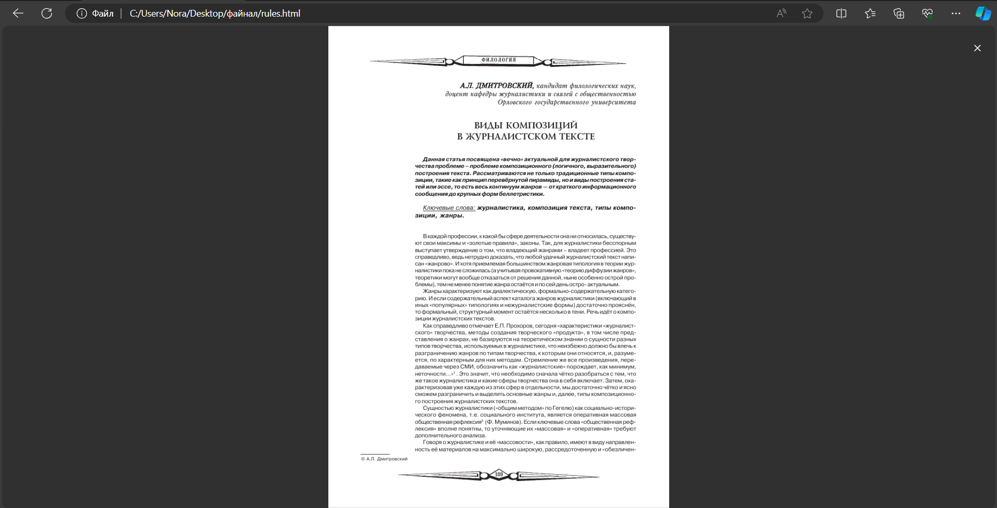

<!DOCTYPE html>

<html lang="en">

<head>

<meta charset="UTF-8">

<meta name="viewport" content="width=device-width, initial-scale=1.0">

<title>Full Screen Image2</title>

<style>

body {

margin: 0;

padding: 0;

display: flex;

justify-content: center;

align-items: center;

height: 100vh;

background-color: #f0f0f0;

}

img {

max-width: 100%;

max-height: 100%;

cursor: zoom-out;

}

.fullscreen {

position: fixed;

top: 0;

left: 0;

width: 100vw;

height: 100vh;

background-color: rgba(0, 0, 0, 0.8);

display: flex;

justify-content: center;

align-items: center;

z-index: 9999;

}

.close {

position: absolute;

top: 20px;

right: 20px;

color: white;

font-size: 24px;

cursor: pointer;

}

</style>

</head>

<body>

<button onclick="openFullscreenImage()">Open Fullscreen Image</button>

<div class="fullscreen" id="fullscreen">

<img src="C:\Users\Nora\Desktop\файнал\правила.png" alt="Fullscreen Image">

<span class="close" onclick="closeFullscreenImage()">&times;</span>

</div>

<script>

function openFullscreenImage() {

var fullscreenElement = document.getElementById("fullscreen");

var imgElement = fullscreenElement.querySelector("img");

var imageUrl = prompt("Enter image URL:");

if (imageUrl) {

imgElement.src = imageUrl;

fullscreenElement.style.display = "flex";

}

}

function closeFullscreenImage() {

document.getElementById("fullscreen").style.display = "none";

window.location.href = "file:///C:/Users/Nora/Desktop/файнал/myfinal.html";

}

</script>

</body>

</html>

**Second link to privacy policy**

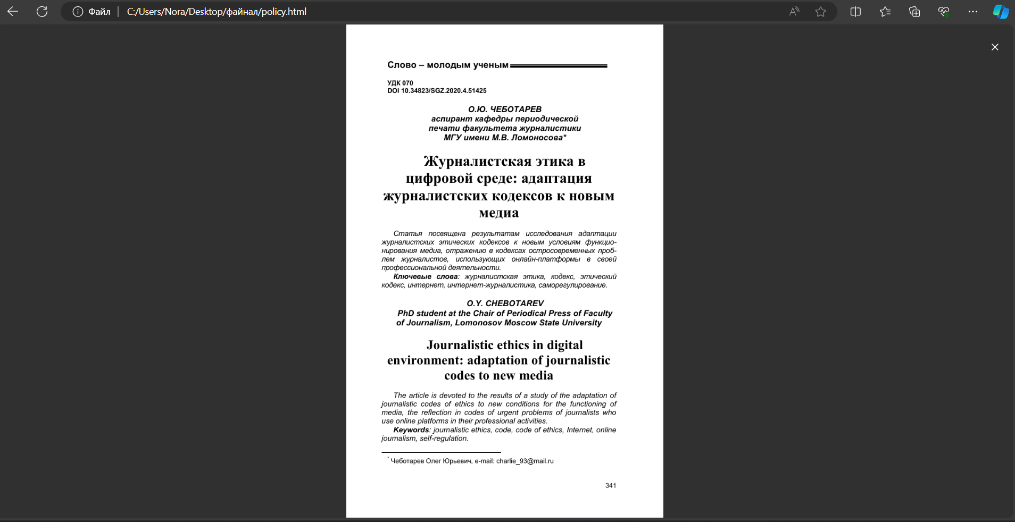

<!DOCTYPE html>

<html lang="en">

<head>

<meta charset="UTF-8">

<meta name="viewport" content="width=device-width, initial-scale=1.0">

<title>Full Screen Image</title>

<style>

body {

margin: 0;

padding: 0;

display: flex;

justify-content: center;

align-items: center;

height: 100vh;

background-color: #f0f0f0;

}

img {

max-width: 100%;

max-height: 100%;

cursor: zoom-out;

}

.fullscreen {

position: fixed;

top: 0;

left: 0;

width: 100vw;

height: 100vh;

background-color: rgba(0, 0, 0, 0.8);

display: flex;

justify-content: center;

align-items: center;

z-index: 9999;

}

.close {

position: absolute;

top: 20px;

right: 20px;

color: white;

font-size: 24px;

cursor: pointer;

}

</style>

</head>

<body>

<button onclick="openFullscreenImage()">Open Fullscreen Image</button>

<div class="fullscreen" id="fullscreen">

<img src="C:\Users\Nora\Desktop\файнал\политика.png" alt="Fullscreen Image">

<span class="close" onclick="closeFullscreenImage()">&times;</span>

</div>

<script>

function openFullscreenImage() {

var fullscreenElement = document.getElementById("fullscreen");

var imgElement = fullscreenElement.querySelector("img");

var imageUrl = prompt("Enter image URL:");

if (imageUrl) {

imgElement.src = imageUrl;

fullscreenElement.style.display = "flex";

}

}

function closeFullscreenImage() {

document.getElementById("fullscreen").style.display = "none";

window.location.href = "file:///C:/Users/Nora/Desktop/файнал/myfinal.html";

}

</script>

</body>

</html>

**Returning to the main page, here you can see a table with the article. Clicking each will open a page with the article.**

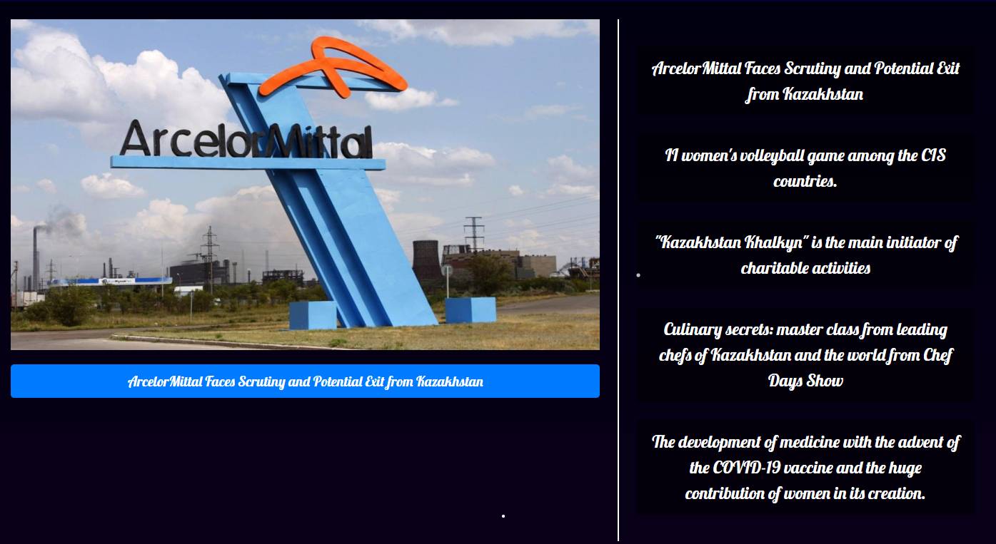

**the button about arcelor metal and the first choice on the table next to the photos BOTH are transferred to one article site.**

**<!DOCTYPE html>**

**<html lang="en">**

**<head>**

**<meta charset="UTF-8">**

**<meta name="viewport" content="width=device-width, initial-scale=1.0">**

**<title>Статья с изображением 1</title>**

**<style>**

**body {**

**margin: 0;**

**padding: 0;**

**background: linear-gradient(180deg, #000033 0%, #330066 100%);**

**color: white;**

**font-family: 'Lobster', cursive;**

**display: flex;**

**justify-content: center;**

**align-items: flex-start;**

**min-height: 100vh;**

**overflow-x: hidden;**

**}**

**.top-menu {**

**position: fixed;**

**top: 0;**

**width: 100%;**

**background-color: rgba(0, 0, 0, 0.7);**

**padding: 10px 20px;**

**display: flex;**

**align-items: center;**

**justify-content: space-between;**

**z-index: 1000;**

**height: 75px;**

**}**

**.navbar-logo img {**

**width: 150px;**

**transition: transform 0.3s;**

**}**

**.navbar-logo img:hover {**

**transform: scale(1.1);**

**}**

**.menu-main {**

**list-style: none;**

**display: flex;**

**margin: 0;**

**padding: 0;**

**}**

**.menu-main li {**

**position: relative;**

**margin-left: 10px;**

**}**

**.menu-main a {**

**text-decoration: none;**

**color: white;**

**padding: 5px 10px;**

**transition: color 0.3s, background-color 0.3s;**

**}**

**.menu-main a:hover {**

**color: yellow;**

**background-color: rgba(255, 255, 255, 0.2);**

**}**

**.menu-main a:hover::after {**

**content: '⭐️';**

**position: absolute;**

**right: -20px;**

**top: 0;**

**}**

**.submenu {**

**display: none;**

**position: absolute;**

**top: 100%;**

**left: 0;**

**background-color: rgba(0, 0, 0, 0.8);**

**list-style: none;**

**margin: 0;**

**padding: 0;**

**}**

**.menu-main li:hover .submenu {**

**display: block;**

**}**

**.submenu li {**

**width: 200px;**

**}**

**.submenu a {**

**padding: 10px;**

**}**

**.article-container {**

**max-width: 800px;**

**margin: 100px 20px 20px 20px;**

**padding: 20px;**

**background-color: rgba(0, 0, 0, 0.7);**

**border-radius: 10px;**

**}**

**.article-header {**

**text-align: center;**

**margin-bottom: 10px;**

**}**

**.article-meta {**

**text-align: center;**

**margin-bottom: 20px;**

**font-size: 0.9em;**

**color: #ccc;**

**}**

**.article-image {**

**display: block;**

**margin: 20px auto;**

**max-width: 100%;**

**height: auto;**

**border: 2px solid white;**

**border-radius: 10px;**

**}**

**.scroll-to-top {**

**position: fixed;**

**bottom: 20px;**

**right: 20px;**

**background-color: #000033;**

**color: white;**

**border: none;**

**padding: 10px 20px;**

**border-radius: 5px;**

**cursor: pointer;**

**font-size: 16px;**

**transition: background-color 0.3s, color 0.3s;**

**}**

**.scroll-to-top:hover {**

**background-color: #330066;**

**}**

**</style>**

**</head>**

**<body>**

**<nav class="top-menu">**

**<a class="navbar-logo" href="C:\Users\Nora\Desktop\файнал\abouusshuga.html"><img src="C:\Users\Nora\Downloads\yoooo-removebg-preview.png" alt="Logo"></a>**

**<ul class="menu-main">**

**<li><a href="C:\Users\Nora\Desktop\файнал\life.html">Life</a></li>**

**<li><a href="C:\Users\Nora\Desktop\файнал\myfinal.html">News</a></li>**

**<li><a href="C:\Users\Nora\Desktop\файнал\consultation.html">Blogs</a></li>**

**<li>**

**<form class="d-flex" role="search">**

**<input class="form-control me-2" list="suggestions" type="search" placeholder="Search" aria-label="Search">**

**<datalist id="suggestions">**

**<option value="II women's volleyball game among the CIS countries" data-url="C:\Users\Nora\Desktop\файнал\articletwo.html">II women's volleyball game among the CIS countries</option>**

**<option value="Kazakhstan Khalkyn is the main initiator of charitable activities" data-url="C:\Users\Nora\Desktop\файнал\articlethree.html">Kazakhstan Khalkyn is the main initiator of charitable activities</option>**

**<option value="The development of medicine with the advent of the COVID-19" data-url="C:\Users\Nora\Desktop\файнал\articlefive.html">The development of medicine with the advent of the COVID-19</option>**

**</datalist>**

**<button class="btn btn-outline-success" id="searchButton" type="button">Search</button>**

**</form>**

**</li>**

**</ul>**

**</nav>**

**<script>**

**document.getElementById('searchButton').addEventListener('click', function() {**

**var input = document.querySelector('input[type="search"]');**

**var selectedOption = document.querySelector('option[value="' + input.value + '"]');**

**if (selectedOption && selectedOption.dataset.url) {**

**window.location.href = selectedOption.dataset.url;**

**}**

**});**

**</script>**

**<div class="article-container">**

**<h1 class="article-header">ArcelorMittal Faces Scrutiny and Potential Exit from Kazakhstan</h1>**

**<div class="article-meta">**

**by Nurbay Shugyla | 26 December 2023**

**</div>**

**<p>In August 2023, Kazakh President Kassym-Jomart Tokayev expressed concern over ongoing accidents at ArcelorMittal's operations in Kazakhstan, citing violations and neglect that he believes are impacting the company's performance in the Kazakh market. These remarks came amid growing tensions between the government of Kazakhstan and the multinational steel manufacturing corporation. The Kazakh government has initiated negotiations regarding ArcelorMittal's potential exit from its assets in Kazakhstan. The discussions gained momentum following a tragic incident at the Lenin mine on November 3, 2023, which raised questions about safety standards and operational practices at ArcelorMittal's facilities in the country.</p>**

**<p>As a result of these negotiations, an agreement was reached to commence comprehensive examinations covering financial, legal, and technical aspects of ArcelorMittal's operations in Kazakhstan. This agreement, signed on December 9, 2023, reflects the government's commitment to thoroughly evaluate the situation and explore potential solutions. One of the key considerations in these discussions is the possibility of attracting a new investor, preferably from Kazakhstan, to take over ArcelorMittal's operations in the country. While this move may not immediately improve the company's income, it is expected to have a positive impact on tax revenues and overall security standards within the industry.</p>**

**<img src="C:\Users\Nora\Pictures\для универа\арселор 3.jpg" alt="Описание изображения" class="article-image">**

**<p>ArcelorMittal's presence in Kazakhstan has been significant, contributing to the country's economy and employment opportunities. However, recent events have highlighted the need for a reassessment of the company's operations to ensure compliance with local regulations and safety standards.</p>**

**<p>The outcome of the negotiations between ArcelorMittal and the Kazakh government will likely have far-reaching implications for both parties. It remains to be seen how the situation will unfold and what measures will be taken to address the concerns raised by President Tokayev and the government of Kazakhstan.</p>**

**</div>**

**<button class="scroll-to-top" onclick="scrollToTop()">up</button>**

**<script>**

**// Показать кнопку, когда прокручено вниз 20px от верха**

**window.onscroll = function() {scrollFunction()};**

**function scrollFunction() {**

**const scrollToTopBtn = document.querySelector(".scroll-to-top");**

**if (document.body.scrollTop > 20 || document.documentElement.scrollTop > 20) {**

**scrollToTopBtn.style.display = "block";**

**} else {**

**scrollToTopBtn.style.display = "none";**

**}**

**}**

**// Прокрутка наверх**

**function scrollToTop() {**

**document.body.scrollTop = 0;**

**document.documentElement.scrollTop = 0;**

**}**

**</script>**

**</body>**

**</html>**

**Photo from the website of the first article**

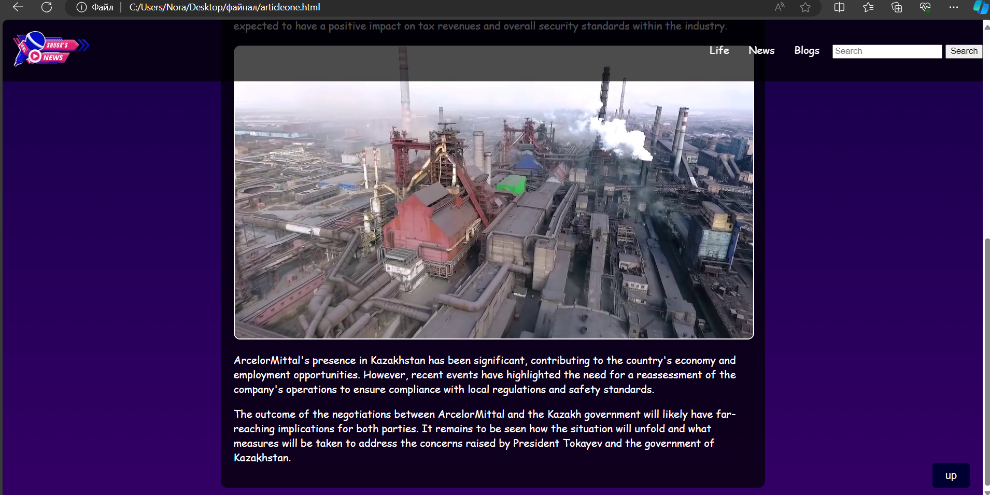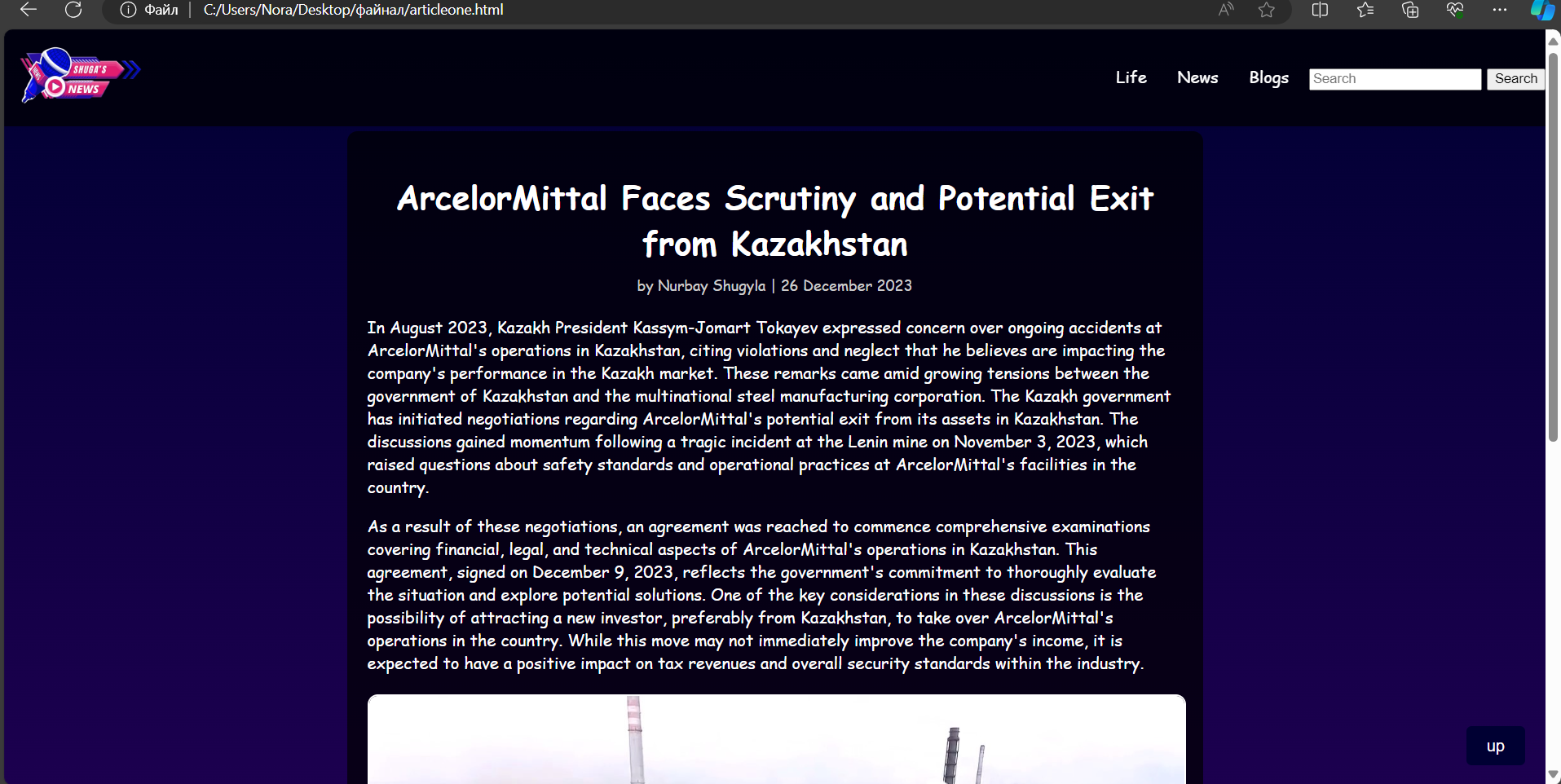

**second article from the main page table**

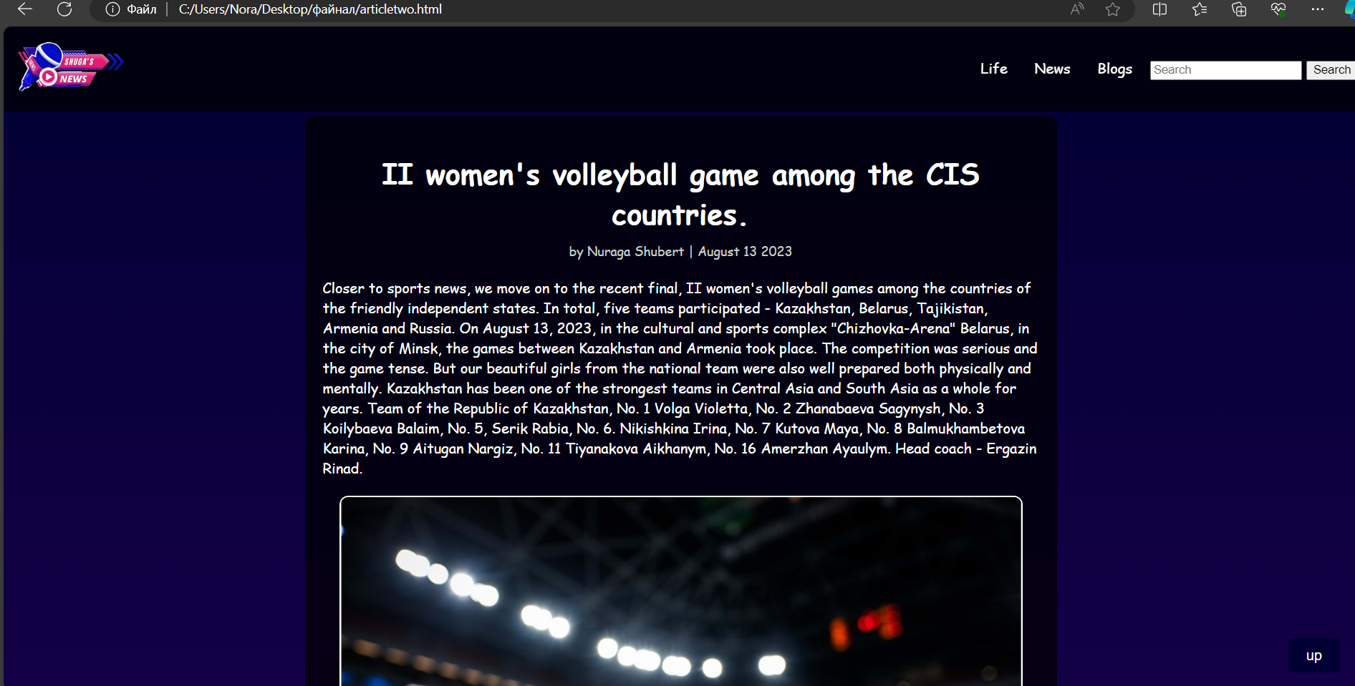

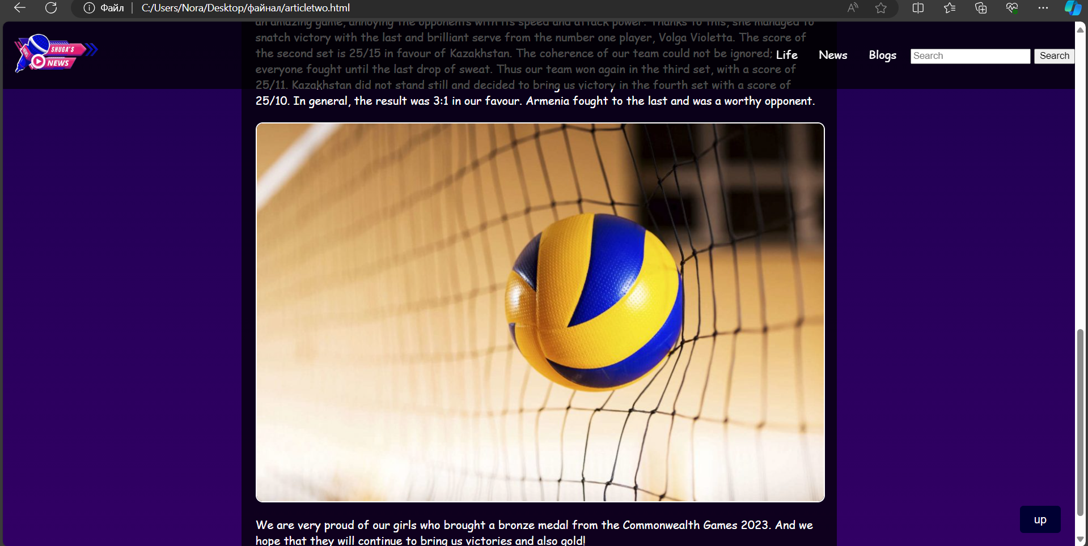

**<!DOCTYPE html>**

**<html lang="en">**

**<head>**

**<meta charset="UTF-8">**

**<meta name="viewport" content="width=device-width, initial-scale=1.0">**

**<title>Статья с изображением 3</title>**

**<style>**

**body {**

**margin: 0;**

**padding: 0;**

**background: linear-gradient(180deg, #000033 0%, #330066 100%);**

**color: white;**

**font-family: 'Lobster', cursive;**

**display: flex;**

**justify-content: center;**

**align-items: flex-start;**

**min-height: 100vh;**

**overflow-x: hidden;**

**}**

**.top-menu {**

**position: fixed;**

**top: 0;**

**width: 100%;**

**background-color: rgba(0, 0, 0, 0.7);**

**padding: 10px 20px;**

**display: flex;**

**align-items: center;**

**justify-content: space-between;**

**z-index: 1000;**

**height: 75px;**

**}**

**.navbar-logo img {**

**width: 150px;**

**transition: transform 0.3s;**

**}**

**.navbar-logo img:hover {**

**transform: scale(1.1);**

**}**

**.menu-main {**

**list-style: none;**

**display: flex;**

**margin: 0;**

**padding: 0;**

**}**

**.menu-main li {**

**position: relative;**

**margin-left: 10px;**

**}**

**.menu-main a {**

**text-decoration: none;**

**color: white;**

**padding: 5px 10px;**

**transition: color 0.3s, background-color 0.3s;**

**}**

**.menu-main a:hover {**

**color: yellow;**

**background-color: rgba(255, 255, 255, 0.2);**

**}**

**.menu-main a:hover::after {**

**content: '⭐️';**

**position: absolute;**

**right: -20px;**

**top: 0;**

**}**

**.submenu {**

**display: none;**

**position: absolute;**

**top: 100%;**

**left: 0;**

**background-color: rgba(0, 0, 0, 0.8);**

**list-style: none;**

**margin: 0;**

**padding: 0;**

**}**

**.menu-main li:hover .submenu {**

**display: block;**

**}**

**.submenu li {**

**width: 200px;**

**}**

**.submenu a {**

**padding: 10px;**

**}**

**.article-container {**

**max-width: 800px;**

**margin: 100px 20px 20px 20px;**

**padding: 20px;**

**background-color: rgba(0, 0, 0, 0.7);**

**border-radius: 10px;**

**}**

**.article-header {**

**text-align: center;**

**margin-bottom: 10px;**

**}**

**.article-meta {**

**text-align: center;**

**margin-bottom: 20px;**

**font-size: 0.9em;**

**color: #ccc;**

**}**

**.article-image {**

**display: block;**

**margin: 20px auto;**

**max-width: 100%;**

**height: auto;**

**border: 2px solid white;**

**border-radius: 10px;**

**}**

**.scroll-to-top {**

**position: fixed;**

**bottom: 20px;**

**right: 20px;**

**background-color: #000033;**

**color: white;**

**border: none;**

**padding: 10px 20px;**

**border-radius: 5px;**

**cursor: pointer;**

**font-size: 16px;**

**transition: background-color 0.3s, color 0.3s;**

**}**

**.scroll-to-top:hover {**

**background-color: #330066;**

**}**

**</style>**

**</head>**

**<body>**

**<nav class="top-menu">**

**<a class="navbar-logo" href="C:\Users\Nora\Desktop\файнал\abouusshuga.html"><img src="C:\Users\Nora\Downloads\yoooo-removebg-preview.png" alt="Logo"></a>**

**<ul class="menu-main">**

**<li><a href="C:\Users\Nora\Desktop\файнал\life.html">Life</a></li>**

**<li><a href="C:\Users\Nora\Desktop\файнал\myfinal.html">News</a></li>**

**<li><a href="C:\Users\Nora\Desktop\файнал\consultation.html">Blogs</a></li>**

**<li>**

**<form class="d-flex" role="search">**

**<input class="form-control me-2" list="suggestions" type="search" placeholder="Search" aria-label="Search">**

**<datalist id="suggestions">**

**<option value="II women's volleyball game among the CIS countries" data-url="C:\Users\Nora\Desktop\файнал\articletwo.html">II women's volleyball game among the CIS countries</option>**

**<option value="Kazakhstan Khalkyn is the main initiator of charitable activities" data-url="C:\Users\Nora\Desktop\файнал\articlethree.html">Kazakhstan Khalkyn is the main initiator of charitable activities</option>**

**<option value="The development of medicine with the advent of the COVID-19" data-url="C:\Users\Nora\Desktop\файнал\articlefive.html">The development of medicine with the advent of the COVID-19</option>**

**</datalist>**

**<button class="btn btn-outline-success" id="searchButton" type="button">Search</button>**

**</form>**

**</li>**

**</ul>**

**</nav>**

**<script>**

**document.getElementById('searchButton').addEventListener('click', function() {**

**var input = document.querySelector('input[type="search"]');**

**var selectedOption = document.querySelector('option[value="' + input.value + '"]');**

**if (selectedOption && selectedOption.dataset.url) {**

**window.location.href = selectedOption.dataset.url;**

**}**

**});**

**</script>**

**<div class="article-container">**

**<h1 class="article-header">II women's volleyball game among the CIS countries.</h1>**

**<div class="article-meta">**

**by Nuraga Shubert | August 13 2023**

**</div>**

**<p>Closer to sports news, we move on to the recent final, II women's volleyball games among the**

**countries of the friendly independent states. In total, five teams participated - Kazakhstan,**

**Belarus, Tajikistan, Armenia and Russia. On August 13, 2023, in the cultural and sports complex**

**"Chizhovka-Arena" Belarus, in the city of Minsk, the games between Kazakhstan and Armenia**

**took place. The competition was serious and the game tense. But our beautiful girls from the**

**national team were also well prepared both physically and mentally. Kazakhstan has been one**

**of the strongest teams in Central Asia and South Asia as a whole for years. Team of the Republic**

**of Kazakhstan, No. 1 Volga Violetta, No. 2 Zhanabaeva Sagynysh, No. 3 Koilybaeva Balaim, No. 5,**

**Serik Rabia, No. 6. Nikishkina Irina, No. 7 Kutova Maya, No. 8 Balmukhambetova Karina, No. 9**

**Aitugan Nargiz, No. 11 Tiyanakova Aikhanym, No. 16 Amerzhan Ayaulym. Head coach - Ergazin**

**Rinad.**

**</p>**

**<img src="C:\Users\Nora\Desktop\файнал\volleyball.jpeg" alt="Описание изображения" class="article-image">**

**<p>The first serve was from Kazakhstan, the game was very intriguing and exciting. The RK team**

**defeated its opponents at the beginning of the first set. The girls showed their incredible attacks,**

**techniques, blocking, defence and endurance, which decided the outcome of the game. But the**

**opponents did not lag behind and the first set favoured Armenia, with a score of 24/26. In the**

**second set, our team also played an amazing game, annoying the opponents with its speed and**

**attack power. Thanks to this, she managed to snatch victory with the last and brilliant serve from**

**the number one player, Volga Violetta. The score of the second set is 25/15 in favour of**

**Kazakhstan. The coherence of our team could not be ignored; everyone fought until the last**

**drop of sweat. Thus our team won again in the third set, with a score of 25/11. Kazakhstan did**

**not stand still and decided to bring us victory in the fourth set with a score of 25/10. In general,**

**the result was 3:1 in our favour. Armenia fought to the last and was a worthy opponent.**

**</p>**

**<img src="C:\Users\Nora\Desktop\файнал\valiktwo.jpg" alt="Описание изображения" class="article-image">**

**<p>We are very proud of our girls who brought a bronze medal from the Commonwealth Games**

**2023. And we hope that they will continue to bring us victories and also gold! </p>**

**</div>**

**<button class="scroll-to-top" onclick="scrollToTop()">up</button>**

**<script>**

**// Показать кнопку, когда прокручено вниз 20px от верха**

**window.onscroll = function() {scrollFunction()};**

**function scrollFunction() {**

**const scrollToTopBtn = document.querySelector(".scroll-to-top");**

**if (document.body.scrollTop > 20 || document.documentElement.scrollTop > 20) {**

**scrollToTopBtn.style.display = "block";**

**} else {**

**scrollToTopBtn.style.display = "none";**

**}**

**}**

**// Прокрутка наверх**

**function scrollToTop() {**

**document.body.scrollTop = 0;**

**document.documentElement.scrollTop = 0;**

**}**

**</script>**

**</body>**

**</html>**

**Third page of the article**

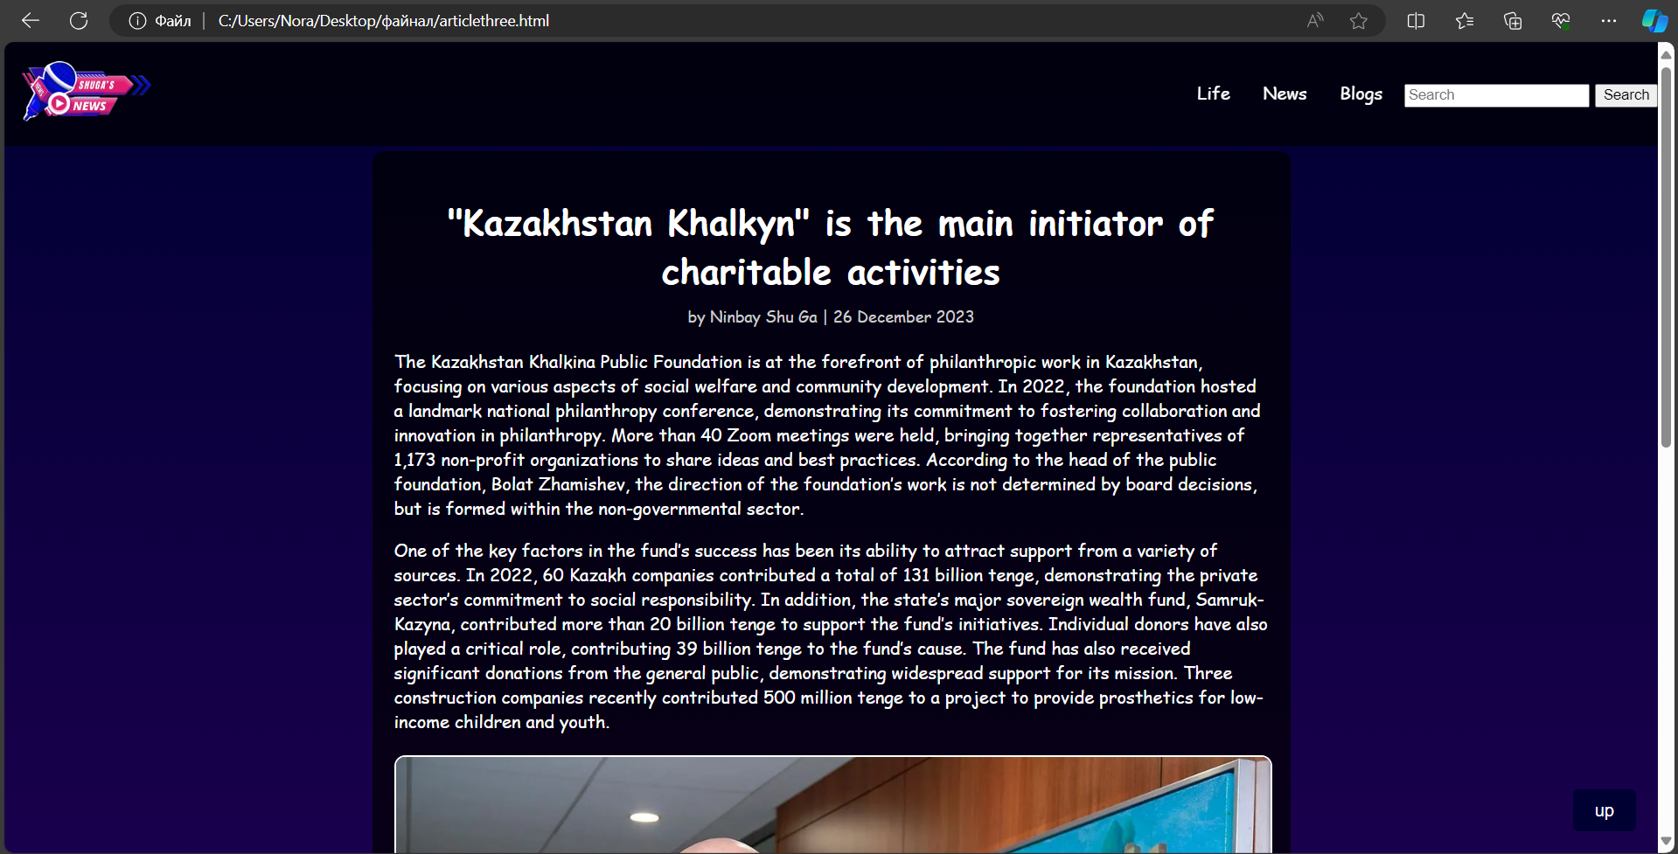

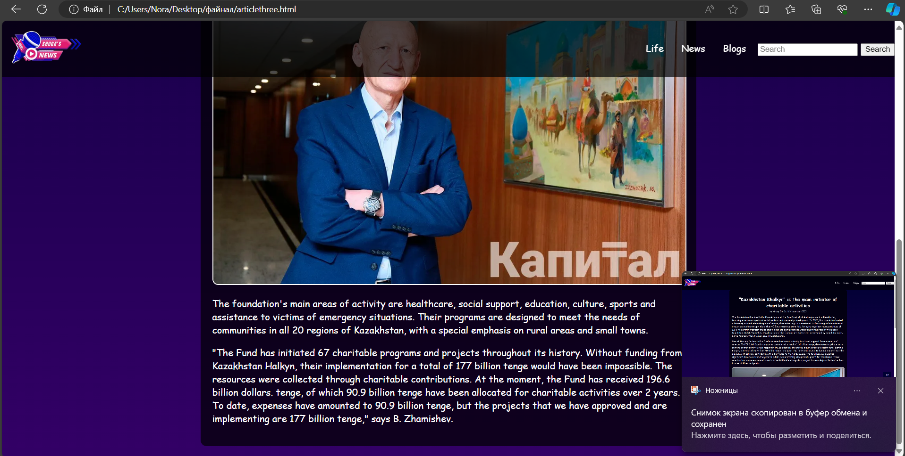

**<!DOCTYPE html>**

**<html lang="en">**

**<head>**

**<meta charset="UTF-8">**

**<meta name="viewport" content="width=device-width, initial-scale=1.0">**

**<title>Статья с изображением 3</title>**

**<style>**

**body {**

**margin: 0;**

**padding: 0;**

**background: linear-gradient(180deg, #000033 0%, #330066 100%);**

**color: white;**

**font-family: 'Lobster', cursive;**

**display: flex;**

**justify-content: center;**

**align-items: flex-start;**

**min-height: 100vh;**

**overflow-x: hidden;**

**}**

**.top-menu {**

**position: fixed;**

**top: 0;**

**width: 100%;**

**background-color: rgba(0, 0, 0, 0.7);**

**padding: 10px 20px;**

**display: flex;**

**align-items: center;**

**justify-content: space-between;**

**z-index: 1000;**

**height: 75px;**

**}**

**.navbar-logo img {**

**width: 150px;**

**transition: transform 0.3s;**

**}**

**.navbar-logo img:hover {**

**transform: scale(1.1);**

**}**

**.menu-main {**

**list-style: none;**

**display: flex;**

**margin: 0;**

**padding: 0;**

**}**

**.menu-main li {**

**position: relative;**

**margin-left: 10px;**

**}**

**.menu-main a {**

**text-decoration: none;**

**color: white;**

**padding: 5px 10px;**

**transition: color 0.3s, background-color 0.3s;**

**}**

**.menu-main a:hover {**

**color: yellow;**

**background-color: rgba(255, 255, 255, 0.2);**

**}**

**.menu-main a:hover::after {**

**content: '⭐️';**

**position: absolute;**

**right: -20px;**

**top: 0;**

**}**

**.submenu {**

**display: none;**

**position: absolute;**

**top: 100%;**

**left: 0;**

**background-color: rgba(0, 0, 0, 0.8);**

**list-style: none;**

**margin: 0;**

**padding: 0;**

**}**

**.menu-main li:hover .submenu {**

**display: block;**

**}**

**.submenu li {**

**width: 200px;**

**}**

**.submenu a {**

**padding: 10px;**

**}**

**.article-container {**

**max-width: 800px;**

**margin: 100px 20px 20px 20px;**

**padding: 20px;**

**background-color: rgba(0, 0, 0, 0.7);**

**border-radius: 10px;**

**}**

**.article-header {**

**text-align: center;**

**margin-bottom: 10px;**

**}**

**.article-meta {**

**text-align: center;**

**margin-bottom: 20px;**

**font-size: 0.9em;**

**color: #ccc;**

**}**

**.article-image {**

**display: block;**

**margin: 20px auto;**

**max-width: 100%;**

**height: auto;**

**border: 2px solid white;**

**border-radius: 10px;**

**}**

**.scroll-to-top {**

**position: fixed;**

**bottom: 20px;**

**right: 20px;**

**background-color: #000033;**

**color: white;**

**border: none;**

**padding: 10px 20px;**

**border-radius: 5px;**

**cursor: pointer;**

**font-size: 16px;**

**transition: background-color 0.3s, color 0.3s;**

**}**

**.scroll-to-top:hover {**

**background-color: #330066;**

**}**

**</style>**

**</head>**

**<body>**

**<nav class="top-menu">**

**<a class="navbar-logo" href="C:\Users\Nora\Desktop\файнал\abouusshuga.html"><img src="C:\Users\Nora\Downloads\yoooo-removebg-preview.png" alt="Logo"></a>**

**<ul class="menu-main">**

**<li><a href="C:\Users\Nora\Desktop\файнал\life.html">Life</a></li>**

**<li><a href="C:\Users\Nora\Desktop\файнал\myfinal.html">News</a></li>**

**<li><a href="C:\Users\Nora\Desktop\файнал\consultation.html">Blogs</a></li>**

**<li>**

**<form class="d-flex" role="search">**

**<input class="form-control me-2" list="suggestions" type="search" placeholder="Search" aria-label="Search">**

**<datalist id="suggestions">**

**<option value="II women's volleyball game among the CIS countries" data-url="C:\Users\Nora\Desktop\файнал\articletwo.html">II women's volleyball game among the CIS countries</option>**

**<option value="Kazakhstan Khalkyn is the main initiator of charitable activities" data-url="C:\Users\Nora\Desktop\файнал\articlethree.html">Kazakhstan Khalkyn is the main initiator of charitable activities</option>**

**<option value="The development of medicine with the advent of the COVID-19" data-url="C:\Users\Nora\Desktop\файнал\articlefive.html">The development of medicine with the advent of the COVID-19</option>**

**</datalist>**

**<button class="btn btn-outline-success" id="searchButton" type="button">Search</button>**

**</form>**

**</li>**

**</ul>**

**</nav>**

**<script>**

**document.getElementById('searchButton').addEventListener('click', function() {**

**var input = document.querySelector('input[type="search"]');**

**var selectedOption = document.querySelector('option[value="' + input.value + '"]');**

**if (selectedOption && selectedOption.dataset.url) {**

**window.location.href = selectedOption.dataset.url;**

**}**

**});**

**</script>**

**<div class="article-container">**

**<h1 class="article-header">"Kazakhstan Khalkyn" is the main initiator of charitable activities</h1>**

**<div class="article-meta">**

**by Ninbay Shu Ga | 26 December 2023**

**</div>**

**<p>The Kazakhstan Khalkina Public Foundation is at the forefront of philanthropic work in Kazakhstan, focusing on various aspects of social welfare and community development. In 2022, the foundation hosted a landmark national philanthropy conference, demonstrating its commitment to fostering collaboration and innovation in philanthropy. More than 40 Zoom meetings were held, bringing together representatives of 1,173 non-profit organizations to share ideas and best practices. According to the head of the public foundation, Bolat Zhamishev, the direction of the foundation’s work is not determined by board decisions, but is formed within the non-governmental sector.</p>**

**<p>One of the key factors in the fund’s success has been its ability to attract support from a variety of sources. In 2022, 60 Kazakh companies contributed a total of 131 billion tenge, demonstrating the private sector’s commitment to social responsibility. In addition, the state’s major sovereign wealth fund, Samruk-Kazyna, contributed more than 20 billion tenge to support the fund’s initiatives. Individual donors have also played a critical role, contributing 39 billion tenge to the fund’s cause. The fund has also received significant donations from the general public, demonstrating widespread support for its mission. Three construction companies recently contributed 500 million tenge to a project to provide prosthetics for low-income children and youth.</p>**

**<img src="C:\Users\Nora\Desktop\файнал\halkyna.webp" alt="Описание изображения" class="article-image">**

**<p>The foundation's main areas of activity are healthcare, social support, education, culture, sports and assistance to victims of emergency situations. Their programs are designed to meet the needs of communities in all 20 regions of Kazakhstan, with a special emphasis on rural areas and small towns.</p>**

**<p>"The Fund has initiated 67 charitable programs and projects throughout its history. Without funding from Kazakhstan Halkyn, their implementation for a total of 177 billion tenge would have been impossible. The resources were collected through charitable contributions. At the moment, the Fund has received 196.6 billion dollars. tenge, of which 90.9 billion tenge have been allocated for charitable activities over 2 years. To date, expenses have amounted to 90.9 billion tenge, but the projects that we have approved and are implementing are 177 billion tenge," says B. Zhamishev.</p>**

**</div>**

**<button class="scroll-to-top" onclick="scrollToTop()">up</button>**

**<script>**

**// Показать кнопку, когда прокручено вниз 20px от верха**

**window.onscroll = function() {scrollFunction()};**

**function scrollFunction() {**

**const scrollToTopBtn = document.querySelector(".scroll-to-top");**

**if (document.body.scrollTop > 20 || document.documentElement.scrollTop > 20) {**

**scrollToTopBtn.style.display = "block";**

**} else {**

**scrollToTopBtn.style.display = "none";**

**}**

**}**

**// Прокрутка наверх**

**function scrollToTop() {**

**document.body.scrollTop = 0;**

**document.documentElement.scrollTop = 0;**

**}**

**</script>**

**</body>**

**</html>**

**Fourth page of the article**

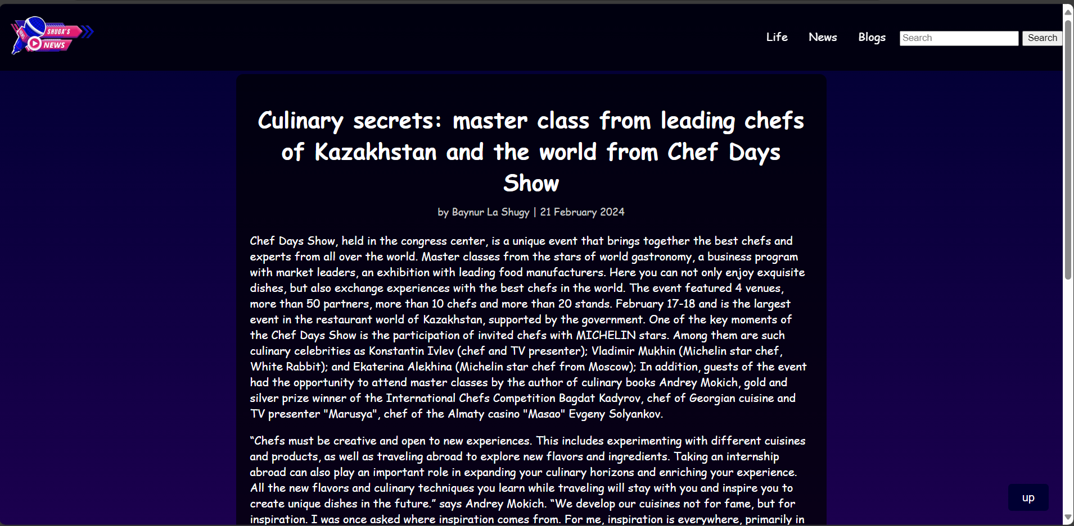

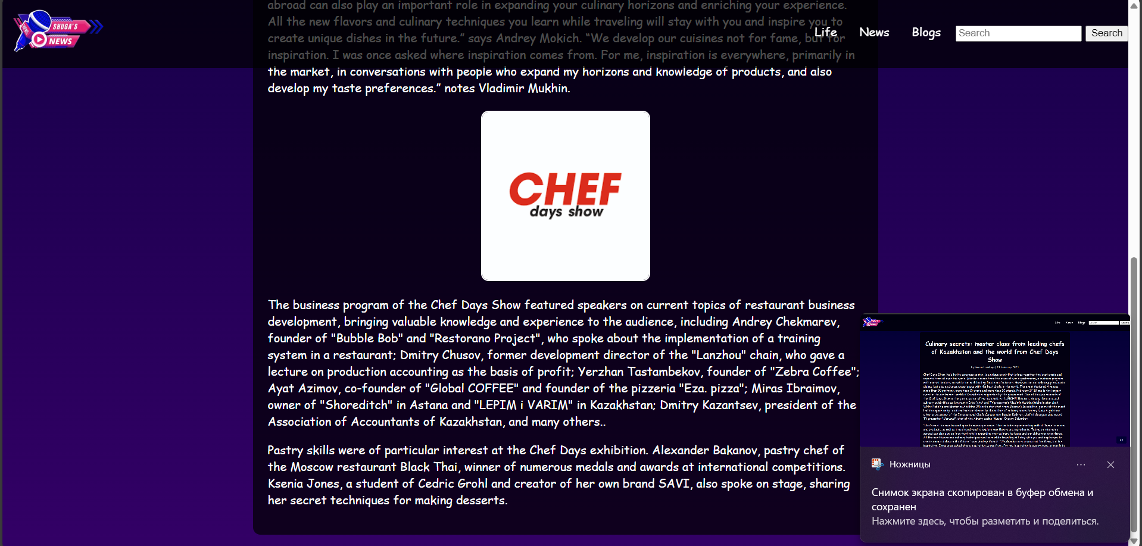

**<!DOCTYPE html>**

**<html lang="en">**

**<head>**

**<meta charset="UTF-8">**

**<meta name="viewport" content="width=device-width, initial-scale=1.0">**

**<title>Статья с изображением 4</title>**

**<style>**

**body {**

**margin: 0;**

**padding: 0;**

**background: linear-gradient(180deg, #000033 0%, #330066 100%);**

**color: white;**

**font-family: 'Lobster', cursive;**

**display: flex;**

**justify-content: center;**

**align-items: flex-start;**

**min-height: 100vh;**

**overflow-x: hidden;**

**}**

**.top-menu {**

**position: fixed;**

**top: 0;**

**width: 100%;**

**background-color: rgba(0, 0, 0, 0.7);**

**padding: 10px 20px;**

**display: flex;**

**align-items: center;**

**justify-content: space-between;**

**z-index: 1000;**

**height: 75px;**

**}**

**.navbar-logo img {**

**width: 150px;**

**transition: transform 0.3s;**

**}**

**.navbar-logo img:hover {**

**transform: scale(1.1);**

**}**

**.menu-main {**

**list-style: none;**

**display: flex;**

**margin: 0;**

**padding: 0;**

**}**

**.menu-main li {**

**position: relative;**

**margin-left: 10px;**

**}**

**.menu-main a {**

**text-decoration: none;**

**color: white;**

**padding: 5px 10px;**

**transition: color 0.3s, background-color 0.3s;**

**}**

**.menu-main a:hover {**

**color: yellow;**

**background-color: rgba(255, 255, 255, 0.2);**

**}**

**.menu-main a:hover::after {**

**content: '⭐️';**

**position: absolute;**

**right: -20px;**

**top: 0;**

**}**

**.submenu {**

**display: none;**

**position: absolute;**

**top: 100%;**

**left: 0;**

**background-color: rgba(0, 0, 0, 0.8);**

**list-style: none;**

**margin: 0;**

**padding: 0;**

**}**

**.menu-main li:hover .submenu {**

**display: block;**

**}**

**.submenu li {**

**width: 200px;**

**}**

**.submenu a {**

**padding: 10px;**

**}**

**.article-container {**

**max-width: 800px;**

**margin: 100px 20px 20px 20px;**

**padding: 20px;**

**background-color: rgba(0, 0, 0, 0.7);**

**border-radius: 10px;**

**}**

**.article-header {**

**text-align: center;**

**margin-bottom: 10px;**

**}**

**.article-meta {**

**text-align: center;**

**margin-bottom: 20px;**

**font-size: 0.9em;**

**color: #ccc;**

**}**

**.article-image {**

**display: block;**

**margin: 20px auto;**

**max-width: 100%;**

**height: auto;**

**border: 2px solid white;**

**border-radius: 10px;**

**}**

**.scroll-to-top {**

**position: fixed;**

**bottom: 20px;**

**right: 20px;**

**background-color: #000033;**

**color: white;**

**border: none;**

**padding: 10px 20px;**

**border-radius: 5px;**

**cursor: pointer;**

**font-size: 16px;**

**transition: background-color 0.3s, color 0.3s;**

**}**

**.scroll-to-top:hover {**

**background-color: #330066;**

**}**

**</style>**

**</head>**

**<body>**

**<nav class="top-menu">**

**<a class="navbar-logo" href="C:\Users\Nora\Desktop\файнал\abouusshuga.html"><img src="C:\Users\Nora\Downloads\yoooo-removebg-preview.png" alt="Logo"></a>**

**<ul class="menu-main">**

**<li><a href="C:\Users\Nora\Desktop\файнал\life.html">Life</a></li>**

**<li><a href="C:\Users\Nora\Desktop\файнал\myfinal.html">News</a></li>**

**<li><a href="C:\Users\Nora\Desktop\файнал\consultation.html">Blogs</a></li>**

**<li>**

**<form class="d-flex" role="search">**

**<input class="form-control me-2" list="suggestions" type="search" placeholder="Search" aria-label="Search">**

**<datalist id="suggestions">**

**<option value="II women's volleyball game among the CIS countries" data-url="C:\Users\Nora\Desktop\файнал\articletwo.html">II women's volleyball game among the CIS countries</option>**

**<option value="Kazakhstan Khalkyn is the main initiator of charitable activities" data-url="C:\Users\Nora\Desktop\файнал\articlethree.html">Kazakhstan Khalkyn is the main initiator of charitable activities</option>**

**<option value="The development of medicine with the advent of the COVID-19" data-url="C:\Users\Nora\Desktop\файнал\articlefive.html">The development of medicine with the advent of the COVID-19</option>**

**</datalist>**

**<button class="btn btn-outline-success" id="searchButton" type="button">Search</button>**

**</form>**

**</li>**

**</ul>**

**</nav>**

**<script>**

**document.getElementById('searchButton').addEventListener('click', function() {**

**var input = document.querySelector('input[type="search"]');**

**var selectedOption = document.querySelector('option[value="' + input.value + '"]');**

**if (selectedOption && selectedOption.dataset.url) {**

**window.location.href = selectedOption.dataset.url;**

**}**

**});**

**</script>**

**<div class="article-container">**

**<h1 class="article-header">Culinary secrets: master class from leading chefs of Kazakhstan and the world from Chef Days Show</h1>**

**<div class="article-meta">**

**by Baynur La Shugy | 21 February 2024**

**</div>**

**<p>Chef Days Show, held in the congress center, is a unique event that brings together the best chefs and experts from all over the world. Master classes from the stars of world gastronomy, a business program with market leaders, an exhibition with leading food manufacturers. Here you can not only enjoy exquisite dishes, but also exchange experiences with the best chefs in the world. The event featured 4 venues, more than 50 partners, more than 10 chefs and more than 20 stands. February 17-18 and is the largest event in the restaurant world of Kazakhstan, supported by the government. One of the key moments of the Chef Days Show is the participation of invited chefs with MICHELIN stars. Among them are such culinary celebrities as Konstantin Ivlev (chef and TV presenter); Vladimir Mukhin (Michelin star chef, White Rabbit); and Ekaterina Alekhina (Michelin star chef from Moscow); In addition, guests of the event had the opportunity to attend master classes by the author of culinary books Andrey Mokich, gold and silver prize winner of the International Chefs Competition Bagdat Kadyrov, chef of Georgian cuisine and TV presenter "Marusya", chef of the Almaty casino "Masao" Evgeny Solyankov.</p>**

**<p>“Chefs must be creative and open to new experiences. This includes experimenting with different cuisines and products, as well as traveling abroad to explore new flavors and ingredients. Taking an internship abroad can also play an important role in expanding your culinary horizons and enriching your experience. All the new flavors and culinary techniques you learn while traveling will stay with you and inspire you to create unique dishes in the future.” says Andrey Mokich. “We develop our cuisines not for fame, but for inspiration. I was once asked where inspiration comes from. For me, inspiration is everywhere, primarily in the market, in conversations with people who expand my horizons and knowledge of products, and also develop my taste preferences.” notes Vladimir Mukhin.</p>**

**<img src="C:\Users\Nora\Desktop\файнал\cheff.png" alt="Описание изображения" class="article-image">**

**<p>The business program of the Chef Days Show featured speakers on current topics of restaurant business development, bringing valuable knowledge and experience to the audience, including Andrey Chekmarev, founder of "Bubble Bob" and "Restorano Project", who spoke about the implementation of a training system in a restaurant; Dmitry Chusov, former development director of the "Lanzhou" chain, who gave a lecture on production accounting as the basis of profit; Yerzhan Tastambekov, founder of "Zebra Coffee"; Ayat Azimov, co-founder of "Global COFFEE" and founder of the pizzeria "Eza. pizza"; Miras Ibraimov, owner of "Shoreditch" in Astana and "LEPIM i VARIM" in Kazakhstan; Dmitry Kazantsev, president of the Association of Accountants of Kazakhstan, and many others..</p>**

**<p>Pastry skills were of particular interest at the Chef Days exhibition. Alexander Bakanov, pastry chef of the Moscow restaurant Black Thai, winner of numerous medals and awards at international competitions. Ksenia Jones, a student of Cedric Grohl and creator of her own brand SAVI, also spoke on stage, sharing her secret techniques for making desserts.</p>**

**</div>**

**<button class="scroll-to-top" onclick="scrollToTop()">up</button>**

**<script>**

**// Показать кнопку, когда прокручено вниз 20px от верха**

**window.onscroll = function() {scrollFunction()};**

**function scrollFunction() {**

**const scrollToTopBtn = document.querySelector(".scroll-to-top");**

**if (document.body.scrollTop > 20 || document.documentElement.scrollTop > 20) {**

**scrollToTopBtn.style.display = "block";**

**} else {**

**scrollToTopBtn.style.display = "none";**

**}**

**}**

**// Прокрутка наверх**

**function scrollToTop() {**

**document.body.scrollTop = 0;**

**document.documentElement.scrollTop = 0;**

**}**

**</script>**

**</body>**

**</html>**

**fifth page of the article**

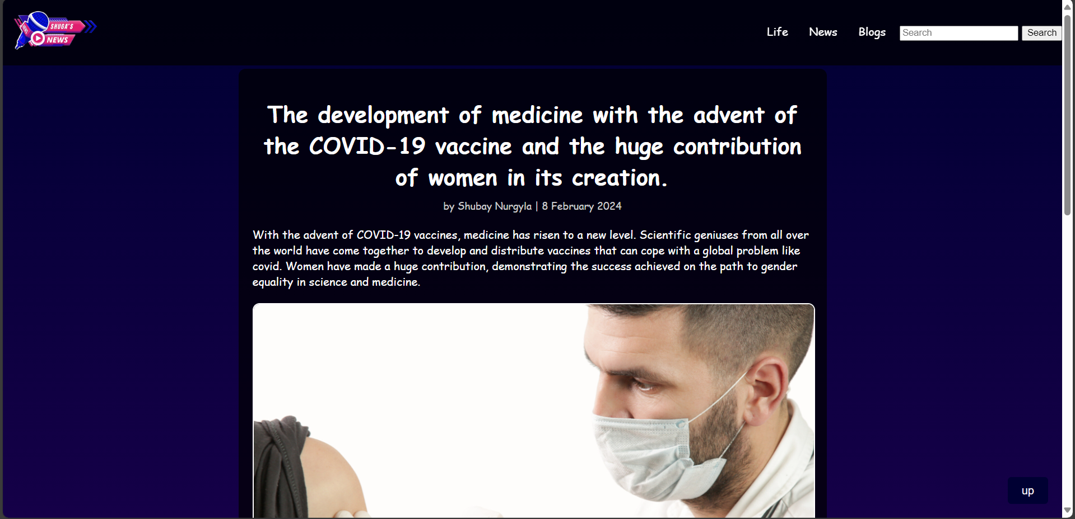

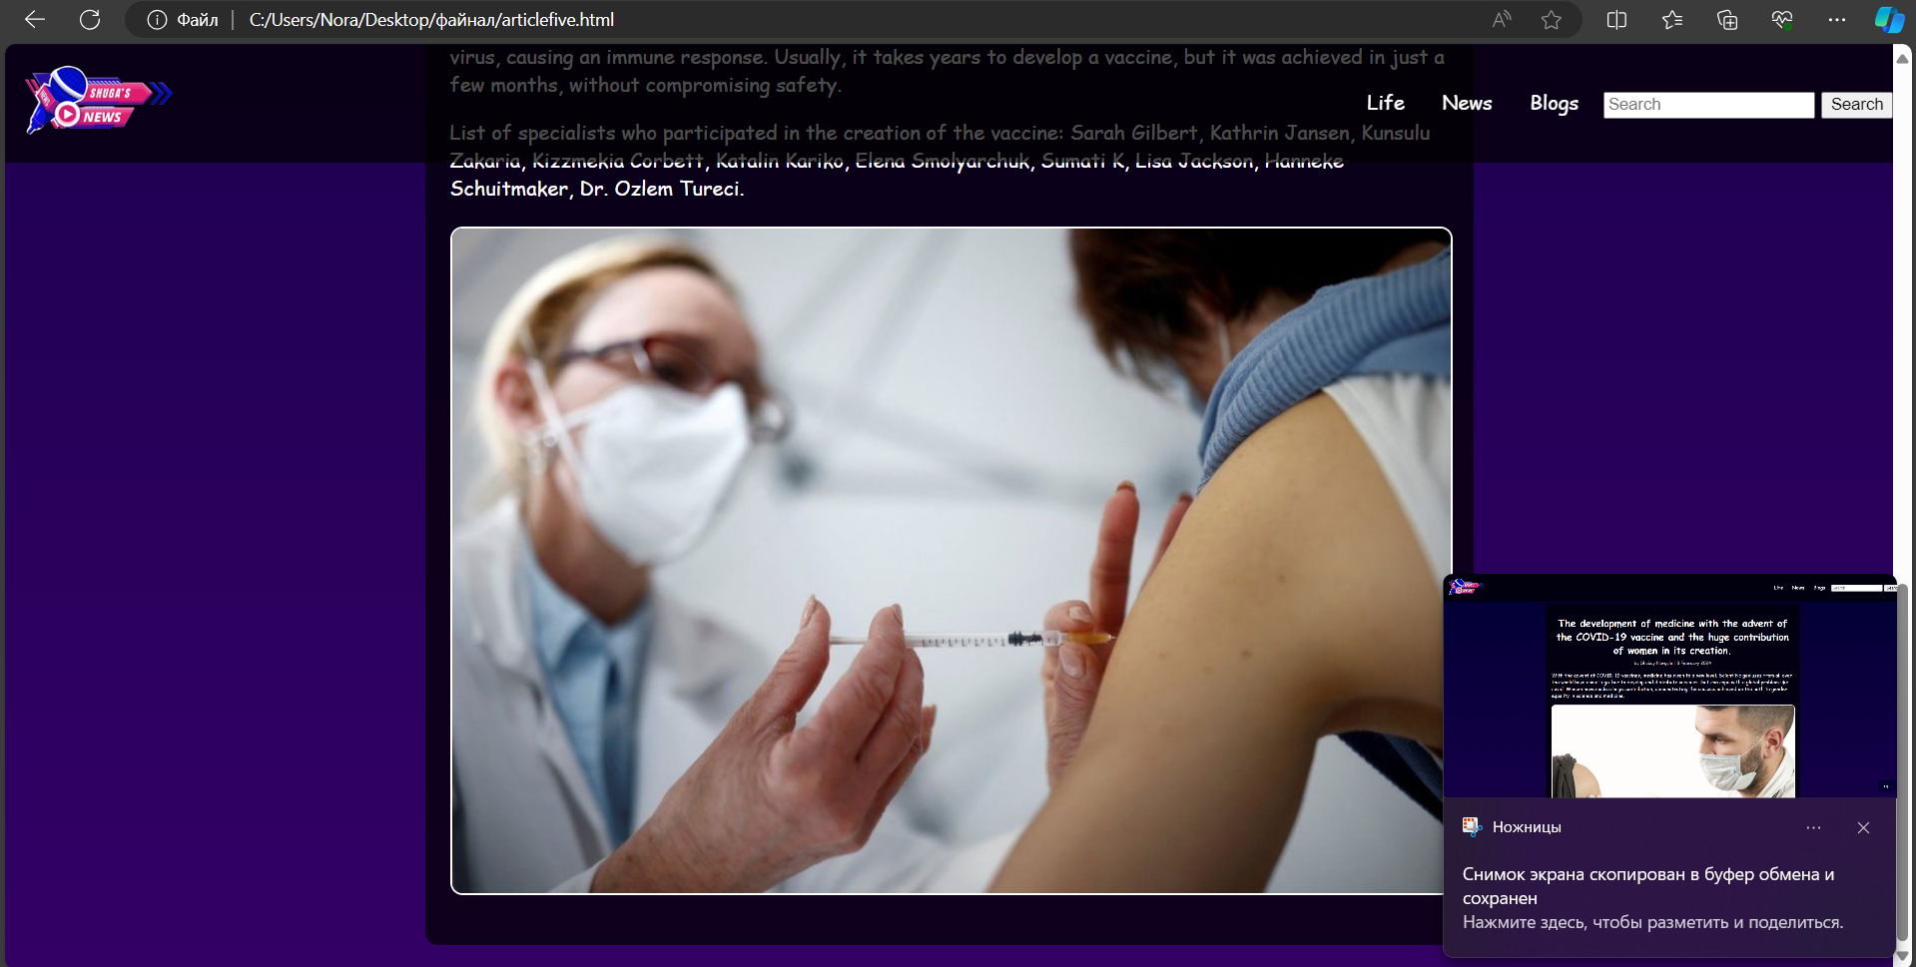

**<!DOCTYPE html>**

**<html lang="en">**

**<head>**

**<meta charset="UTF-8">**

**<meta name="viewport" content="width=device-width, initial-scale=1.0">**

**<title>Статья с изображением 5</title>**

**<style>**

**body {**

**margin: 0;**

**padding: 0;**

**background: linear-gradient(180deg, #000033 0%, #330066 100%);**

**color: white;**

**font-family: 'Lobster', cursive;**

**display: flex;**

**justify-content: center;**

**align-items: flex-start;**

**min-height: 100vh;**

**overflow-x: hidden;**

**}**

**.top-menu {**

**position: fixed;**

**top: 0;**

**width: 100%;**

**background-color: rgba(0, 0, 0, 0.7);**

**padding: 10px 20px;**

**display: flex;**

**align-items: center;**

**justify-content: space-between;**

**z-index: 1000;**

**height: 75px;**

**}**

**.navbar-logo img {**

**width: 150px;**

**transition: transform 0.3s;**

**}**

**.navbar-logo img:hover {**

**transform: scale(1.1);**

**}**

**.menu-main {**

**list-style: none;**

**display: flex;**

**margin: 0;**

**padding: 0;**

**}**

**.menu-main li {**

**position: relative;**

**margin-left: 10px;**

**}**

**.menu-main a {**

**text-decoration: none;**

**color: white;**

**padding: 5px 10px;**

**transition: color 0.3s, background-color 0.3s;**

**}**

**.menu-main a:hover {**

**color: yellow;**

**background-color: rgba(255, 255, 255, 0.2);**

**}**

**.menu-main a:hover::after {**

**content: '⭐️';**

**position: absolute;**

**right: -20px;**

**top: 0;**

**}**

**.submenu {**

**display: none;**

**position: absolute;**

**top: 100%;**

**left: 0;**

**background-color: rgba(0, 0, 0, 0.8);**

**list-style: none;**

**margin: 0;**

**padding: 0;**

**}**

**.menu-main li:hover .submenu {**

**display: block;**

**}**

**.submenu li {**

**width: 200px;**

**}**

**.submenu a {**

**padding: 10px;**

**}**

**.article-container {**

**max-width: 800px;**

**margin: 100px 20px 20px 20px;**

**padding: 20px;**

**background-color: rgba(0, 0, 0, 0.7);**

**border-radius: 10px;**

**}**

**.article-header {**

**text-align: center;**

**margin-bottom: 10px;**

**}**

**.article-meta {**

**text-align: center;**

**margin-bottom: 20px;**

**font-size: 0.9em;**

**color: #ccc;**

**}**

**.article-image {**

**display: block;**

**margin: 20px auto;**

**max-width: 100%;**

**height: auto;**

**border: 2px solid white;**

**border-radius: 10px;**

**}**

**.scroll-to-top {**

**position: fixed;**

**bottom: 20px;**

**right: 20px;**

**background-color: #000033;**

**color: white;**

**border: none;**

**padding: 10px 20px;**

**border-radius: 5px;**

**cursor: pointer;**

**font-size: 16px;**

**transition: background-color 0.3s, color 0.3s;**

**}**

**.scroll-to-top:hover {**

**background-color: #330066;**

**}**

**</style>**

**</head>**

**<body>**

**<nav class="top-menu">**

**<a class="navbar-logo" href="C:\Users\Nora\Desktop\файнал\abouusshuga.html"><img src="C:\Users\Nora\Downloads\yoooo-removebg-preview.png" alt="Logo"></a>**

**<ul class="menu-main">**

**<li><a href="C:\Users\Nora\Desktop\файнал\life.html">Life</a></li>**

**<li><a href="C:\Users\Nora\Desktop\файнал\myfinal.html">News</a></li>**

**<li><a href="C:\Users\Nora\Desktop\файнал\consultation.html">Blogs</a></li>**

**<li>**

**<form class="d-flex" role="search">**

**<input class="form-control me-2" list="suggestions" type="search" placeholder="Search" aria-label="Search">**

**<datalist id="suggestions">**

**<option value="II women's volleyball game among the CIS countries" data-url="C:\Users\Nora\Desktop\файнал\articletwo.html">II women's volleyball game among the CIS countries</option>**

**<option value="Kazakhstan Khalkyn is the main initiator of charitable activities" data-url="C:\Users\Nora\Desktop\файнал\articlethree.html">Kazakhstan Khalkyn is the main initiator of charitable activities</option>**

**<option value="The development of medicine with the advent of the COVID-19" data-url="C:\Users\Nora\Desktop\файнал\articlefive.html">The development of medicine with the advent of the COVID-19</option>**

**</datalist>**

**<button class="btn btn-outline-success" id="searchButton" type="button">Search</button>**

**</form>**

**</li>**

**</ul>**

**</nav>**

**<script>**

**document.getElementById('searchButton').addEventListener('click', function() {**

**var input = document.querySelector('input[type="search"]');**

**var selectedOption = document.querySelector('option[value="' + input.value + '"]');**

**if (selectedOption && selectedOption.dataset.url) {**

**window.location.href = selectedOption.dataset.url;**

**}**

**});**

**</script>**

**<div class="article-container">**

**<h1 class="article-header">The development of medicine with the advent of the COVID-19 vaccine and the huge contribution of women in its creation.</h1>**

**<div class="article-meta">**

**by Shubay Nurgyla | 8 February 2024**

**</div>**

**<p>With the advent of COVID-19 vaccines, medicine has risen to a new level. Scientific geniuses from all over the world have come together to develop and distribute vaccines that can cope with a global problem like covid. Women have made a huge contribution, demonstrating the success achieved on the path to gender equality in science and medicine.</p>**

**<img src="C:\Users\Nora\Desktop\файнал\ковид.jpg" alt="Описание изображения" class="article-image">**

**<p>In 2020, a disease spread to our land, after which scientists gathered to study and fight SARS-CoV-2. Scientists, using mRNA technologies, used revolutionary methods, deciphered its genetic composition, which was the key to developing a vaccine. mRNA-based vaccines cause cells to produce a protein of the virus, causing an immune response. Usually, it takes years to develop a vaccine, but it was achieved in just a few months, without compromising safety.</p>**

**<p>List of specialists who participated in the creation of the vaccine:**

**Sarah Gilbert, Kathrin Jansen, Kunsulu Zakaria, Kizzmekia Corbett, Katalin Kariko, Elena Smolyarchuk, Sumati K, Lisa Jackson, Hanneke Schuitmaker, Dr. Ozlem Tureci.</p>**

**<img src="C:\Users\Nora\Desktop\файнал\ковиддва.jpg" class="article-image">**

**</div>**

**<button class="scroll-to-top" onclick="scrollToTop()">up</button>**

**<script>**

**// Показать кнопку, когда прокручено вниз 20px от верха**

**window.onscroll = function() {scrollFunction()};**

**function scrollFunction() {**

**const scrollToTopBtn = document.querySelector(".scroll-to-top");**

**if (document.body.scrollTop > 20 || document.documentElement.scrollTop > 20) {**

**scrollToTopBtn.style.display = "block";**

**} else {**

**scrollToTopBtn.style.display = "none";**

**}**

**}**

**// Прокрутка наверх**

**function scrollToTop() {**

**document.body.scrollTop = 0;**

**document.documentElement.scrollTop = 0;**

**}**

**</script>**

**</body>**

**</html>**

**And now regarding this. Everything is working. When we click on the logo, we are redirected to a page about us. About the journalistic agency**



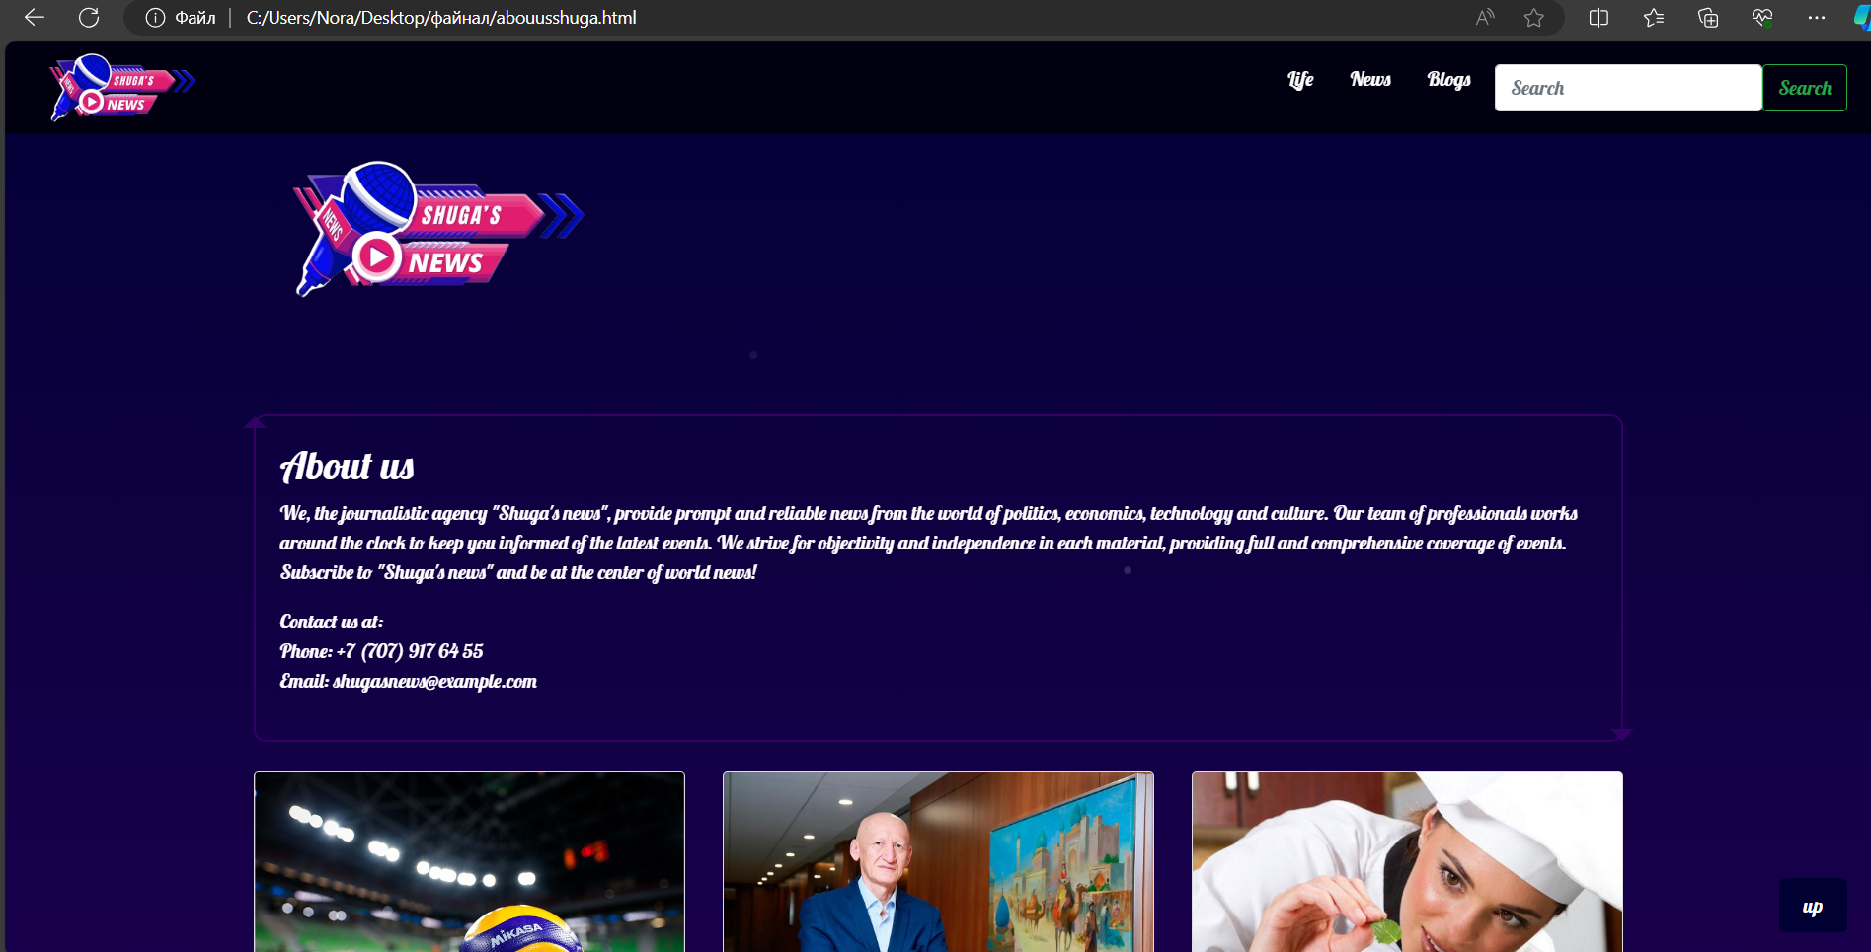

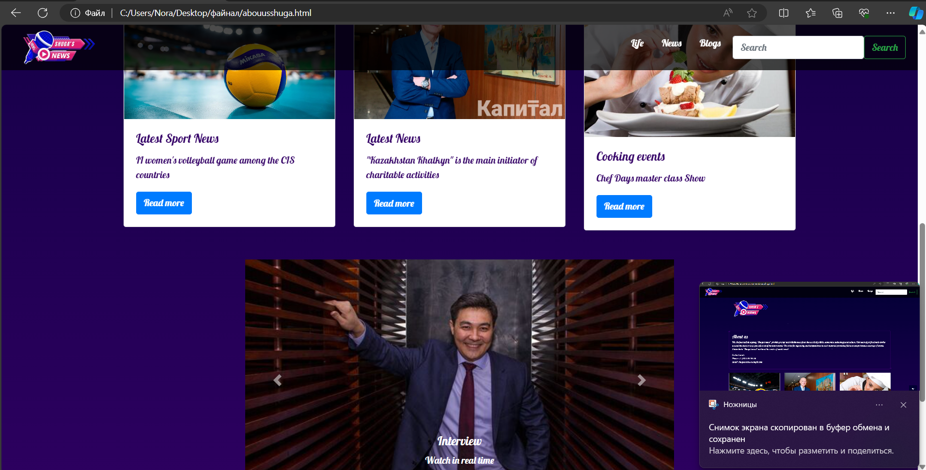

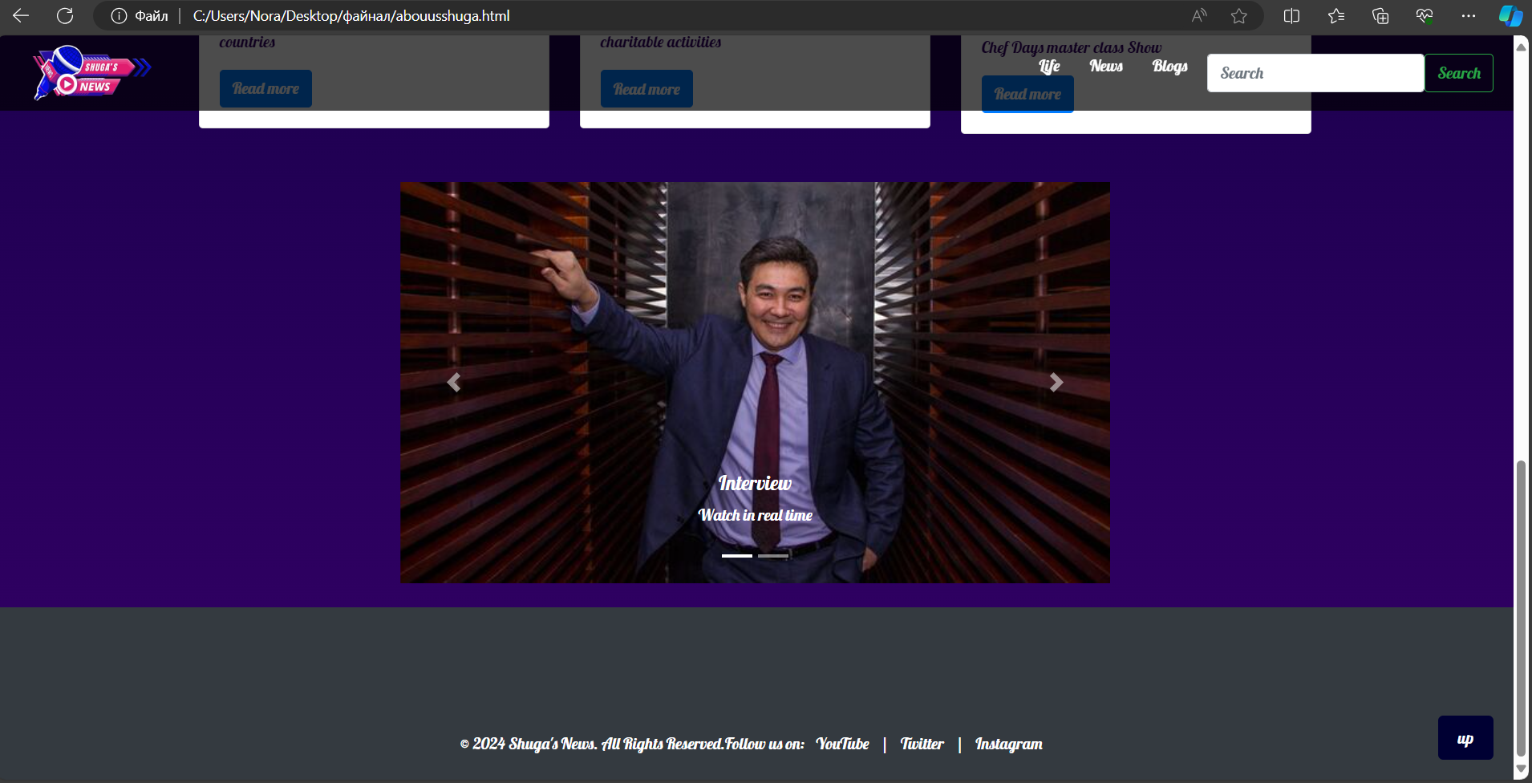

**Links to social networks also work here. And I added working links.**



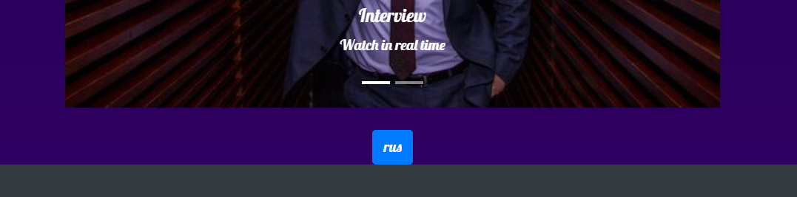

**(тоже меняет на русский)**

**<!DOCTYPE html>**

**<html lang="en">**

**<head>**

**<meta charset="UTF-8">**

**<meta name="viewport" content="width=device-width, initial-scale=1.0">**

**<title>Это сделала Шуги</title>**

**<!-- Bootstrap CSS -->**

**<link href="https://stackpath.bootstrapcdn.com/bootstrap/4.5.2/css/bootstrap.min.css" rel="stylesheet">**

**<style>**

**@import url('https://fonts.googleapis.com/css2?family=Lobster&display=swap');**

**body {**

**margin: 0;**

**padding: 0;**

**background: linear-gradient(180deg, #000033 0%, #330066 100%);**

**color: white;**

**font-family: 'Lobster', cursive;**

**display: flex;**

**flex-direction: column;**

**align-items: center;**

**min-height: 100vh;**

**overflow-x: hidden;**

**position: relative;**

**}**

**/* Fireworks animation */**

**@keyframes fireworks {**

**0% { opacity: 1; transform: scale(1); }**

**100% { opacity: 0; transform: scale(2); }**

**}**

**.firework {**

**position: absolute;**

**background-color: white;**

**border-radius: 50%;**

**width: 3px;**

**height: 3px;**

**animation: fireworks 1.5s infinite;**

**}**

**.firework:nth-child(1) { top: 20%; left: 40%; animation-delay: 0.1s; }**

**.firework:nth-child(2) { top: 30%; left: 60%; animation-delay: 0.3s; }**

**.firework:nth-child(3) { top: 50%; left: 50%; animation-delay: 0.5s; }**

**.firework:nth-child(4) { top: 70%; left: 30%; animation-delay: 0.7s; }**

**.firework:nth-child(5) { top: 80%; left: 70%; animation-delay: 0.9s; }**

**.top-menu {**

**position: fixed;**

**top: 0;**

**width: 100%;**

**background-color: rgba(0, 0, 0, 0.7);**

**padding: 10px 20px;**

**display: flex;**

**align-items: center;**

**justify-content: space-between;**

**z-index: 1000;**

**height: 75px;**

**}**

**.navbar-logo img {**

**width: 150px;**

**transition: transform 0.3s;**

**}**

**.navbar-logo img:hover {**

**transform: scale(1.1);**

**}**

**.menu-main {**

**list-style: none;**

**display: flex;**

**margin: 0;**

**padding: 0;**

**}**

**.menu-main li {**

**position: relative;**

**margin-left: 10px;**

**}**

**.menu-main a {**

**text-decoration: none;**

**color: white;**

**padding: 5px 10px;**

**transition: color 0.3s, background-color 0.3s;**

**}**

**.menu-main a:hover {**

**color: yellow;**

**background-color: rgba(255, 255, 255, 0.2);**

**}**

**.menu-main a:hover::after {**

**content: '⭐️';**

**position: absolute;**

**right: -20px;**

**top: 0;**

**}**

**.container {**

**display: flex;**

**margin-top: 100px;**

**justify-content: center;**

**width: 100%;**

**}**

**.carousel-container {**

**flex: 2;**

**max-width: 60%;**

**}**

**.links-container {**

**flex: 1;**

**display: flex;**

**flex-direction: column;**

**justify-content: center;**

**align-items: flex-start;**

**padding: 20px;**

**border-left: 2px solid white;**

**margin-left: 20px;**

**}**

**.links-container a {**

**color: white;**

**text-decoration: none;**

**margin: 10px 0;**

**padding: 10px 15px;**

**background-color: rgba(0, 0, 0, 0.5);**

**font-size: 1.2em;**

**transition: background-color 0.3s;**

**}**

**.links-container a:hover {**

**background-color: rgba(255, 255, 255, 0.2);**

**}**

**footer {**

**margin-top: auto;**

**padding: 10px;**

**background-color: rgba(0, 0, 0, 0.7);**

**text-align: center;**

**width: 100%;**

**}**

**footer p {**

**margin: 0;**

**}**

**.scroll-to-top {**

**position: fixed;**

**bottom: 20px;**

**right: 20px;**

**background-color: #000033;**

**color: white;**

**border: none;**

**padding: 10px 20px;**

**border-radius: 5px;**

**cursor: pointer;**

**font-size: 16px;**

**transition: background-color 0.3s, color 0.3s;**

**}**

**.scroll-to-top:hover {**

**background-color: #330066;**

**}**

**.profile-info {**

**border: 2px solid #330066;**

**padding: 20px;**

**border-radius: 10px;**

**position: relative;**

**}**

**.profile-info:before {**

**content: " ";**

**position: absolute;**

**top: -10px;**

**left: -10px;**

**border-top: 10px solid transparent;**

**border-left: 10px solid transparent;**

**border-right: 10px solid transparent;**

**border-bottom: 10px solid #330066;**

**}**

**.profile-info:after {**

**content: " ";**

**position: absolute;**

**bottom: -10px;**

**right: -10px;**

**border-top: 10px solid #330066;**

**border-left: 10px solid transparent;**

**border-right: 10px solid transparent;**

**border-bottom: 10px solid transparent;**

**}**

**.card-title,**

**.card-text {**

**color: #330066;**

**}**

**</style>**

**</head>**

**<body>**

**<!-- Fireworks Background -->**

**<div class="firework"></div>**

**<div class="firework"></div>**

**<div class="firework"></div>**

**<div class="firework"></div>**

**<div class="firework"></div>**

**<nav class="top-menu">**

**<a class="navbar-logo" href="C:\Users\Nora\Desktop\файнал\abouusshuga.html"><img src="C:\Users\Nora\Downloads\yoooo-removebg-preview.png" alt="Logo"></a>**

**<ul class="menu-main">**

**<li><a href="C:\Users\Nora\Desktop\файнал\life.html">Life</a></li>**

**<li><a href="C:\Users\Nora\Desktop\файнал\myfinal.html">News</a></li>**

**<li><a href="C:\Users\Nora\Desktop\файнал\consultation.html">Blogs</a></li>**

**<li>**

**<form class="d-flex" role="search">**

**<input class="form-control me-2" list="suggestions" type="search" placeholder="Search" aria-label="Search">**

**<datalist id="suggestions">**

**<option value="II women's volleyball game among the CIS countries" data-url="C:\Users\Nora\Desktop\файнал\articletwo.html">II women's volleyball game among the CIS countries</option>**

**<option value="Kazakhstan Khalkyn is the main initiator of charitable activities" data-url="C:\Users\Nora\Desktop\файнал\articlethree.html">Kazakhstan Khalkyn is the main initiator of charitable activities</option>**

**<option value="The development of medicine with the advent of the COVID-19" data-url="C:\Users\Nora\Desktop\файнал\articlefive.html">The development of medicine with the advent of the COVID-19</option>**

**</datalist>**

**<button class="btn btn-outline-success" id="searchButton" type="button">Search</button>**

**</form>**

**</li>**

**</ul>**

**</nav>**

**<script>**

**document.getElementById('searchButton').addEventListener('click', function() {**

**var input = document.querySelector('input[type="search"]');**

**var selectedOption = document.querySelector('option[value="' + input.value + '"]');**

**if (selectedOption && selectedOption.dataset.url) {**

**window.location.href = selectedOption.dataset.url;**

**}**

**});**

**</script>**

**<div class="container">**

**<div class="profile">**

**<img src="C:\Users\Nora\Downloads\yoooo-removebg-preview.png" alt="Profile Picture" width="300">**

**<div class="profile-info">**

**<h2>About us</h2>**

**<p>We, the journalistic agency "Shuga's news", provide prompt and reliable news from the world of politics, economics, technology and culture. Our team of professionals works around the clock to keep you informed of the latest events. We strive for objectivity and independence in each material, providing full and comprehensive coverage of events. Subscribe to "Shuga's news" and be at the center of world news!</p>**

**<p>Contact us at: <br>**

**Phone: +7 (707) 917 64 55 <br>**

**Email: shugasnews@example.com</p>**

**</div>**

**</div>**

**<hr>**

**</div>**

**<!-- Bootstrap Cards Component -->**

**<div class="container my-4">**

**<div class="row">**

**<div class="col-md-4">**

**<div class="card">**

**<img src="C:\Users\Nora\Desktop\файнал\volleyball.jpeg" class="card-img-top" alt="Article 1">**

**<div class="card-body">**

**<h5 class="card-title">Latest Sport News</h5>**

**<p class="card-text">II women's volleyball game among the CIS countries</p>**

**<a href="C:\Users\Nora\Desktop\файнал\articletwo.html" class="btn btn-primary">Read more</a>**

**</div>**

**</div>**

**</div>**

**<div class="col-md-4">**

**<div class="card">**

**<img src="C:\Users\Nora\Desktop\файнал\halkyna.webp" class="card-img-top" alt="Article 2">**

**<div class="card-body">**

**<h5 class="card-title">Latest News</h5>**

**<p class="card-text">"Kazakhstan Khalkyn" is the main initiator of charitable activities</p>**

**<a href="C:\Users\Nora\Desktop\файнал\articlethree.html" class="btn btn-primary">Read more</a>**

**</div>**

**</div>**

**</div>**

**<div class="col-md-4">**

**<div class="card">**

**<img src="C:\Users\Nora\Desktop\файнал\cooking.jpg" class="card-img-top" alt="Article 3">**

**<div class="card-body">**

**<h5 class="card-title">Cooking events</h5>**

**<p class="card-text">Chef Days master class Show</p>**

**<a href="C:\Users\Nora\Desktop\файнал\articlefour.html" class="btn btn-primary">Read more</a>**

**</div>**

**</div>**

**</div>**

**</div>**

**</div>**

**<!-- Bootstrap Carousel Component -->**

**<div class="container my-4">**

**<div id="newsCarousel" class="carousel slide" data-ride="carousel">**

**<ol class="carousel-indicators">**

**<li data-target="#newsCarousel" data-slide-to="0" class="active"></li>**

**<li data-target="#newsCarousel" data-slide-to="1"></li>**

**</ol>**

**<div class="carousel-inner">**

**<div class="carousel-item active">**

**<img src="C:\Users\Nora\Desktop\файнал\Tima.jpg" class="d-block w-100" style="width: 800px; height: 400px;" alt="Slide 1">**

**<div class="carousel-caption d-none d-md-block">**

**<h5>Interview</h5>**

**<p>Watch in real time</p>**

**</div>**

**</div>**

**<div class="carousel-item">**

**<img src="C:\Users\Nora\Desktop\файнал\timatwo.jpg" class="d-block w-100" style="width: 800px; height: 400px;" alt="Slide 2">**

**<div class="carousel-caption d-none d-md-block">**

**<h5>Interview</h5>**

**<p>Watch in real time</p>**

**</div>**

**</div>**

**</div>**

**<a class="carousel-control-prev" href="#newsCarousel" role="button" data-slide="prev">**

**<span class="carousel-control-prev-icon" aria-hidden="true"></span>**

**<span class="sr-only">Previous</span>**

**</a>**

**<a class="carousel-control-next" href="#newsCarousel" role="button" data-slide="next">**

**<span class="carousel-control-next-icon" aria-hidden="true"></span>**

**<span class="sr-only">Next</span>**

**</a>**

**</div>**

**</div>**

**<a class="btn btn-primary" href="C:\Users\Nora\Desktop\файнал\aboutusrus.html" role="button">rus</a>**

**<!-- Footer -->**

**<footer class="bg-dark text-white py-4">**

**<div class="container text-center">**

**<p>&copy; 2024 Shuga's News. All Rights Reserved.</p>**

**<p>Follow us on:**

**<a href="https://www.youtube.com/@TengrinewsTVKZ" class="text-white mx-2">YouTube</a> |**

**<a href="https://x.com/tengrinewskz?ref_src=twsrc%5Egoogle%7Ctwcamp%5Eserp%7Ctwgr%5Eauthor" class="text-white mx-2">Twitter</a> |**

**<a href="https://www.instagram.com/shugagoy/" class="text-white mx-2">Instagram</a>**

**</p>**

**</div>**

**</footer>**

**<button class="scroll-to-top" onclick="scrollToTop()">up</button>**

**</style>**

**<!-- Bootstrap JS and dependencies -->**

**<script src="https://code.jquery.com/jquery-3.5.1.slim.min.js"></script>**

**<script src="https://cdn.jsdelivr.net/npm/@popperjs/core@2.5.4/dist/umd/popper.min.js"></script>**

**<script src="https://stackpath.bootstrapcdn.com/bootstrap/4.5.2/js/bootstrap.min.js"></script>**

**<script>**

**// Показать кнопку, когда прокручено вниз 20px от верха**

**window.onscroll = function() {scrollFunction()};**

**function scrollFunction() {**

**const scrollToTopBtn = document.querySelector(".scroll-to-top");**

**if (document.body.scrollTop > 20 || document.documentElement.scrollTop > 20) {**

**scrollToTopBtn.style.display = "block";**

**} else {**

**scrollToTopBtn.style.display = "none";**

**}**

**}**

**// Прокрутка наверх**

**function scrollToTop() {**

**document.body.scrollTop = 0;**

**document.documentElement.scrollTop = 0;**

**}**

**</script>**

**<script src="https://code.jquery.com/jquery-3.5.1.slim.min.js"></script>**

**<script src="https://cdn.jsdelivr.net/npm/@popperjs/core@2.9.3/dist/umd/popper.min.js"></script>**

**<script src="https://maxcdn.bootstrapcdn.com/bootstrap/4.6.0/js/bootstrap.min.js"></script>**

**</body></html>**

**Section Life. Here we have a video and broadcasts should be inserted. Links only work if it is an official site where the video is available to everyone.**

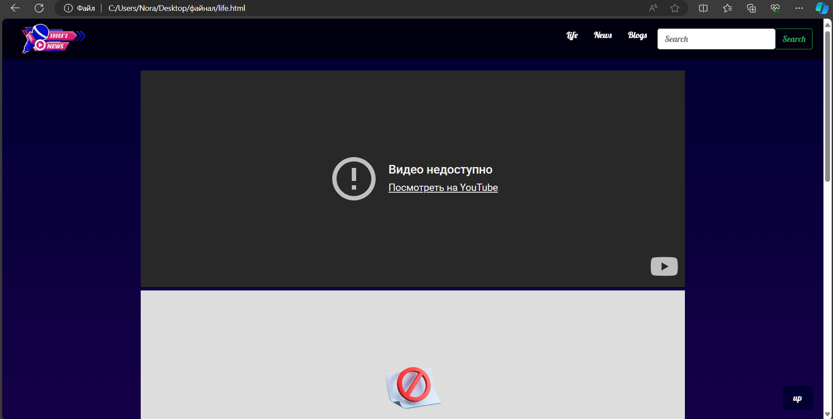

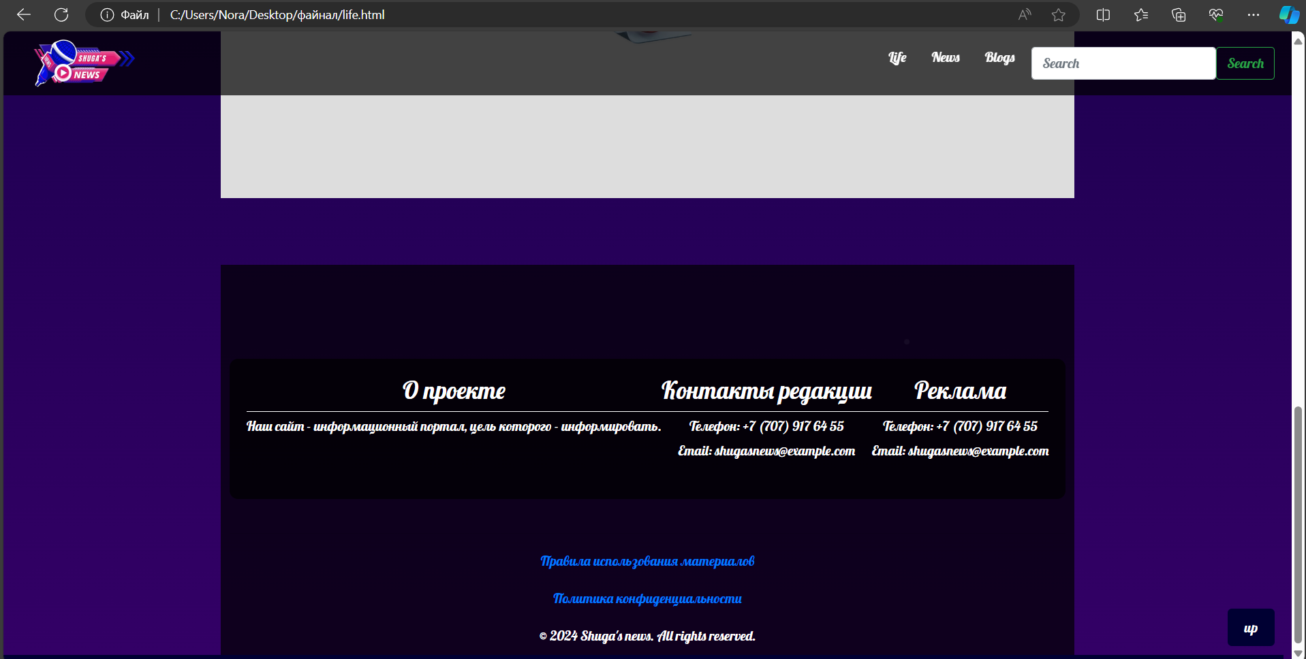

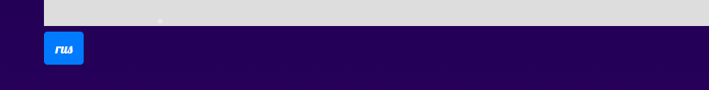

**(меняет на русский)**

**Clicking on the links opens the video.**

**<!DOCTYPE html>**

**<html lang="en">**

**<head>**

**<meta charset="UTF-8">**

**<meta name="viewport" content="width=device-width, initial-scale=1.0">**

**<title>Это сделала Шуги</title>**

**<!-- Bootstrap CSS -->**

**<link href="https://stackpath.bootstrapcdn.com/bootstrap/4.5.2/css/bootstrap.min.css" rel="stylesheet">**

**<style>**

**@import url('https://fonts.googleapis.com/css2?family=Lobster&display=swap');**

**body {**

**margin: 0;**

**padding: 0;**

**background: linear-gradient(180deg, #000033 0%, #330066 100%);**

**color: white;**

**font-family: 'Lobster', cursive;**

**display: flex;**

**flex-direction: column;**

**align-items: center;**

**min-height: 100vh;**

**overflow-x: hidden;**

**position: relative;**

**}**

**/* Fireworks animation */**

**@keyframes fireworks {**

**0% { opacity: 1; transform: scale(1); }**

**100% { opacity: 0; transform: scale(2); }**

**}**

**.firework {**

**position: absolute;**

**background-color: white;**

**border-radius: 50%;**

**width: 3px;**

**height: 3px;**

**animation: fireworks 1.5s infinite;**

**}**

**.firework:nth-child(1) { top: 20%; left: 40%; animation-delay: 0.1s; }**

**.firework:nth-child(2) { top: 30%; left: 60%; animation-delay: 0.3s; }**

**.firework:nth-child(3) { top: 50%; left: 50%; animation-delay: 0.5s; }**

**.firework:nth-child(4) { top: 70%; left: 30%; animation-delay: 0.7s; }**

**.firework:nth-child(5) { top: 80%; left: 70%; animation-delay: 0.9s; }**

**.top-menu {**

**position: fixed;**

**top: 0;**

**width: 100%;**

**background-color: rgba(0, 0, 0, 0.7);**

**padding: 10px 20px;**

**display: flex;**

**align-items: center;**

**justify-content: space-between;**

**z-index: 1000;**

**height: 75px;**

**}**

**.navbar-logo img {**

**width: 150px;**

**transition: transform 0.3s;**

**}**

**.navbar-logo img:hover {**

**transform: scale(1.1);**

**}**

**.menu-main {**

**list-style: none;**

**display: flex;**

**margin: 0;**

**padding: 0;**

**}**

**.menu-main li {**

**position: relative;**

**margin-left: 10px;**

**}**

**.menu-main a {**

**text-decoration: none;**

**color: white;**

**padding: 5px 10px;**

**transition: color 0.3s, background-color 0.3s;**

**}**

**.menu-main a:hover {**

**color: yellow;**

**background-color: rgba(255, 255, 255, 0.2);**

**}**

**.menu-main a:hover::after {**

**content: '⭐️';**

**position: absolute;**

**right: -20px;**

**top: 0;**

**}**

**.container {**

**display: flex;**

**margin-top: 100px;**

**justify-content: center;**

**width: 100%;**

**}**

**.carousel-container {**

**flex: 2;**

**max-width: 60%;**

**}**

**.links-container {**

**flex: 1;**

**display: flex;**

**flex-direction: column;**

**justify-content: center;**

**align-items: flex-start;**

**padding: 20px;**

**border-left: 2px solid white;**

**margin-left: 20px;**

**}**

**.links-container a {**

**color: white;**

**text-decoration: none;**

**margin: 10px 0;**

**padding: 10px 15px;**

**background-color: rgba(0, 0, 0, 0.5);**

**font-size: 1.2em;**

**transition: background-color 0.3s;**

**}**

**.links-container a:hover {**

**background-color: rgba(255, 255, 255, 0.2);**

**}**

**footer {**

**margin-top: auto;**

**padding: 10px;**

**background-color: rgba(0, 0, 0, 0.7);**

**text-align: center;**

**width: 100%;**

**}**

**footer p {**

**margin: 0;**

**}**

**.scroll-to-top {**

**position: fixed;**

**bottom: 20px;**

**right: 20px;**

**background-color: #000033;**

**color: white;**

**border: none;**

**padding: 10px 20px;**

**border-radius: 5px;**

**cursor: pointer;**

**font-size: 16px;**

**transition: background-color 0.3s, color 0.3s;**

**}**

**.scroll-to-top:hover {**

**background-color: #330066;**

**}**

**.profile-info {**

**border: 2px solid #330066;**

**padding: 20px;**

**border-radius: 10px;**

**position: relative;**

**}**

**<style>**

**/* Video frame styles */**

**.video-frame {**

**position: relative;**

**max-width: 800px;**

**margin: 0 auto;**

**padding: 20px;**

**border: 2px solid #330066;**

**border-radius: 10px;**

**overflow: hidden;**

**}**

**.video-frame:before,**

**.video-frame:after {**

**content: "";**

**position: absolute;**

**width: 20px;**

**height: 20px;**

**background-color: #330066;**

**}**

**.video-frame:before {**

**top: -10px;**

**left: -10px;**

**border-top-left-radius: 10px;**

**}**

**.video-frame:after {**

**bottom: -10px;**

**right: -10px;**

**border-bottom-right-radius: 10px;**

**}**

**/* Video styles */**

**iframe {**

**width: 100%;**

**height: 400px; /* Set the desired height for the video */**

**border: none; /* Remove default border */**

**}**

**</style>**

**<body>**

**<!-- Fireworks Background -->**

**<div class="firework"></div>**

**<div class="firework"></div>**

**<div class="firework"></div>**

**<div class="firework"></div>**

**<div class="firework"></div>**

**<nav class="top-menu">**

**<a class="navbar-logo" href="C:\Users\Nora\Desktop\файнал\abouusshuga.html"><img src="C:\Users\Nora\Downloads\yoooo-removebg-preview.png" alt="Logo"></a>**

**<ul class="menu-main">**

**<li><a href="C:\Users\Nora\Desktop\файнал\life.html">Life</a></li>**

**<li><a href="C:\Users\Nora\Desktop\файнал\myfinal.html">News</a></li>**

**<li><a href="C:\Users\Nora\Desktop\файнал\consultation.html">Blogs</a></li>**

**<li>**

**<form class="d-flex" role="search">**

**<input class="form-control me-2" list="suggestions" type="search" placeholder="Search" aria-label="Search">**

**<datalist id="suggestions">**

**<option value="II women's volleyball game among the CIS countries" data-url="C:\Users\Nora\Desktop\файнал\articletwo.html">II women's volleyball game among the CIS countries</option>**

**<option value="Kazakhstan Khalkyn is the main initiator of charitable activities" data-url="C:\Users\Nora\Desktop\файнал\articlethree.html">Kazakhstan Khalkyn is the main initiator of charitable activities</option>**

**<option value="The development of medicine with the advent of the COVID-19" data-url="C:\Users\Nora\Desktop\файнал\articlefive.html">The development of medicine with the advent of the COVID-19</option>**

**</datalist>**

**<button class="btn btn-outline-success" id="searchButton" type="button">Search</button>**

**</form>**

**</li>**

**</ul>**

**</nav>**

**<script>**

**document.getElementById('searchButton').addEventListener('click', function() {**

**var input = document.querySelector('input[type="search"]');**

**var selectedOption = document.querySelector('option[value="' + input.value + '"]');**

**if (selectedOption && selectedOption.dataset.url) {**

**window.location.href = selectedOption.dataset.url;**

**}**

**});**

**</script>**

**<br><br><br><br>**

**<div>**

**<div class="video-frame">**

**<iframe src="https://www.youtube.com/embed/dQw4w9WgXcQ" allowfullscreen></iframe>**

**</div>**

**<div>**

**<div class="video-frame">**

**<iframe src="https://youtu.be/8cnkHygkBcY" allowfullscreen></iframe>**

**</div>**

**<div>**

**<div class="video-frame">**

**<iframe src="https://youtu.be/NIPW__52cMs?si=I5e_BD-29Xh92jD0" allowfullscreen></iframe>**

**</div>**

**<button class="scroll-to-top" onclick="scrollToTop()">up</button>**

**<a class="btn btn-primary" href="C:\Users\Nora\Desktop\файнал\liferus.html" role="button">rus</a>**

**<br> <br> <br>**

**<footer>**

**<div class="container">**

**<div class="info-section">**

**<h3>about the project</h3>**

**<hr>**

**<p>Our website is an information portal whose purpose is to inform.</p>**

**</div>**

**<div class="info-section">**

**<h3>Editorial contacts</h3>**

**<hr>**

**<p>+7 (707) 917 64 55</p>**

**<p>Email: shugasnews@example.com</p>**

**</div>**

**<div class="info-section">**

**<h3>Advertising</h3>**

**<hr>**

**<p>+7 (707) 917 64 55</p>**

**<p>Email: shugasnews@example.com</p>**

**</div>**

**</div>**

**<div class="copyright">**

**<hr>**

**<p><a href="C:\Users\Nora\Desktop\файнал\rules.html">Rules for using materials</a></p>**

**<p><a href="C:\Users\Nora\Desktop\файнал\policy.html">Privacy Policy</a></p>**

**</div>**

**<p>&copy; 2024 Shuga's news. All rights reserved.</p>**

**</footer>**

**<style>**

**.container {**

**padding: 20px;**

**background-color: rgba(0, 0, 0, 0.7);**

**border-radius: 10px;**

**color: white;**

**text-align: center;**

**}**

**.info-section {**

**margin-bottom: 20px;**

**}**

**.info-section hr {**

**border: 0;**

**border-top: 1px solid white;**

**margin: 5px 0;**

**}**

**.info-section p {**

**margin: 0;**

**margin-bottom: 5px;**

**}**

**.info-section a {**

**color: white;**

**text-decoration: none;**

**}**

**.info-section a:hover {**

**text-decoration: underline;**

**}**

**footer p {**

**text-align: center;**

**margin-top: 20px;**

**}**

**.copyright {**

**margin-top: 40px;**

**}**

**</style>**

**<!-- Bootstrap JS and dependencies -->**

**<script src="https://code.jquery.com/jquery-3.5.1.slim.min.js"></script>**

**<script src="https://cdn.jsdelivr.net/npm/@popperjs/core@2.5.4/dist/umd/popper.min.js"></script>**

**<script src="https://stackpath.bootstrapcdn.com/bootstrap/4.5.2/js/bootstrap.min.js"></script>**

**<script>**

**// Показать кнопку, когда прокручено вниз 20px от верха**

**window.onscroll = function() {scrollFunction()};**

**function scrollFunction() {**

**const scrollToTopBtn = document.querySelector(".scroll-to-top");**

**if (document.body.scrollTop > 20 || document.documentElement.scrollTop > 20) {**

**scrollToTopBtn.style.display = "block";**

**} else {**

**scrollToTopBtn.style.display = "none";**

**}**

**}**

**// Прокрутка наверх**

**function scrollToTop() {**

**document.body.scrollTop = 0;**

**document.documentElement.scrollTop = 0;**

**}**

**</script>**

**</body>**

**</html>**

**News is the main page regarding the Blog. This is how the team's contacts will appear**

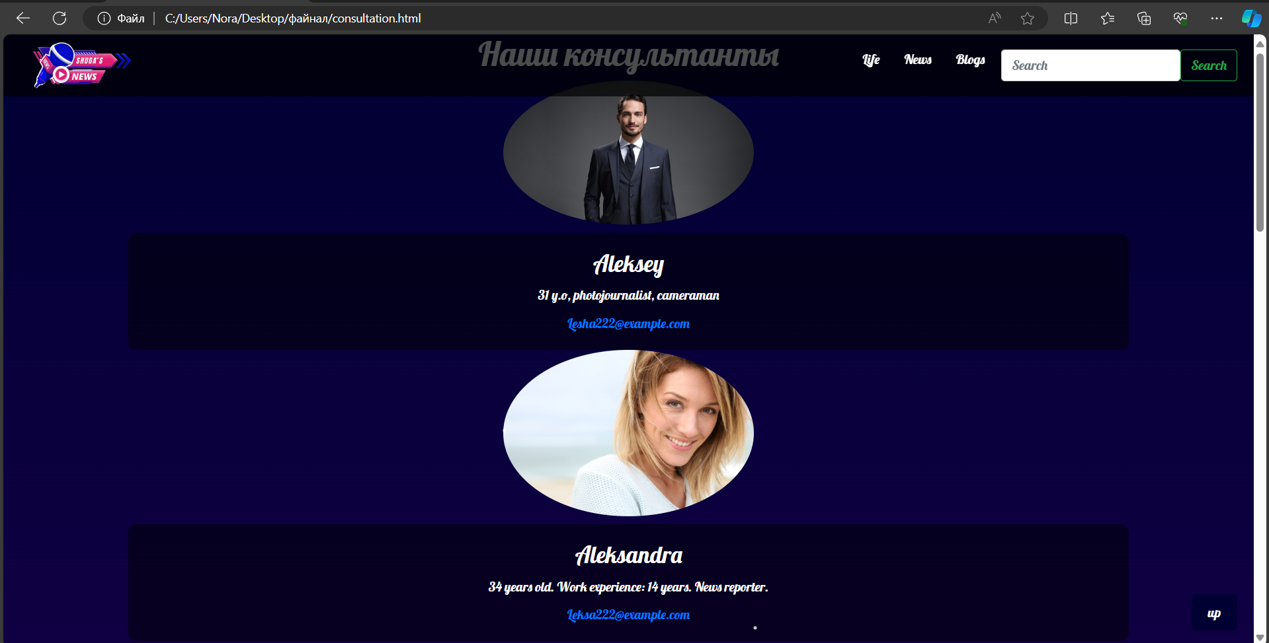

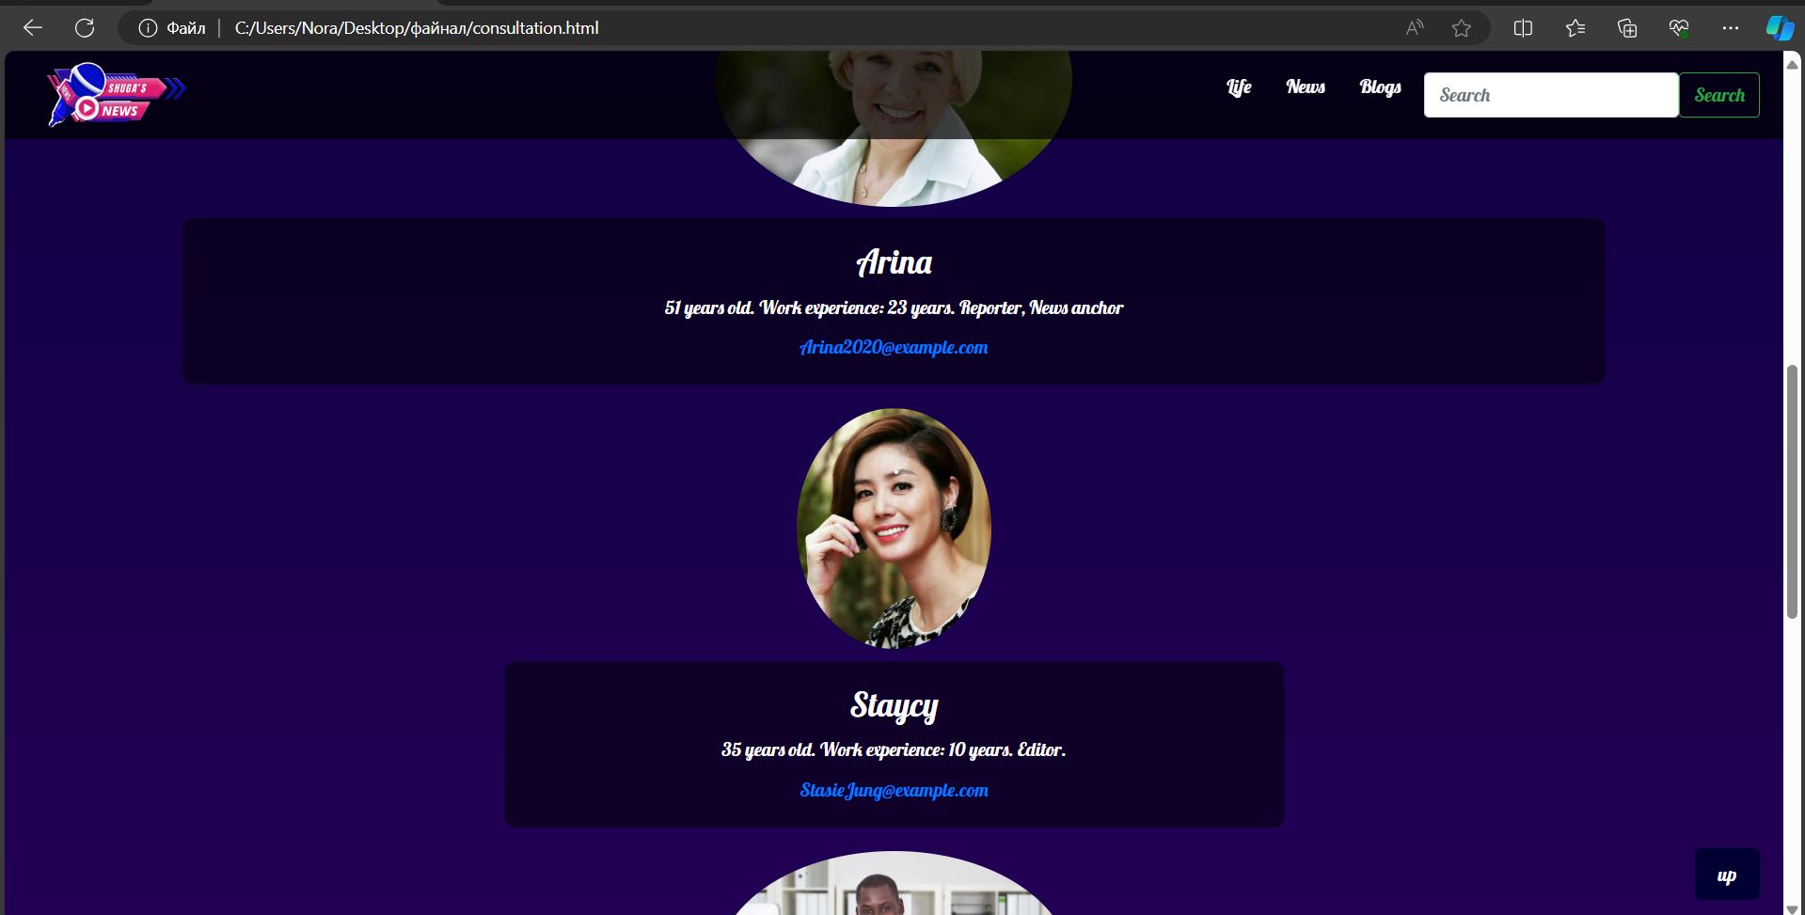

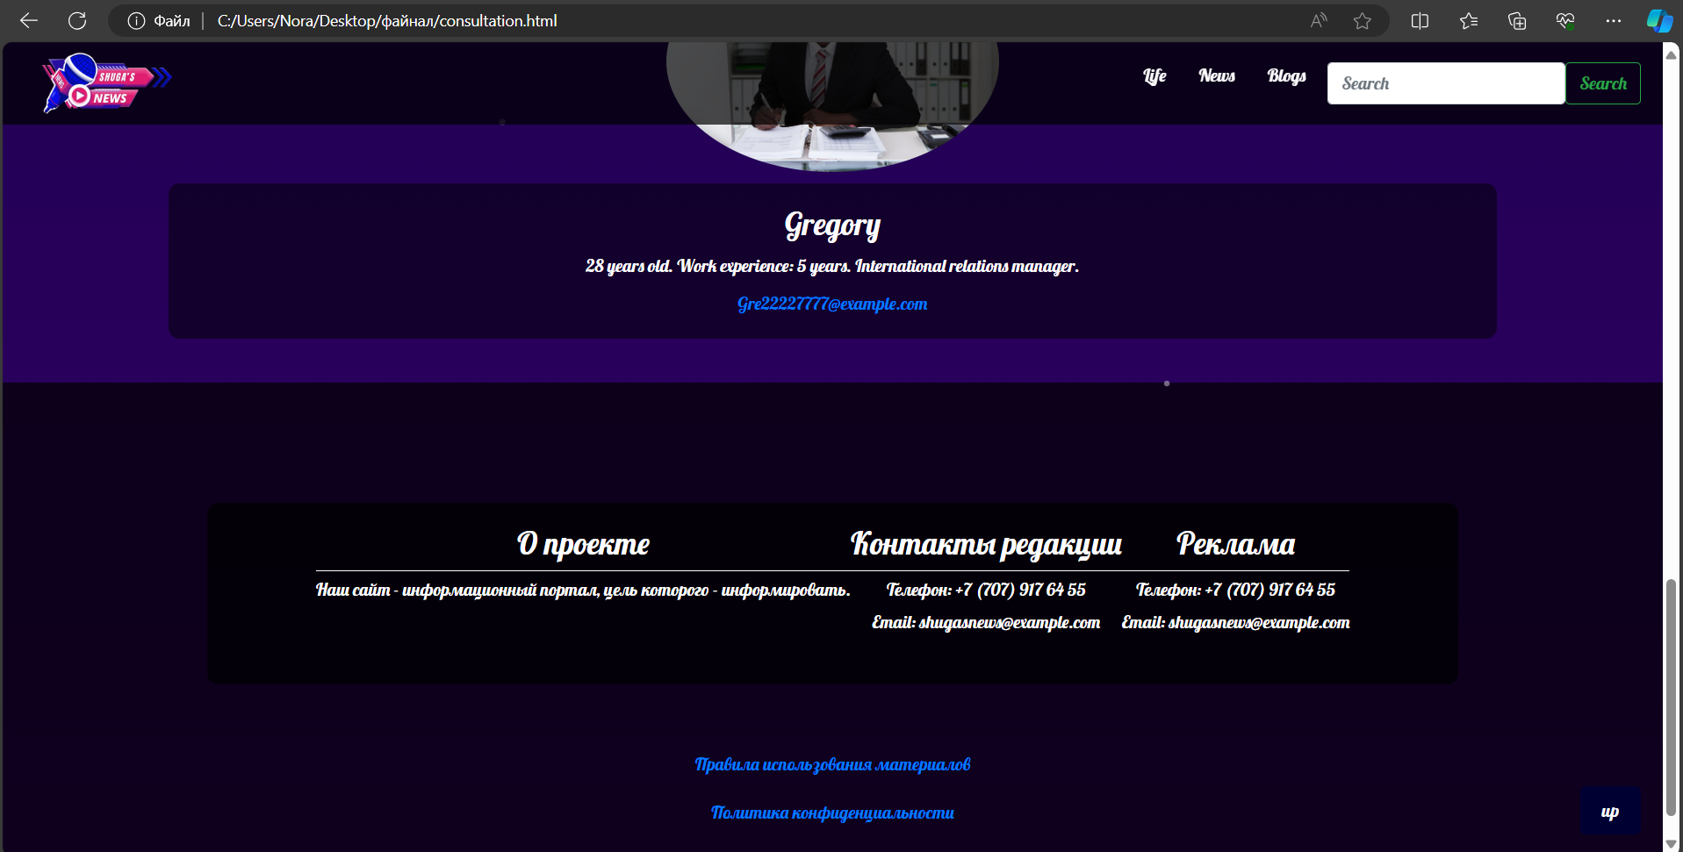

**<!DOCTYPE html>**

**<html lang="en">**

**<head>**

**<meta charset="UTF-8">**

**<meta name="viewport" content="width=device-width, initial-scale=1.0">**

**<title>CONSLAGERBUDTO</title>**

**<!-- Bootstrap CSS -->**

**<link href="https://stackpath.bootstrapcdn.com/bootstrap/4.5.2/css/bootstrap.min.css" rel="stylesheet">**

**<style>**

**@import url('https://fonts.googleapis.com/css2?family=Lobster&display=swap');**

**body {**

**margin: 0;**

**padding: 0;**

**background: linear-gradient(180deg, #000033 0%, #330066 100%);**

**color: white;**

**font-family: 'Lobster', cursive;**

**display: flex;**

**flex-direction: column;**

**align-items: center;**

**min-height: 100vh;**

**overflow-x: hidden;**

**position: relative;**

**}**

**/* Fireworks animation */**

**@keyframes fireworks {**

**0% { opacity: 1; transform: scale(1); }**

**100% { opacity: 0; transform: scale(2); }**

**}**

**.firework {**

**position: absolute;**

**background-color: white;**

**border-radius: 50%;**

**width: 3px;**

**height: 3px;**

**animation: fireworks 1.5s infinite;**

**}**

**.firework:nth-child(1) { top: 20%; left: 40%; animation-delay: 0.1s; }**

**.firework:nth-child(2) { top: 30%; left: 60%; animation-delay: 0.3s; }**

**.firework:nth-child(3) { top: 50%; left: 50%; animation-delay: 0.5s; }**

**.firework:nth-child(4) { top: 70%; left: 30%; animation-delay: 0.7s; }**

**.firework:nth-child(5) { top: 80%; left: 70%; animation-delay: 0.9s; }**

**.top-menu {**

**position: fixed;**

**top: 0;**

**width: 100%;**

**background-color: rgba(0, 0, 0, 0.7);**

**padding: 10px 20px;**

**display: flex;**

**align-items: center;**

**justify-content: space-between;**

**z-index: 1000;**

**height: 75px;**

**}**

**.navbar-logo img {**

**width: 150px;**

**transition: transform 0.3s;**

**}**

**.navbar-logo img:hover {**

**transform: scale(1.1);**

**}**

**.menu-main {**

**list-style: none;**

**display: flex;**

**margin: 0;**

**padding: 0;**

**}**

**.menu-main li {**

**position: relative;**

**margin-left: 10px;**

**}**

**.menu-main a {**

**text-decoration: none;**

**color: white;**

**padding: 5px 10px;**

**transition: color 0.3s, background-color 0.3s;**

**}**

**.menu-main a:hover {**

**color: yellow;**

**background-color: rgba(255, 255, 255, 0.2);**

**}**

**.menu-main a:hover::after {**

**content: '⭐️';**

**position: absolute;**

**right: -20px;**

**top: 0;**

**}**

**.container {**

**display: flex;**

**margin-top: 100px;**

**justify-content: center;**

**width: 100%;**

**}**

**.carousel-container {**

**flex: 2;**

**max-width: 60%;**

**}**

**.links-container {**

**flex: 1;**

**display: flex;**

**flex-direction: column;**

**justify-content: center;**

**align-items: flex-start;**

**padding: 20px;**

**border-left: 2px solid white;**

**margin-left: 20px;**

**}**

**.links-container a {**

**color: white;**

**text-decoration: none;**

**margin: 10px 0;**

**padding: 10px 15px;**

**background-color: rgba(0, 0, 0, 0.5);**

**font-size: 1.2em;**

**transition: background-color 0.3s;**

**}**

**.links-container a:hover {**

**background-color: rgba(255, 255, 255, 0.2);**

**}**

**footer {**

**margin-top: auto;**

**padding: 10px;**

**background-color: rgba(0, 0, 0, 0.7);**

**text-align: center;**

**width: 100%;**

**}**

**footer p {**

**margin: 0;**

**}**

**.scroll-to-top {**

**position: fixed;**

**bottom: 20px;**

**right: 20px;**

**background-color: #000033;**

**color: white;**

**border: none;**

**padding: 10px 20px;**

**border-radius: 5px;**

**cursor: pointer;**

**font-size: 16px;**

**transition: background-color 0.3s, color 0.3s;**

**}**

**.scroll-to-top:hover {**

**background-color: #330066;**

**}**

**.consultant {**

**display: flex;**

**flex-direction: column;**

**align-items: center;**

**text-align: center;**

**margin-bottom: 20px;**

**}**

**.consultant img {**

**width: 20%;**

**height: auto;**

**border-radius: 50%;**

**margin-bottom: 10px;**

**}**

**.consultant .content {**

**background-color: rgba(0, 0, 0, 0.5);**

**padding: 10px;**

**border-radius: 10px;**

**width: 80%;**

**}**

**.consultant .content h3 {**

**margin: 10px 0;**

**}**

**.consultant .content p {**

**margin: 10px 0;**

**}**

**.consultant .content .contact-info {**

**margin: 10px 0;**

**}**

**.consultant .content button {**

**background-color: #000033;**

**color: white;**

**border: none;**

**padding: 10px 20px;**

**border-radius: 5px;**

**cursor: pointer;**

**font-size: 16px;**

**transition: background-color 0.3s, color 0.3s;**

**}**

**.consultant .content button:hover {**

**background-color: #330066;**

**}**

**</style>**

**</head>**

**<body>**

**<!-- Fireworks Background -->**

**<div class="firework"></div>**

**<div class="firework"></div>**

**<div class="firework"></div>**

**<div class="firework"></div>**

**<div class="firework"></div>**

**<nav class="top-menu">**

**<a class="navbar-logo" href="C:\Users\Nora\Desktop\файнал\abouusshuga.html"><img src="C:\Users\Nora\Downloads\yoooo-removebg-preview.png" alt="Logo"></a>**

**<ul class="menu-main">**

**<li><a href="C:\Users\Nora\Desktop\файнал\life.html">Life</a></li>**

**<li><a href="C:\Users\Nora\Desktop\файнал\myfinal.html">News</a></li>**

**<li><a href="C:\Users\Nora\Desktop\файнал\consultation.html">Blogs</a></li>**

**<li>**

**<form class="d-flex" role="search">**

**<input class="form-control me-2" list="suggestions" type="search" placeholder="Search" aria-label="Search">**

**<datalist id="suggestions">**

**<option value="II women's volleyball game among the CIS countries" data-url="C:\Users\Nora\Desktop\файнал\articletwo.html">II women's volleyball game among the CIS countries</option>**

**<option value="Kazakhstan Khalkyn is the main initiator of charitable activities" data-url="C:\Users\Nora\Desktop\файнал\articlethree.html">Kazakhstan Khalkyn is the main initiator of charitable activities</option>**

**<option value="The development of medicine with the advent of the COVID-19" data-url="C:\Users\Nora\Desktop\файнал\articlefive.html">The development of medicine with the advent of the COVID-19</option>**

**</datalist>**

**<button class="btn btn-outline-success" id="searchButton" type="button">Search</button>**

**</form>**

**</li>**

**</ul>**

**</nav>**

**<script>**

**document.getElementById('searchButton').addEventListener('click', function() {**

**var input = document.querySelector('input[type="search"]');**

**var selectedOption = document.querySelector('option[value="' + input.value + '"]');**

**if (selectedOption && selectedOption.dataset.url) {**

**window.location.href = selectedOption.dataset.url;**

**}**

**});**

**</script>**

**</nav>**

**</div>**

**<div class="consultant">**

**<h1 class="section">Наши консультанты</h1>**

**<div>**

**</div>**

**<div class="consultant">**

**<img src="C:\Users\Nora\Pictures\Алексей.jpg" alt="Фото консультанта Александра">**

**<div class="content">**

**<h3>Aleksey</h3>**

**<p>31 y.o, photojournalist, cameraman</p>**

**<div class="contact-info">**

**<a href="mailto:Lesha222@example.com">Lesha222@example.com</a>**

**</div>**

**</div>**

**<div class="consultant">**

**<img src="C:\Users\Nora\Pictures\Александра.jpg" alt="Фото консультанта Александра">**

**<div class="content">**

**<h3>Aleksandra</h3>**

**<p>34 years old. Work experience: 14 years. News reporter.</p>**

**<div class="contact-info">**

**<a href="mailto:Leksa222@example.com">Leksa222@example.com</a>**

**</div>**

**</div>**

**</div>**

**<div class="consultant">**

**<img src="C:\Users\Nora\Pictures\Арина.jpg" alt="Фото консультанта Арина">**

**<div class="content">**

**<h3>Arina</h3>**

**<p>51 years old. Work experience: 23 years. Reporter, News anchor</p>**

**<div class="contact-info">**

**<a href="mailto:Arina2020@example.com">Arina2020@example.com</a>**

**</div>**

**</div>**

**</div>**

**<div class="consultant">**

**<img src="C:\Users\Nora\Pictures\6173-8.jpg" alt="Фото консультанта Стейси">**

**<div class="content">**

**<h3>Staycy</h3>**

**<p>35 years old. Work experience: 10 years. Editor.</p>**

**<div class="contact-info">**

**<a href="mailto:StasieJung@example.com">StasieJung@example.com</a>**

**</div>**

**</div>**

**</div>**

**<div class="consultant">**

**<img src="C:\Users\Nora\Pictures\Черный консультант.webp" alt="Фото консультанта Грегори">**

**<div class="content">**

**<h3>Gregory</h3>**

**<p>28 years old. Work experience: 5 years. International relations manager.</p>**

**<div class="contact-info">**

**<a href="mailto:Gre22227777@example.com">Gre22227777@example.com</a>**

**</div>**

**</div>**

**</div>**

**</div>**

**<button class="scroll-to-top" onclick="scrollToTop()">up</button>**

**<footer>**

**<div class="container">**

**<div class="info-section">**

**<h3>О проекте</h3>**

**<hr>**

**<p>Наш сайт - информационный портал, цель которого - информировать.</p>**

**</div>**

**<div class="info-section">**

**<h3>Контакты редакции</h3>**

**<hr>**

**<p>Телефон: +7 (707) 917 64 55</p>**

**<p>Email: shugasnews@example.com</p>**

**</div>**

**<div class="info-section">**

**<h3>Реклама</h3>**

**<hr>**

**<p>Телефон: +7 (707) 917 64 55</p>**

**<p>Email: shugasnews@example.com</p>**

**</div>**

**</div>**

**<div class="copyright">**

**<hr>**

**<p><a href="C:\Users\Nora\Desktop\файнал\rules.html">Правила использования материалов</a></p>**

**<p><a href="C:\Users\Nora\Desktop\файнал\policy.html">Политика конфиденциальности</a></p>**

**</div>**

**<p>&copy; 2024 Shuga's news. All rights reserved.</p>**

**</footer>**

**<style>**

**.container {**

**padding: 20px;**

**background-color: rgba(0, 0, 0, 0.7);**

**border-radius: 10px;**

**color: white;**

**text-align: center;**

**}**

**.info-section {**

**margin-bottom: 20px;**

**}**

**.info-section hr {**

**border: 0;**

**border-top: 1px solid white;**

**margin: 5px 0;**

**}**

**.info-section p {**

**margin: 0;**

**margin-bottom: 5px;**

**}**

**.info-section a {**

**color: white;**

**text-decoration: none;**

**}**

**.info-section a:hover {**

**text-decoration: underline;**

**}**

**footer p {**

**text-align: center;**

**margin-top: 20px;**

**}**

**.copyright {**

**margin-top: 40px;**

**}**

**</style>**

**<!-- Bootstrap JS and dependencies -->**

**<script src="https://code.jquery.com/jquery-3.5.1.slim.min.js"></script>**

**<script src="https://cdn.jsdelivr.net/npm/@popperjs/core@2.5.4/dist/umd/popper.min.js"></script>**

**<script src="https://stackpath.bootstrapcdn.com/bootstrap/4.5.2/js/bootstrap.min.js"></script>**

**<script>**

**// Показать кнопку, когда прокручено вниз 20px от верха**

**window.**

**onscroll = function() {scrollFunction()};**

**function scrollFunction() {**

**const scrollToTopBtn = document.querySelector(".scroll-to-top");**

**if (document.body.scrollTop > 20 || document.documentElement.scrollTop > 20) {**

**scrollToTopBtn.style.display = "block";**

**} else {**

**scrollToTopBtn.style.display = "none";**

**}**

**}**

**// Прокрутка наверх**

**function scrollToTop() {**

**document.body.scrollTop = 0;**

**document.documentElement.scrollTop = 0;**

**}**

**</script>**

**</body>**

**</html>**

**ТЕПЕРЬ ИДУТ РУССКИЙ ПЕРЕВОД СТРАНИЧКИ НОВОСТЕЙ**

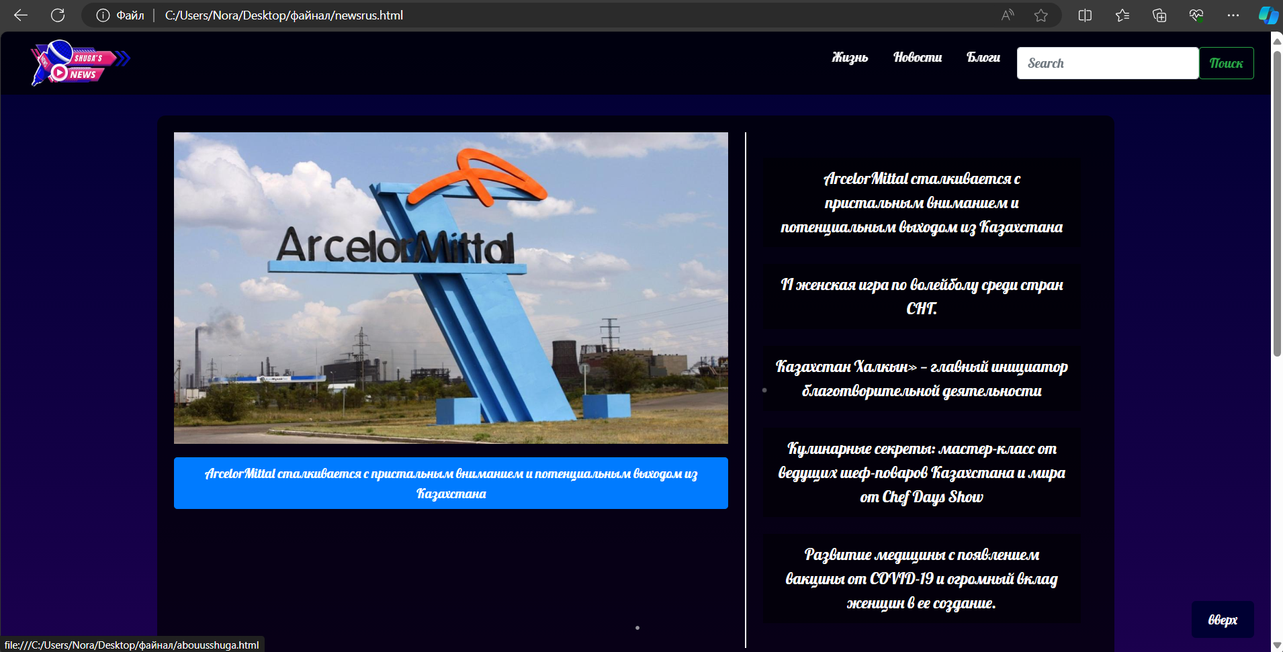

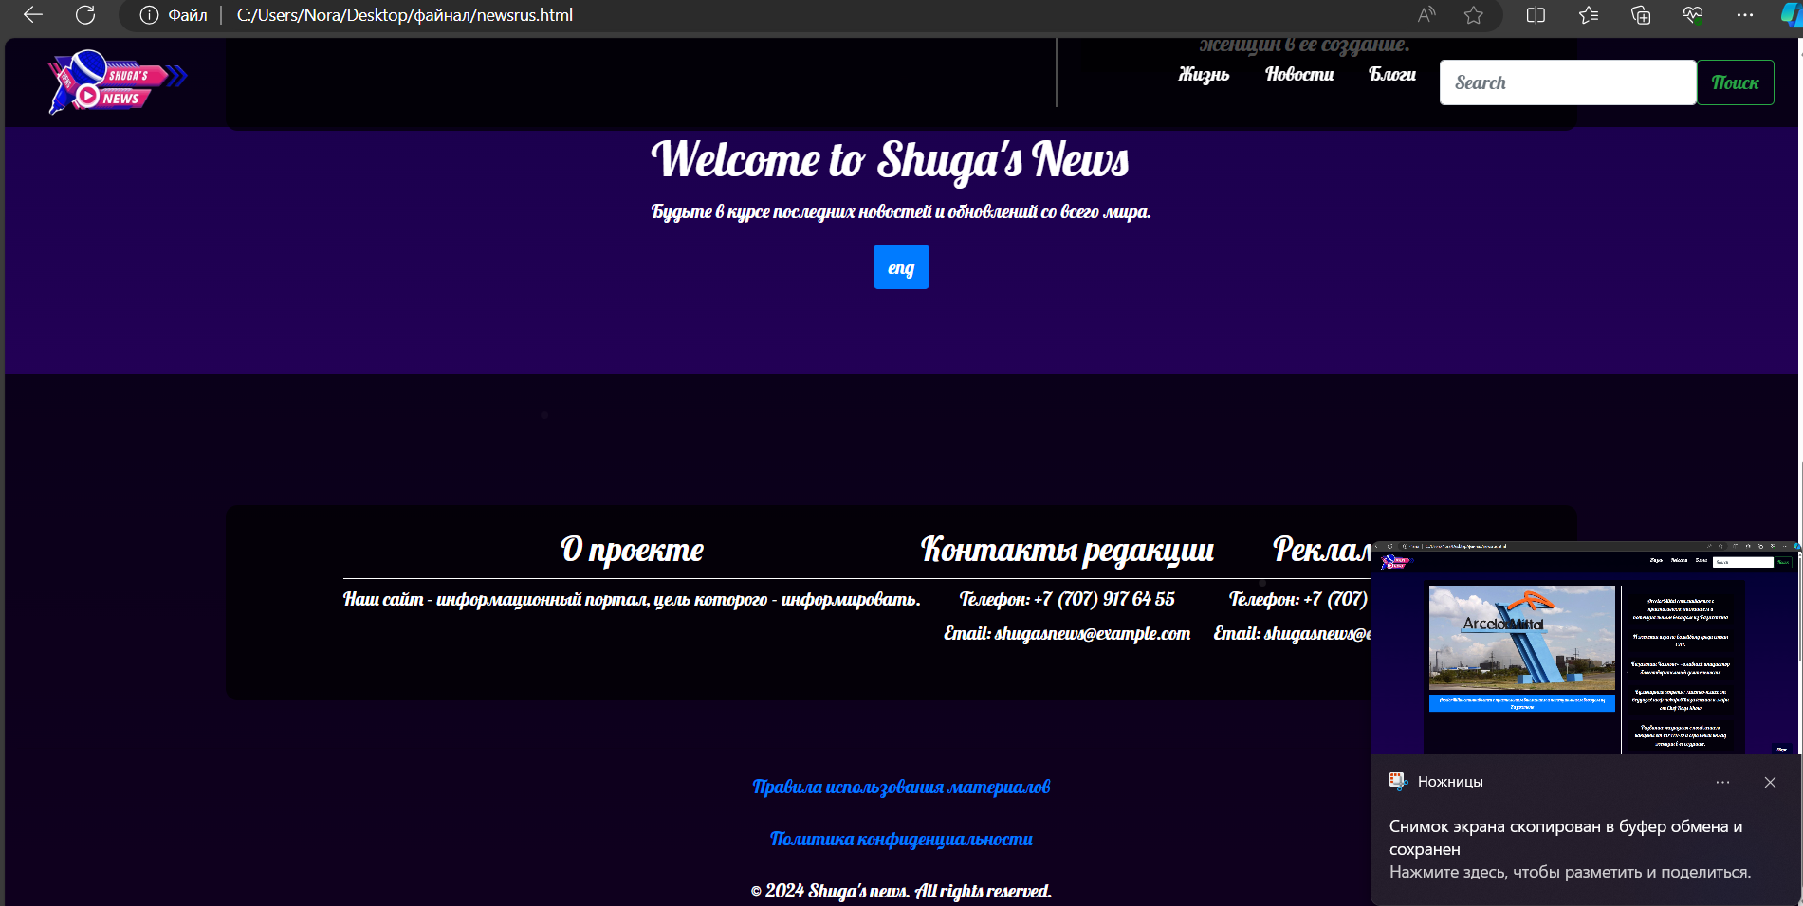

**<!DOCTYPE html>**

**<html lang="en">**

**<head>**

**<meta charset="UTF-8">**

**<meta name="viewport" content="width=device-width, initial-scale=1.0">**

**<title>Это сделала Шуги</title>**

**<!-- Bootstrap CSS -->**

**<link href="https://stackpath.bootstrapcdn.com/bootstrap/4.5.2/css/bootstrap.min.css" rel="stylesheet">**

**<style>**

**@import url('https://fonts.googleapis.com/css2?family=Lobster&display=swap');**

**body {**

**margin: 0;**

**padding: 0;**

**background: linear-gradient(180deg, #000033 0%, #330066 100%);**

**color: white;**

**font-family: 'Lobster', cursive;**

**display: flex;**

**flex-direction: column;**

**align-items: center;**

**min-height: 100vh;**

**overflow-x: hidden;**

**position: relative;**

**}**

**/* Fireworks animation */**

**@keyframes fireworks {**

**0% { opacity: 1; transform: scale(1); }**

**100% { opacity: 0; transform: scale(2); }**

**}**

**.firework {**

**position: absolute;**

**background-color: white;**

**border-radius: 50%;**

**width: 3px;**

**height: 3px;**

**animation: fireworks 1.5s infinite;**

**}**

**.firework:nth-child(1) { top: 20%; left: 40%; animation-delay: 0.1s; }**

**.firework:nth-child(2) { top: 30%; left: 60%; animation-delay: 0.3s; }**

**.firework:nth-child(3) { top: 50%; left: 50%; animation-delay: 0.5s; }**

**.firework:nth-child(4) { top: 70%; left: 30%; animation-delay: 0.7s; }**

**.firework:nth-child(5) { top: 80%; left: 70%; animation-delay: 0.9s; }**

**.top-menu {**

**position: fixed;**

**top: 0;**

**width: 100%;**

**background-color: rgba(0, 0, 0, 0.7);**

**padding: 10px 20px;**

**display: flex;**

**align-items: center;**

**justify-content: space-between;**

**z-index: 1000;**

**height: 75px;**

**}**

**.navbar-logo img {**

**width: 150px;**

**transition: transform 0.3s;**

**}**

**.navbar-logo img:hover {**

**transform: scale(1.1);**

**}**

**.menu-main {**

**list-style: none;**

**display: flex;**

**margin: 0;**

**padding: 0;**

**}**

**.menu-main li {**

**position: relative;**

**margin-left: 10px;**

**}**

**.menu-main a {**

**text-decoration: none;**

**color: white;**

**padding: 5px 10px;**

**transition: color 0.3s, background-color 0.3s;**

**}**

**.menu-main a:hover {**

**color: yellow;**

**background-color: rgba(255, 255, 255, 0.2);**

**}**

**.menu-main a:hover::after {**

**content: '⭐️';**

**position: absolute;**

**right: -20px;**

**top: 0;**

**}**

**.container {**

**display: flex;**

**margin-top: 100px;**

**justify-content: center;**

**width: 100%;**

**}**

**.carousel-container {**

**flex: 2;**

**max-width: 60%;**

**}**

**.links-container {**

**flex: 1;**

**display: flex;**

**flex-direction: column;**

**justify-content: center;**

**align-items: flex-start;**

**padding: 20px;**

**border-left: 2px solid white;**

**margin-left: 20px;**

**}**

**.links-container a {**

**color: white;**

**text-decoration: none;**

**margin: 10px 0;**

**padding: 10px 15px;**

**background-color: rgba(0, 0, 0, 0.5);**

**font-size: 1.2em;**

**transition: background-color 0.3s;**

**}**

**.links-container a:hover {**

**background-color: rgba(255, 255, 255, 0.2);**

**}**

**footer {**

**margin-top: auto;**

**padding: 10px;**

**background-color: rgba(0, 0, 0, 0.7);**

**text-align: center;**

**width: 100%;**

**}**

**footer p {**

**margin: 0;**

**}**

**.scroll-to-top {**

**position: fixed;**

**bottom: 20px;**

**right: 20px;**

**background-color: #000033;**

**color: white;**

**border: none;**

**padding: 10px 20px;**

**border-radius: 5px;**

**cursor: pointer;**

**font-size: 16px;**

**transition: background-color 0.3s, color 0.3s;**

**}**

**.scroll-to-top:hover {**

**background-color: #330066;**

**}**

**</style>**

**</head>**

**<body>**

**<!-- Fireworks Background -->**

**<div class="firework"></div>**

**<div class="firework"></div>**

**<div class="firework"></div>**

**<div class="firework"></div>**

**<div class="firework"></div>**

**<nav class="top-menu">**

**<a class="navbar-logo" href="C:\Users\Nora\Desktop\файнал\abouusshuga.html"><img src="C:\Users\Nora\Downloads\yoooo-removebg-preview.png" alt="Logo"></a>**

**<ul class="menu-main">**

**<li><a href="C:\Users\Nora\Desktop\файнал\life.html">Жизнь</a></li>**

**<li><a href="C:\Users\Nora\Desktop\файнал\myfinal.html">Новости</a></li>**

**<li><a href="C:\Users\Nora\Desktop\файнал\consultation.html">Блоги</a></li>**

**<li>**

**<form class="d-flex" role="search">**

**<input class="form-control me-2" list="suggestions" type="search" placeholder="Search" aria-label="Search">**

**<datalist id="suggestions">**

**<option value="II женская игра по волейболу среди стран СНГ" data-url="C:\Users\Nora\Desktop\файнал\articletwo.html">II women's volleyball game among the CIS countries</option>**

**<option value="Казахстанский Халкын – главный инициатор благотворительной деятельности" data-url="C:\Users\Nora\Desktop\файнал\articlethree.html">Kazakhstan Khalkyn is the main initiator of charitable activities</option>**

**<option value="Развитие медицины с появлением COVID-19" data-url="C:\Users\Nora\Desktop\файнал\articlefive.html">The development of medicine with the advent of the COVID-19</option>**

**</datalist>**

**<button class="btn btn-outline-success" id="searchButton" type="button">Поиск</button>**

**</form>**

**</li>**

**</ul>**

**</nav>**

**<script>**

**document.getElementById('searchButton').addEventListener('click', function() {**

**var input = document.querySelector('input[type="search"]');**

**var selectedOption = document.querySelector('option[value="' + input.value + '"]');**

**if (selectedOption && selectedOption.dataset.url) {**

**window.location.href = selectedOption.dataset.url;**

**}**

**});**

**</script>**

**<div class="container">**

**<div class="carousel-container">**

**<div id="carouselExampleSlidesOnly" class="carousel slide" data-ride="carousel">**

**<div class="carousel-inner">**

**<div class="carousel-item active">**

**<img src="C:\Users\Nora\Pictures\для универа\арселор 2.jpg" class="d-block w-100" alt="...">**

**</div>**

**<div class="carousel-item">**

**<img src="C:\Users\Nora\Pictures\для универа\арселор 3.jpg" class="d-block w-100" alt="...">**

**</div>**

**<div class="carousel-item">**

**<img src="C:\Users\Nora\Pictures\для универа\арселор 2.jpg" class="d-block w-100" alt="...">**

**</div>**

**</div>**

**</div>**

**<a href="C:\Users\Nora\Desktop\файнал\articleone.html" class="btn btn-primary mt-3" style="display: block; text-align: center;">ArcelorMittal сталкивается с пристальным вниманием и потенциальным выходом из Казахстана</a>**

**</div>**

**<div class="links-container">**

**<a href="C:\Users\Nora\Desktop\файнал\articleone.html">ArcelorMittal сталкивается с пристальным вниманием и потенциальным выходом из Казахстана</a>**

**<a href="C:\Users\Nora\Desktop\файнал\articletwo.html">II женская игра по волейболу среди стран СНГ.</a>**

**<a href="C:\Users\Nora\Desktop\файнал\articlethree.html">Казахстан Халкын» — главный инициатор благотворительной деятельности</a>**

**<a href="C:\Users\Nora\Desktop\файнал\articlefour.html">Кулинарные секреты: мастер-класс от ведущих шеф-поваров Казахстана и мира от Chef Days Show</a>**

**<a href="C:\Users\Nora\Desktop\файнал\articlefive.html">Развитие медицины с появлением вакцины от COVID-19 и огромный вклад женщин в ее создание.</a>**

**</div>**

**</div>**

**<div>**

**<h1>Welcome to Shuga's News</h1>**

**<p>Будьте в курсе последних новостей и обновлений со всего мира.</p>**

**</div>**

**<button class="scroll-to-top" onclick="scrollToTop()">вверх</button>**

**<a class="btn btn-primary" href="C:\Users\Nora\Desktop\файнал\myfinal.html" role="button">eng</a>**

**<br> <br> <br>**

**<footer>**

**<div class="container">**

**<div class="info-section">**

**<h3>О проекте</h3>**

**<hr>**

**<p>Наш сайт - информационный портал, цель которого - информировать.</p>**

**</div>**

**<div class="info-section">**

**<h3>Контакты редакции</h3>**

**<hr>**

**<p>Телефон: +7 (707) 917 64 55</p>**

**<p>Email: shugasnews@example.com</p>**

**</div>**

**<div class="info-section">**

**<h3>Реклама</h3>**

**<hr>**

**<p>Телефон: +7 (707) 917 64 55</p>**

**<p>Email: shugasnews@example.com</p>**

**</div>**

**</div>**

**<div class="copyright">**

**<hr>**

**<p><a href="C:\Users\Nora\Desktop\файнал\rules.html">Правила использования материалов</a></p>**

**<p><a href="C:\Users\Nora\Desktop\файнал\policy.html">Политика конфиденциальности</a></p>**

**</div>**

**<p>&copy; 2024 Shuga's news. All rights reserved.</p>**

**</footer>**

**<style>**

**.container {**

**padding: 20px;**

**background-color: rgba(0, 0, 0, 0.7);**

**border-radius: 10px;**

**color: white;**

**text-align: center;**

**}**

**.info-section {**

**margin-bottom: 20px;**

**}**

**.info-section hr {**

**border: 0;**

**border-top: 1px solid white;**

**margin: 5px 0;**

**}**

**.info-section p {**

**margin: 0;**

**margin-bottom: 5px;**

**}**

**.info-section a {**

**color: white;**

**text-decoration: none;**

**}**

**.info-section a:hover {**

**text-decoration: underline;**

**}**

**footer p {**

**text-align: center;**

**margin-top: 20px;**

**}**

**.copyright {**

**margin-top: 40px;**

**}**

**</style>**

**<!-- Bootstrap JS and dependencies -->**

**<script src="https://code.jquery.com/jquery-3.5.1.slim.min.js"></script>**

**<script src="https://cdn.jsdelivr.net/npm/@popperjs/core@2.5.4/dist/umd/popper.min.js"></script>**

**<script src="https://stackpath.bootstrapcdn.com/bootstrap/4.5.2/js/bootstrap.min.js"></script>**

**<script>**

**// Показать кнопку, когда прокручено вниз 20px от верха**

**window.onscroll = function() {scrollFunction()};**

**function scrollFunction() {**

**const scrollToTopBtn = document.querySelector(".scroll-to-top");**

**if (document.body.scrollTop > 20 || document.documentElement.scrollTop > 20) {**

**scrollToTopBtn.style.display = "block";**

**} else {**

**scrollToTopBtn.style.display = "none";**

**}**

**}**

**// Прокрутка наверх**

**function scrollToTop() {**

**document.body.scrollTop = 0;**

**document.documentElement.scrollTop = 0;**

**}**

**</script>**

**</body>**

**</html>**

**А ТЕПЕРЬ СЕКЦИЯ ПРО НАС ПРИ НАЖАТИЙ НА ЛОГО**

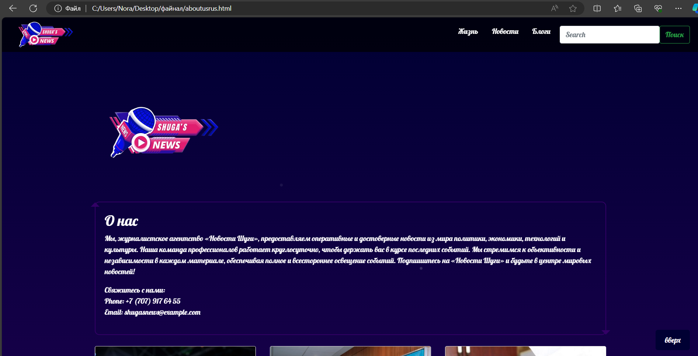

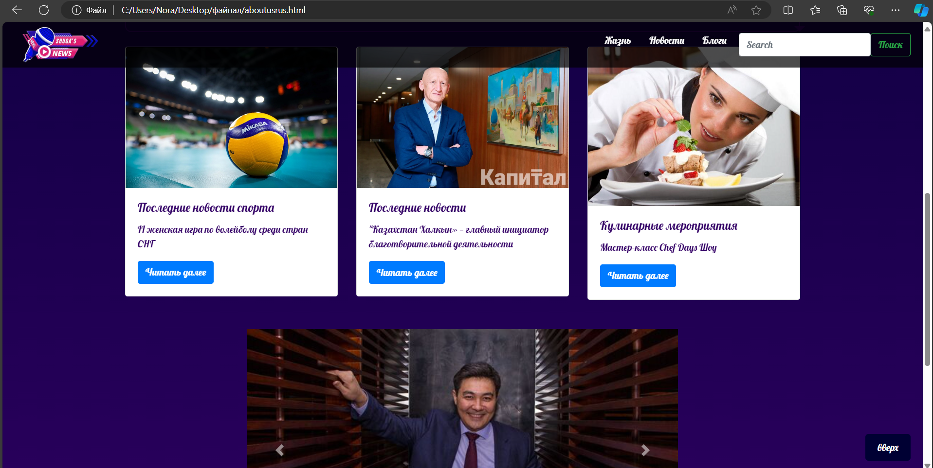

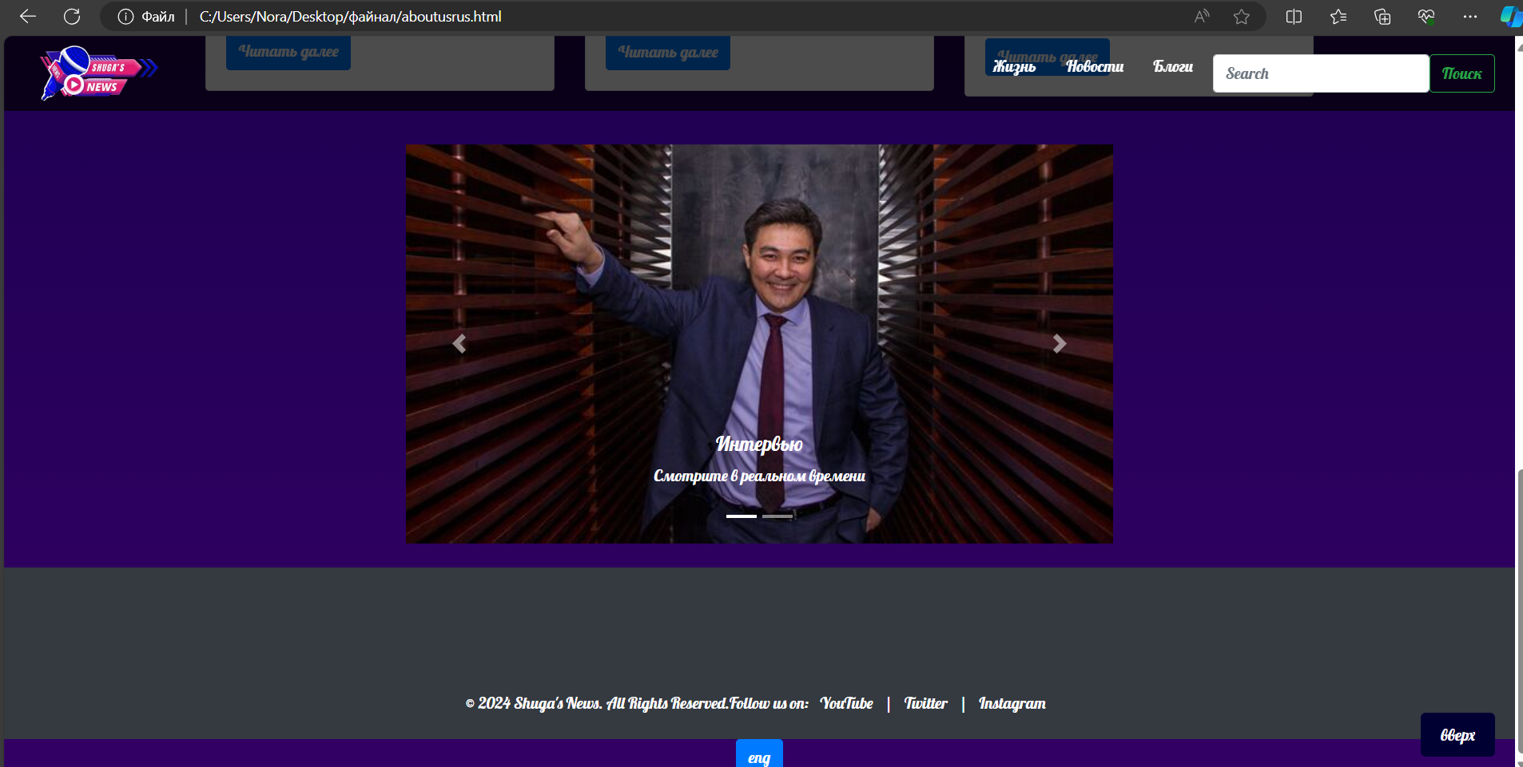

**<!DOCTYPE html>**

**<html lang="en">**

**<head>**

**<meta charset="UTF-8">**

**<meta name="viewport" content="width=device-width, initial-scale=1.0">**

**<title>Это сделала Шуги</title>**

**<!-- Bootstrap CSS -->**

**<link href="https://stackpath.bootstrapcdn.com/bootstrap/4.5.2/css/bootstrap.min.css" rel="stylesheet">**

**<style>**

**@import url('https://fonts.googleapis.com/css2?family=Lobster&display=swap');**

**body {**

**margin: 0;**

**padding: 0;**

**background: linear-gradient(180deg, #000033 0%, #330066 100%);**

**color: white;**

**font-family: 'Lobster', cursive;**

**display: flex;**

**flex-direction: column;**

**align-items: center;**

**min-height: 100vh;**

**overflow-x: hidden;**

**position: relative;**

**}**

**/* Fireworks animation */**

**@keyframes fireworks {**

**0% { opacity: 1; transform: scale(1); }**

**100% { opacity: 0; transform: scale(2); }**

**}**

**.firework {**

**position: absolute;**

**background-color: white;**

**border-radius: 50%;**

**width: 3px;**

**height: 3px;**

**animation: fireworks 1.5s infinite;**

**}**

**.firework:nth-child(1) { top: 20%; left: 40%; animation-delay: 0.1s; }**

**.firework:nth-child(2) { top: 30%; left: 60%; animation-delay: 0.3s; }**

**.firework:nth-child(3) { top: 50%; left: 50%; animation-delay: 0.5s; }**

**.firework:nth-child(4) { top: 70%; left: 30%; animation-delay: 0.7s; }**

**.firework:nth-child(5) { top: 80%; left: 70%; animation-delay: 0.9s; }**

**.top-menu {**

**position: fixed;**

**top: 0;**

**width: 100%;**

**background-color: rgba(0, 0, 0, 0.7);**

**padding: 10px 20px;**

**display: flex;**

**align-items: center;**

**justify-content: space-between;**

**z-index: 1000;**

**height: 75px;**

**}**

**.navbar-logo img {**

**width: 150px;**

**transition: transform 0.3s;**

**}**

**.navbar-logo img:hover {**

**transform: scale(1.1);**

**}**

**.menu-main {**

**list-style: none;**

**display: flex;**

**margin: 0;**

**padding: 0;**

**}**

**.menu-main li {**

**position: relative;**

**margin-left: 10px;**

**}**

**.menu-main a {**

**text-decoration: none;**

**color: white;**

**padding: 5px 10px;**

**transition: color 0.3s, background-color 0.3s;**

**}**

**.menu-main a:hover {**

**color: yellow;**

**background-color: rgba(255, 255, 255, 0.2);**

**}**

**.menu-main a:hover::after {**

**content: '⭐️';**

**position: absolute;**

**right: -20px;**

**top: 0;**

**}**

**.container {**

**display: flex;**

**margin-top: 100px;**

**justify-content: center;**

**width: 100%;**

**}**

**.carousel-container {**

**flex: 2;**

**max-width: 60%;**

**}**

**.links-container {**

**flex: 1;**

**display: flex;**

**flex-direction: column;**

**justify-content: center;**

**align-items: flex-start;**

**padding: 20px;**

**border-left: 2px solid white;**

**margin-left: 20px;**

**}**

**.links-container a {**

**color: white;**

**text-decoration: none;**

**margin: 10px 0;**

**padding: 10px 15px;**

**background-color: rgba(0, 0, 0, 0.5);**

**font-size: 1.2em;**

**transition: background-color 0.3s;**

**}**

**.links-container a:hover {**

**background-color: rgba(255, 255, 255, 0.2);**

**}**

**footer {**

**margin-top: auto;**

**padding: 10px;**

**background-color: rgba(0, 0, 0, 0.7);**

**text-align: center;**

**width: 100%;**

**}**

**footer p {**

**margin: 0;**

**}**

**.scroll-to-top {**

**position: fixed;**

**bottom: 20px;**

**right: 20px;**

**background-color: #000033;**

**color: white;**

**border: none;**

**padding: 10px 20px;**

**border-radius: 5px;**

**cursor: pointer;**

**font-size: 16px;**

**transition: background-color 0.3s, color 0.3s;**

**}**

**.scroll-to-top:hover {**

**background-color: #330066;**

**}**

**.profile-info {**

**border: 2px solid #330066;**

**padding: 20px;**

**border-radius: 10px;**

**position: relative;**

**}**

**.profile-info:before {**

**content: " ";**

**position: absolute;**

**top: -10px;**

**left: -10px;**

**border-top: 10px solid transparent;**

**border-left: 10px solid transparent;**

**border-right: 10px solid transparent;**

**border-bottom: 10px solid #330066;**

**}**

**.profile-info:after {**

**content: " ";**

**position: absolute;**

**bottom: -10px;**

**right: -10px;**

**border-top: 10px solid #330066;**

**border-left: 10px solid transparent;**

**border-right: 10px solid transparent;**

**border-bottom: 10px solid transparent;**

**}**

**.card-title,**

**.card-text {**

**color: #330066;**

**}**

**</style>**

**</head>**

**<body>**

**<!-- Fireworks Background -->**

**<div class="firework"></div>**

**<div class="firework"></div>**

**<div class="firework"></div>**

**<div class="firework"></div>**

**<div class="firework"></div>**

**<nav class="top-menu">**

**<a class="navbar-logo" href="C:\Users\Nora\Desktop\файнал\abouusshuga.html"><img src="C:\Users\Nora\Downloads\yoooo-removebg-preview.png" alt="Logo"></a>**

**<ul class="menu-main">**

**<li><a href="C:\Users\Nora\Desktop\файнал\life.html">Жизнь</a></li>**

**<li><a href="C:\Users\Nora\Desktop\файнал\myfinal.html">Новости</a></li>**

**<li><a href="C:\Users\Nora\Desktop\файнал\consultation.html">Блоги</a></li>**

**<li>**

**<form class="d-flex" role="search">**

**<input class="form-control me-2" list="suggestions" type="search" placeholder="Search" aria-label="Search">**

**<datalist id="suggestions">**

**<option value="II женская игра по волейболу среди стран СНГ" data-url="C:\Users\Nora\Desktop\файнал\articletwo.html">II women's volleyball game among the CIS countries</option>**

**<option value="Казахстанский Халкын – главный инициатор благотворительной деятельности" data-url="C:\Users\Nora\Desktop\файнал\articlethree.html">Kazakhstan Khalkyn is the main initiator of charitable activities</option>**

**<option value="Развитие медицины с появлением COVID-19" data-url="C:\Users\Nora\Desktop\файнал\articlefive.html">The development of medicine with the advent of the COVID-19</option>**

**</datalist>**

**<button class="btn btn-outline-success" id="searchButton" type="button">Поиск</button>**

**</form>**

**</li>**

**</ul>**

**</nav>**

**<script>**

**document.getElementById('searchButton').addEventListener('click', function() {**

**var input = document.querySelector('input[type="search"]');**

**var selectedOption = document.querySelector('option[value="' + input.value + '"]');**

**if (selectedOption && selectedOption.dataset.url) {**

**window.location.href = selectedOption.dataset.url;**

**}**

**});**

**</script>**

**<div class="container">**

**<div class="profile">**

**<img src="C:\Users\Nora\Downloads\yoooo-removebg-preview.png" alt="Profile Picture" width="300">**

**<div class="profile-info">**

**<h2>О нас</h2>**

**<p>Мы, журналистское агентство «Новости Шуги», предоставляем оперативные и достоверные новости из мира политики, экономики, технологий и культуры. Наша команда профессионалов работает круглосуточно, чтобы держать вас в курсе последних событий. Мы стремимся к объективности и независимости в каждом материале, обеспечивая полное и всестороннее освещение событий. Подпишитесь на «Новости Шуги» и будьте в центре мировых новостей!</p>**

**<p>Свяжитесь с нами: <br>**

**Phone: +7 (707) 917 64 55 <br>**

**Email: shugasnews@example.com</p>**

**</div>**

**</div>**

**<hr>**

**</div>**

**<!-- Bootstrap Cards Component -->**

**<div class="container my-4">**

**<div class="row">**

**<div class="col-md-4">**

**<div class="card">**

**<img src="C:\Users\Nora\Desktop\файнал\volleyball.jpeg" class="card-img-top" alt="Article 1">**

**<div class="card-body">**

**<h5 class="card-title">Последние новости спорта</h5>**

**<p class="card-text">II женская игра по волейболу среди стран СНГ</p>**

**<a href="C:\Users\Nora\Desktop\файнал\articletwo.html" class="btn btn-primary">Читать далее</a>**

**</div>**

**</div>**

**</div>**

**<div class="col-md-4">**

**<div class="card">**

**<img src="C:\Users\Nora\Desktop\файнал\halkyna.webp" class="card-img-top" alt="Article 2">**

**<div class="card-body">**

**<h5 class="card-title">Последние новости</h5>**

**<p class="card-text">"Казахстан Халкын» — главный инициатор благотворительной деятельности</p>**

**<a href="C:\Users\Nora\Desktop\файнал\articlethree.html" class="btn btn-primary">Читать далее</a>**

**</div>**

**</div>**

**</div>**

**<div class="col-md-4">**

**<div class="card">**

**<img src="C:\Users\Nora\Desktop\файнал\cooking.jpg" class="card-img-top" alt="Article 3">**

**<div class="card-body">**

**<h5 class="card-title">Кулинарные мероприятия</h5>**

**<p class="card-text">Мастер-класс Chef Days Шоу</p>**

**<a href="C:\Users\Nora\Desktop\файнал\articlefour.html" class="btn btn-primary">Читать далее</a>**

**</div>**

**</div>**

**</div>**

**</div>**

**</div>**

**<!-- Bootstrap Carousel Component -->**

**<div class="container my-4">**

**<div id="newsCarousel" class="carousel slide" data-ride="carousel">**

**<ol class="carousel-indicators">**

**<li data-target="#newsCarousel" data-slide-to="0" class="active"></li>**

**<li data-target="#newsCarousel" data-slide-to="1"></li>**

**</ol>**

**<div class="carousel-inner">**

**<div class="carousel-item active">**

**<img src="C:\Users\Nora\Desktop\файнал\Tima.jpg" class="d-block w-100" style="width: 800px; height: 400px;" alt="Slide 1">**

**<div class="carousel-caption d-none d-md-block">**

**<h5>Интервью</h5>**

**<p>Смотрите в реальном времени</p>**

**</div>**

**</div>**

**<div class="carousel-item">**

**<img src="C:\Users\Nora\Desktop\файнал\timatwo.jpg" class="d-block w-100" style="width: 800px; height: 400px;" alt="Slide 2">**

**<div class="carousel-caption d-none d-md-block">**

**<h5>Интервью</h5>**

**<p>Смотрите в реальном времени</p>**

**</div>**

**</div>**

**</div>**

**<a class="carousel-control-prev" href="#newsCarousel" role="button" data-slide="prev">**

**<span class="carousel-control-prev-icon" aria-hidden="true"></span>**

**<span class="sr-only">Previous</span>**

**</a>**

**<a class="carousel-control-next" href="#newsCarousel" role="button" data-slide="next">**

**<span class="carousel-control-next-icon" aria-hidden="true"></span>**

**<span class="sr-only">Next</span>**

**</a>**

**</div>**

**</div>**

**<!-- Footer -->**

**<footer class="bg-dark text-white py-4">**

**<div class="container text-center">**

**<p>&copy; 2024 Shuga's News. All Rights Reserved.</p>**

**<p>Follow us on:**

**<a href="https://www.youtube.com/@TengrinewsTVKZ" class="text-white mx-2">YouTube</a> |**

**<a href="https://x.com/tengrinewskz?ref_src=twsrc%5Egoogle%7Ctwcamp%5Eserp%7Ctwgr%5Eauthor" class="text-white mx-2">Twitter</a> |**

**<a href="https://www.instagram.com/shugagoy/" class="text-white mx-2">Instagram</a>**

**</p>**

**</div>**

**</footer>**

**<button class="scroll-to-top" onclick="scrollToTop()">вверх</button>**

**<a class="btn btn-primary" href="C:\Users\Nora\Desktop\файнал\abouusshuga.html" role="button">eng</a>**

**</style>**

**<!-- Bootstrap JS and dependencies -->**

**<script src="https://code.jquery.com/jquery-3.5.1.slim.min.js"></script>**

**<script src="https://cdn.jsdelivr.net/npm/@popperjs/core@2.5.4/dist/umd/popper.min.js"></script>**

**<script src="https://stackpath.bootstrapcdn.com/bootstrap/4.5.2/js/bootstrap.min.js"></script>**

**<script>**

**// Показать кнопку, когда прокручено вниз 20px от верха**

**window.onscroll = function() {scrollFunction()};**

**function scrollFunction() {**

**const scrollToTopBtn = document.querySelector(".scroll-to-top");**

**if (document.body.scrollTop > 20 || document.documentElement.scrollTop > 20) {**

**scrollToTopBtn.style.display = "block";**

**} else {**

**scrollToTopBtn.style.display = "none";**

**}**

**}**

**// Прокрутка наверх**

**function scrollToTop() {**

**document.body.scrollTop = 0;**

**document.documentElement.scrollTop = 0;**

**}**

**</script>**

**<script src="https://code.jquery.com/jquery-3.5.1.slim.min.js"></script>**

**<script src="https://cdn.jsdelivr.net/npm/@popperjs/core@2.9.3/dist/umd/popper.min.js"></script>**

**<script src="https://maxcdn.bootstrapcdn.com/bootstrap/4.6.0/js/bootstrap.min.js"></script>**

**</body></html>**

**А ТЕПЕРЬ СЕКЦИЯ ЖИЗНЬ**

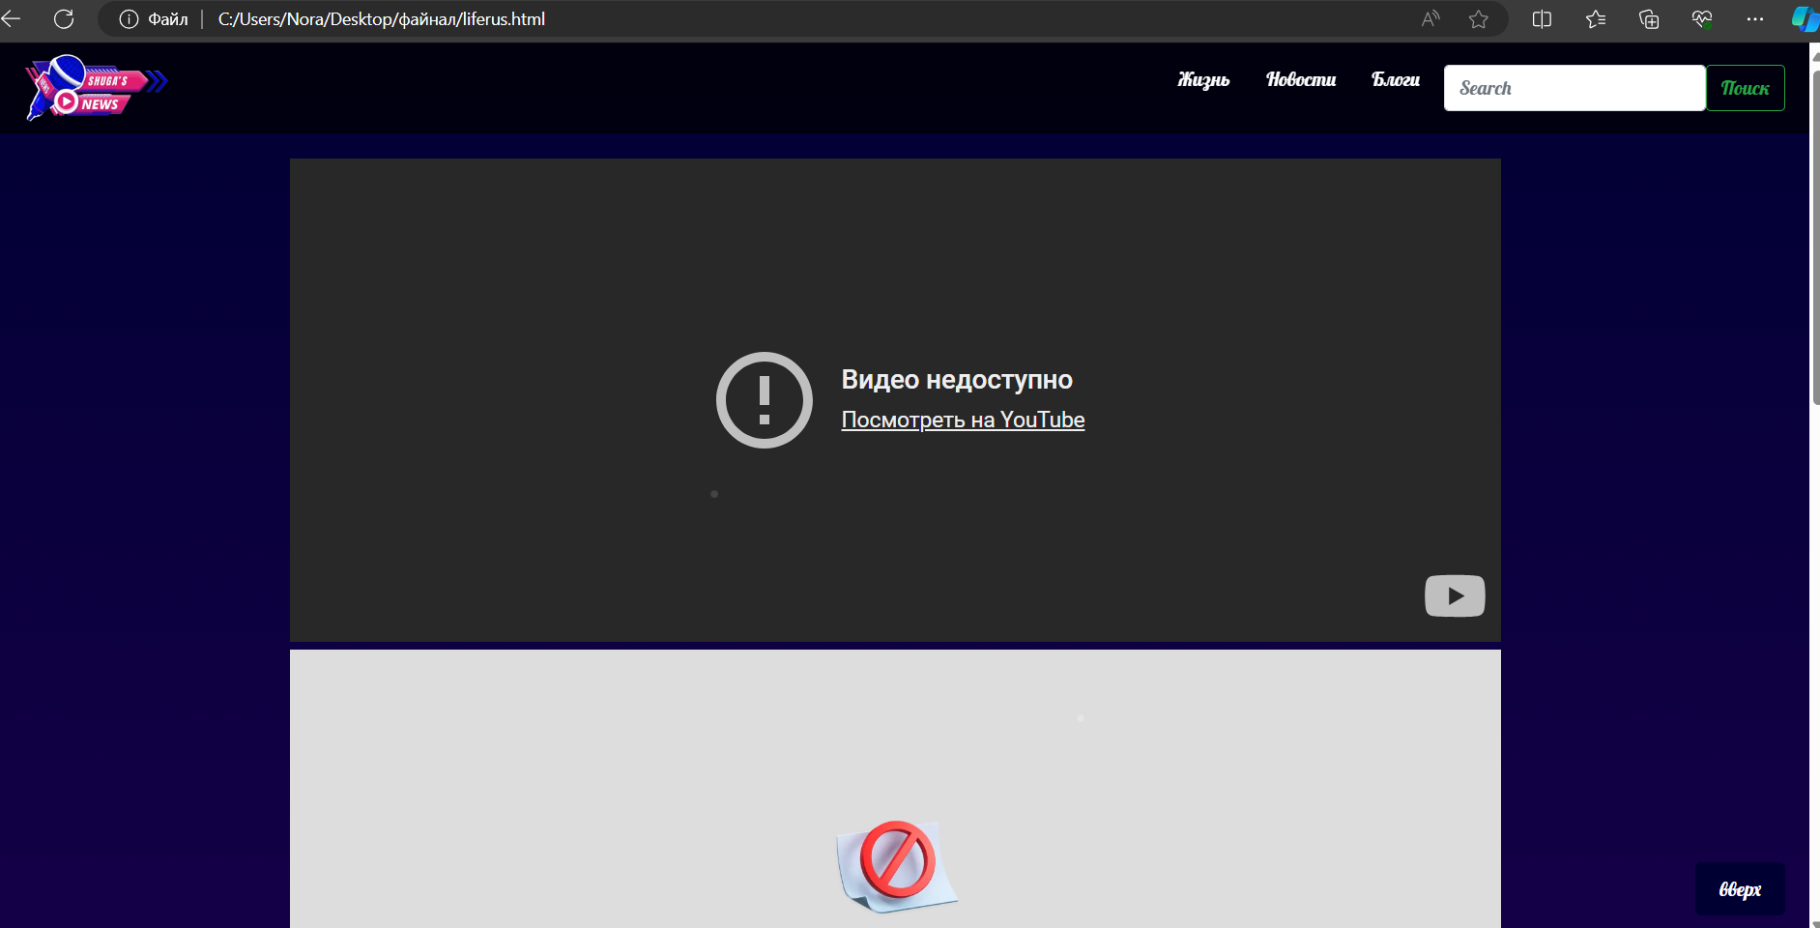

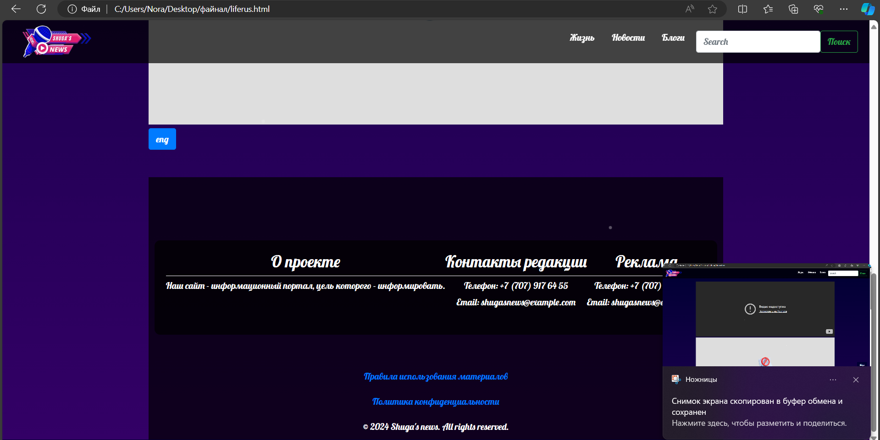

**<!DOCTYPE html>**

**<html lang="en">**

**<head>**

**<meta charset="UTF-8">**

**<meta name="viewport" content="width=device-width, initial-scale=1.0">**

**<title>Это сделала Шуги</title>**

**<!-- Bootstrap CSS -->**

**<link href="https://stackpath.bootstrapcdn.com/bootstrap/4.5.2/css/bootstrap.min.css" rel="stylesheet">**

**<style>**

**@import url('https://fonts.googleapis.com/css2?family=Lobster&display=swap');**

**body {**

**margin: 0;**

**padding: 0;**

**background: linear-gradient(180deg, #000033 0%, #330066 100%);**

**color: white;**

**font-family: 'Lobster', cursive;**

**display: flex;**

**flex-direction: column;**

**align-items: center;**

**min-height: 100vh;**

**overflow-x: hidden;**

**position: relative;**

**}**

**/* Fireworks animation */**

**@keyframes fireworks {**

**0% { opacity: 1; transform: scale(1); }**

**100% { opacity: 0; transform: scale(2); }**

**}**

**.firework {**

**position: absolute;**

**background-color: white;**

**border-radius: 50%;**

**width: 3px;**

**height: 3px;**

**animation: fireworks 1.5s infinite;**

**}**

**.firework:nth-child(1) { top: 20%; left: 40%; animation-delay: 0.1s; }**

**.firework:nth-child(2) { top: 30%; left: 60%; animation-delay: 0.3s; }**

**.firework:nth-child(3) { top: 50%; left: 50%; animation-delay: 0.5s; }**

**.firework:nth-child(4) { top: 70%; left: 30%; animation-delay: 0.7s; }**

**.firework:nth-child(5) { top: 80%; left: 70%; animation-delay: 0.9s; }**

**.top-menu {**

**position: fixed;**

**top: 0;**

**width: 100%;**

**background-color: rgba(0, 0, 0, 0.7);**

**padding: 10px 20px;**

**display: flex;**

**align-items: center;**

**justify-content: space-between;**

**z-index: 1000;**

**height: 75px;**

**}**

**.navbar-logo img {**

**width: 150px;**

**transition: transform 0.3s;**

**}**

**.navbar-logo img:hover {**

**transform: scale(1.1);**

**}**

**.menu-main {**

**list-style: none;**

**display: flex;**

**margin: 0;**

**padding: 0;**

**}**

**.menu-main li {**

**position: relative;**

**margin-left: 10px;**

**}**

**.menu-main a {**

**text-decoration: none;**

**color: white;**

**padding: 5px 10px;**

**transition: color 0.3s, background-color 0.3s;**

**}**

**.menu-main a:hover {**

**color: yellow;**

**background-color: rgba(255, 255, 255, 0.2);**

**}**

**.menu-main a:hover::after {**

**content: '⭐️';**

**position: absolute;**

**right: -20px;**

**top: 0;**

**}**

**.container {**

**display: flex;**

**margin-top: 100px;**

**justify-content: center;**

**width: 100%;**

**}**

**.carousel-container {**

**flex: 2;**

**max-width: 60%;**

**}**

**.links-container {**

**flex: 1;**

**display: flex;**

**flex-direction: column;**

**justify-content: center;**

**align-items: flex-start;**

**padding: 20px;**

**border-left: 2px solid white;**

**margin-left: 20px;**

**}**

**.links-container a {**

**color: white;**

**text-decoration: none;**

**margin: 10px 0;**

**padding: 10px 15px;**

**background-color: rgba(0, 0, 0, 0.5);**

**font-size: 1.2em;**

**transition: background-color 0.3s;**

**}**

**.links-container a:hover {**

**background-color: rgba(255, 255, 255, 0.2);**

**}**

**footer {**

**margin-top: auto;**

**padding: 10px;**

**background-color: rgba(0, 0, 0, 0.7);**

**text-align: center;**

**width: 100%;**

**}**

**footer p {**

**margin: 0;**

**}**

**.scroll-to-top {**

**position: fixed;**

**bottom: 20px;**

**right: 20px;**

**background-color: #000033;**

**color: white;**

**border: none;**

**padding: 10px 20px;**

**border-radius: 5px;**

**cursor: pointer;**

**font-size: 16px;**

**transition: background-color 0.3s, color 0.3s;**

**}**

**.scroll-to-top:hover {**

**background-color: #330066;**

**}**

**.profile-info {**

**border: 2px solid #330066;**

**padding: 20px;**

**border-radius: 10px;**

**position: relative;**

**}**

**<style>**

**/* Video frame styles */**

**.video-frame {**

**position: relative;**

**max-width: 800px;**

**margin: 0 auto;**

**padding: 20px;**

**border: 2px solid #330066;**

**border-radius: 10px;**

**overflow: hidden;**

**}**

**.video-frame:before,**

**.video-frame:after {**

**content: "";**

**position: absolute;**

**width: 20px;**

**height: 20px;**

**background-color: #330066;**

**}**

**.video-frame:before {**

**top: -10px;**

**left: -10px;**

**border-top-left-radius: 10px;**

**}**

**.video-frame:after {**

**bottom: -10px;**

**right: -10px;**

**border-bottom-right-radius: 10px;**

**}**

**/* Video styles */**

**iframe {**

**width: 100%;**

**height: 400px; /* Set the desired height for the video */**

**border: none; /* Remove default border */**

**}**

**</style>**

**<body>**

**<!-- Fireworks Background -->**

**<div class="firework"></div>**

**<div class="firework"></div>**

**<div class="firework"></div>**

**<div class="firework"></div>**

**<div class="firework"></div>**

**<nav class="top-menu">**

**<a class="navbar-logo" href="C:\Users\Nora\Desktop\файнал\abouusshuga.html"><img src="C:\Users\Nora\Downloads\yoooo-removebg-preview.png" alt="Logo"></a>**

**<ul class="menu-main">**

**<li><a href="C:\Users\Nora\Desktop\файнал\life.html">Жизнь</a></li>**

**<li><a href="C:\Users\Nora\Desktop\файнал\myfinal.html">Новости</a></li>**

**<li><a href="C:\Users\Nora\Desktop\файнал\consultation.html">Блоги</a></li>**

**<li>**

**<form class="d-flex" role="search">**

**<input class="form-control me-2" list="suggestions" type="search" placeholder="Search" aria-label="Search">**

**<datalist id="suggestions">**

**<option value="II женская игра по волейболу среди стран СНГ" data-url="C:\Users\Nora\Desktop\файнал\articletwo.html">II women's volleyball game among the CIS countries</option>**

**<option value="Казахстанский Халкын – главный инициатор благотворительной деятельности" data-url="C:\Users\Nora\Desktop\файнал\articlethree.html">Kazakhstan Khalkyn is the main initiator of charitable activities</option>**

**<option value="Развитие медицины с появлением COVID-19" data-url="C:\Users\Nora\Desktop\файнал\articlefive.html">The development of medicine with the advent of the COVID-19</option>**

**</datalist>**

**<button class="btn btn-outline-success" id="searchButton" type="button">Поиск</button>**

**</form>**

**</li>**

**</ul>**

**</nav>**

**<script>**

**document.getElementById('searchButton').addEventListener('click', function() {**

**var input = document.querySelector('input[type="search"]');**

**var selectedOption = document.querySelector('option[value="' + input.value + '"]');**

**if (selectedOption && selectedOption.dataset.url) {**

**window.location.href = selectedOption.dataset.url;**

**}**

**});**

**</script>**

**<br><br><br><br>**

**<div>**

**<div class="video-frame">**

**<iframe src="https://www.youtube.com/embed/dQw4w9WgXcQ" allowfullscreen></iframe>**

**</div>**

**<div>**

**<div class="video-frame">**

**<iframe src="https://youtu.be/8cnkHygkBcY" allowfullscreen></iframe>**

**</div>**

**<div>**

**<div class="video-frame">**

**<iframe src="https://youtu.be/NIPW__52cMs?si=I5e_BD-29Xh92jD0" allowfullscreen></iframe>**

**</div>**

**<button class="scroll-to-top" onclick="scrollToTop()">вверх</button>**

**<a class="btn btn-primary" href="C:\Users\Nora\Desktop\файнал\life.html" role="button">eng</a>**

**<br> <br> <br>**

**<footer>**

**<div class="container">**

**<div class="info-section">**

**<h3>О проекте</h3>**

**<hr>**

**<p>Наш сайт - информационный портал, цель которого - информировать.</p>**

**</div>**

**<div class="info-section">**

**<h3>Контакты редакции</h3>**

**<hr>**

**<p>Телефон: +7 (707) 917 64 55</p>**

**<p>Email: shugasnews@example.com</p>**

**</div>**

**<div class="info-section">**

**<h3>Реклама</h3>**

**<hr>**

**<p>Телефон: +7 (707) 917 64 55</p>**

**<p>Email: shugasnews@example.com</p>**

**</div>**

**</div>**

**<div class="copyright">**

**<hr>**

**<p><a href="C:\Users\Nora\Desktop\файнал\rules.html">Правила использования материалов</a></p>**

**<p><a href="C:\Users\Nora\Desktop\файнал\policy.html">Политика конфиденциальности</a></p>**

**</div>**

**<p>&copy; 2024 Shuga's news. All rights reserved.</p>**

**</footer>**

**<style>**

**.container {**

**padding: 20px;**

**background-color: rgba(0, 0, 0, 0.7);**

**border-radius: 10px;**

**color: white;**

**text-align: center;**

**}**

**.info-section {**

**margin-bottom: 20px;**

**}**

**.info-section hr {**

**border: 0;**

**border-top: 1px solid white;**

**margin: 5px 0;**

**}**

**.info-section p {**

**margin: 0;**

**margin-bottom: 5px;**

**}**

**.info-section a {**

**color: white;**

**text-decoration: none;**

**}**

**.info-section a:hover {**

**text-decoration: underline;**

**}**

**footer p {**

**text-align: center;**

**margin-top: 20px;**

**}**

**.copyright {**

**margin-top: 40px;**

**}**

**</style>**

**<!-- Bootstrap JS and dependencies -->**

**<script src="https://code.jquery.com/jquery-3.5.1.slim.min.js"></script>**

**<script src="https://cdn.jsdelivr.net/npm/@popperjs/core@2.5.4/dist/umd/popper.min.js"></script>**

**<script src="https://stackpath.bootstrapcdn.com/bootstrap/4.5.2/js/bootstrap.min.js"></script>**

**<script>**

**// Показать кнопку, когда прокручено вниз 20px от верха**

**window.onscroll = function() {scrollFunction()};**

**function scrollFunction() {**

**const scrollToTopBtn = document.querySelector(".scroll-to-top");**

**if (document.body.scrollTop > 20 || document.documentElement.scrollTop > 20) {**

**scrollToTopBtn.style.display = "block";**

**} else {**

**scrollToTopBtn.style.display = "none";**

**}**

**}**

**// Прокрутка наверх**

**function scrollToTop() {**

**document.body.scrollTop = 0;**

**document.documentElement.scrollTop = 0;**

**}**

**</script>**

**</body>**

**</html>**

**LINK AND ACCESS TO FIGURE**

**https://www.figma.com/design/xLDQgprmxSt1VXbknV3PcN/Untitled?node-id=0-1&t=bPT3qNGa32fVjehd-1**